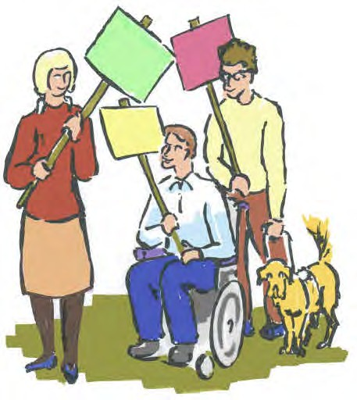International agreement on the rights of disabled people
EasyRead version

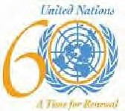
This paper is an EasyRead guide to the full agreement. It is not a legal paper. You need to look at the full agreement itself if you want to know what exactly the agreement says, or what countries have signed up to.

You can find the full agreement on the UN enable website at:

www.un.org/disabilities/

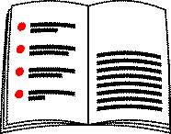
The name of the full agreement is the United Nations Convention on the Rights of Persons with Disabilities. You may also see or hear it called the United Nations Convention on Disability Rights.

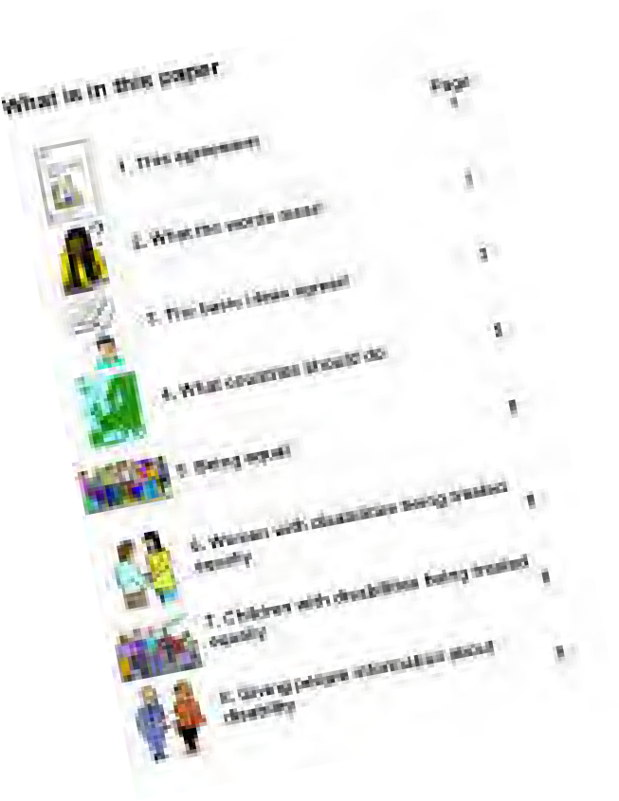There is a list of what is in this paper at the end of this paper on page 51

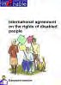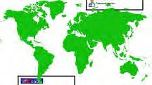This agreement

This agreement sets out what countries have to do to make sure that disabled people have the same rights as everybody else.

What the words mean

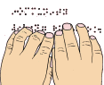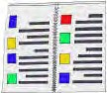Communication means the ways that help disabled people to talk and understand information, for example computers, easy read or Braille.

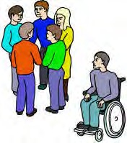
Discrimination means being treated unfairly or not getting the changes you need because you are disabled.

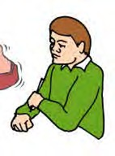Language means any way people talk to each other including sign language.

The basic ideas

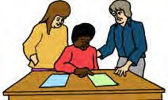
These are:

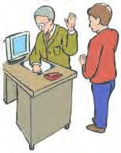People are free to make their own choices.

No one will be discriminated against.

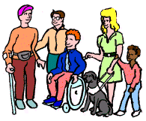
Disabled people have the same rights to be included in society as anybody else.

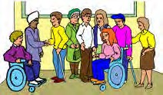
Disabled people are to be respected for who they are.

Everyone should have equal opportunities.

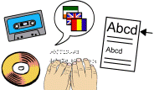
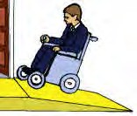
Everyone should have equal access.

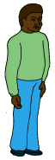
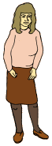
Men and women should have equal opportunities.

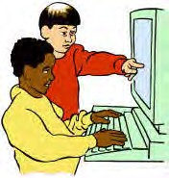
Disabled children should be respected for who they are as they grow up

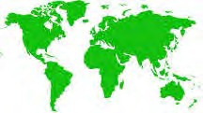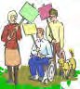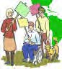What countries should do

All countries should make sure that disabled people actually do get treated equally.

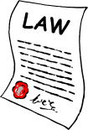
They agree to do this by:

Making rules and laws to give disabled people their rights and changing any laws that aren’t fair.

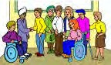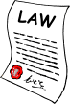Making sure the rights of disabled people to be treated equally are included in all policies.

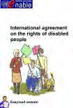Not doing things that are against this agreement

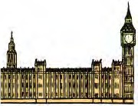Making sure governments and authorities do the things in this agreement.

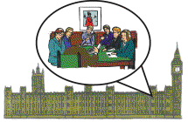
Doing as much as they can to make sure no one discriminates against disabled people.

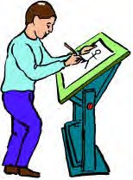
Making sure things are designed for everyone to use or that can be easily changed.

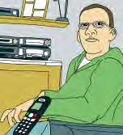
Using new technology to help disabled people.

Giving accessible information to disabled people about the things that will help them.

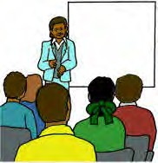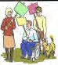Training people about this agreement.

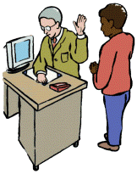All countries promise to do as much as they can afford to make sure disabled people have equal access to things like housing, education and health care.

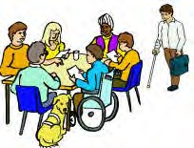
All countries should involve disabled people in making new laws and policies.

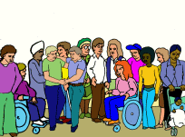
Being equal

Countries agree that everyone is equal under the law and that discrimination against disabled people will not be allowed.

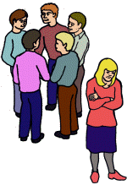
Women with disabilities being treated equally

Countries agree that women and girls who are disabled are treated unfairly in lots of different ways.

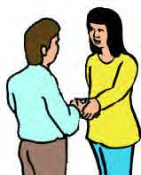
Countries will work to make sure that disabled women and girls have full, free and equal lives.

Children with disabilities being treated equally

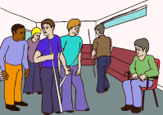
Countries agree that disabled children have the same rights as other children and are treated equally with others.

What is best for the child will be the most important thing to think about.

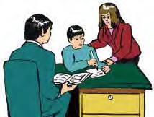
Countries agree that disabled children have the right to be heard in all things that can affect them in their lives. Support will be given to children to help make this happen.

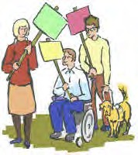
Giving people information about disability

Countries agree to do things to make everyone else aware that disabled people have the same rights as everyone else and to show them what disabled people can do.

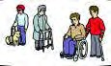They should do this by:

Having campaigns to change the way some people think about disabled people’s lives.

Showing everyone what jobs disabled people can do.

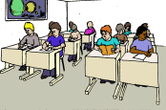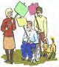Teaching all children about equal rights for disabled people.

Getting the media to show disabled people properly.

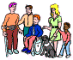Supporting more disability awareness work.

Accessibility

Countries should make sure disabled people have better access to things in all areas of life.

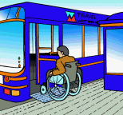There should be better access to public buildings like hospitals and schools, and transport.

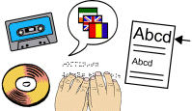
There should be better access to information.

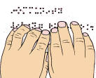 Signs should be in easy read and Braille.

More guides and sign language interpreters should be available in public buildings.

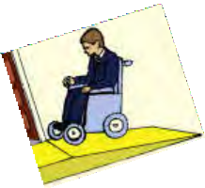There should be guidelines about how to make access to public services better.

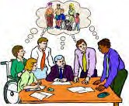
Anyone providing services should plan for good access for disabled people.

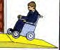Accessibility training should be given.

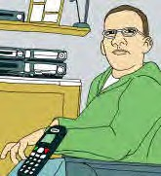
They should make sure that disabled people have access to new technology.

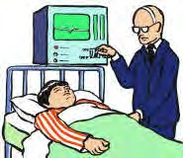Right to life

Everyone has the right to life including disabled people.

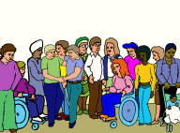
Countries should make sure disabled people have the same chances as anyone else to live their lives.

Emergencies

Making sure that disabled people are properly protected when there are risky situations for everyone, for example when hurricanes happen.

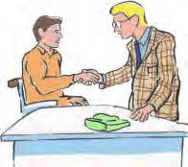
Being treated equally by the law

Disabled people are to be respected by the law like everyone else.

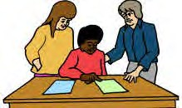
Disabled people have the same right to make their own decisions about important things as everyone else.

Disabled people should have the proper support they need when making decisions.

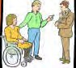If a person really does need someone else to speak for them there should be rules to make sure this is done properly.

Disabled people have equal rights to:

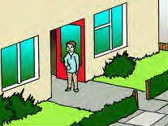
Own or be given property.

Control their own money.

Be able to borrow money the same as anyone else.

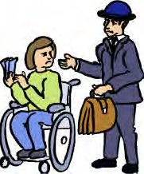
Not have their homes or money taken away from them.

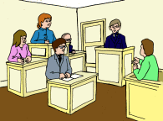
Getting justice

Disabled people should have the same rights to go to court, take other people to court or take part in what happens in courts as anyone else.

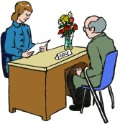
Disabled people should get support to make sure they get these rights.

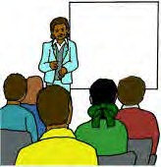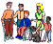Countries should have special training for courts, police and prison staff.

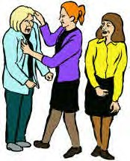
Being free and safe

Disabled people should be free and safe, the same as everyone else.

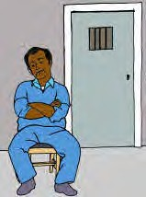
Disabled people should not be locked up just because they are disabled but only if the law says so for other reasons.

If disabled people are locked up they should be treated in the ways this agreement says.

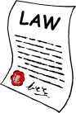
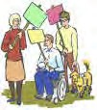
They should also have the same rights that everyone else has under other international laws. This agreement does not list those rights but they include being:

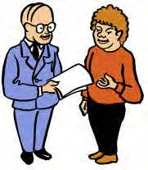Given accessible information about their rights.

Given access to help and support to get a fair hearing in a court.

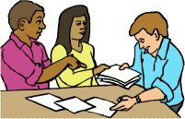
Having their case reviewed as often as other people would.

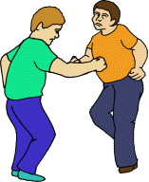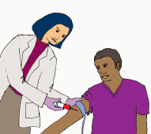Not being tortured or treated cruelly

Disabled people must not be treated cruelly or tortured.

Disabled people must not be experimented on, especially medical experiments, (unless they freely agree).

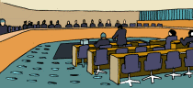
Countries must do everything possible to make sure these things do not happen.

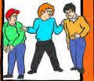Not being used or abused

Countries must make laws and rules to make sure disabled people are protected in the home and outside from violence, being used or abused.

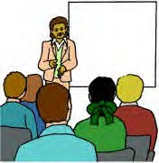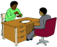Countries must also try to prevent abuse and they should make sure there is proper support, information and training on how to see abuse and how to report it.

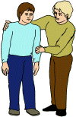
Countries should make sure that services that support disabled people are properly checked up on to make sure abuse does not happen.

Countries should make sure that disabled people who have been abused get the help and support they need to keep them safe and help recover from the abuse.

Countries must make sure they have good ways of finding out about abuse and making the abusers go to court.

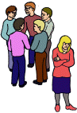Countries must think especially about the abuse of women and children.

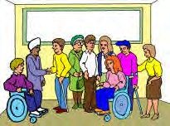
Treating disabled people as people first

Disabled people’s minds and bodies are their own and must be respected the same as everyone else’s.

Moving around

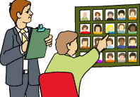Disabled people have the right:

To decide where they live and to move about the same as every one else.

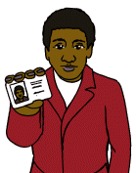
To belong to a country (be a citizen) and not have that taken away because they are disabled.

To have papers, like passports, that other people have.

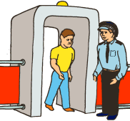
To leave any country including their own.

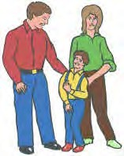
Disabled children will have the right to a name from birth, a right to be a citizen and if possible, the right to know and be cared for by their parents.

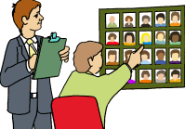
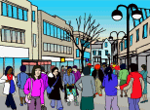
Independent living and being a part of the Community

Countries should make sure disabled people have the same choices as everyone else about how they live and being part of their communities.

Disabled people can choose:

Where they live, the same as everyone else.

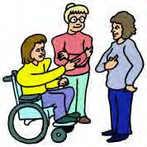Who they live with, the same as everyone else.

And not to live in a particular place like a hostel if they don’t want to.

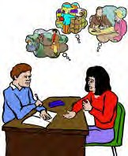
From a range of different support services including personal assistance.

From the same range of services that other people can choose from and get a good service.

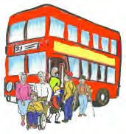
Getting about

Countries should make sure disabled people can get about independently as much as possible.

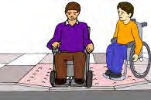
They should:

Help people get about.

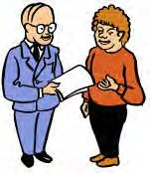
Help people get good aids and help to get about.

Make sure these things don’t cost too much.

Give training on how to get about.

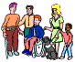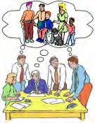Get companies that make aids to think about all different needs of disabled people.

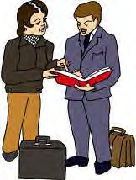
Saying what you want and access to information

Countries must make sure that disabled people have the right to find out and give information and to say what they want, the same as everyone else.

This includes:

Information in the way you need it, EasyRead for example.

Providing sign languages, Braille and other ways of information.

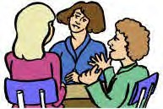
Telling other services to do accessible information.

Getting the media, including the Internet to provide accessible information.

Supporting the use of sign language.

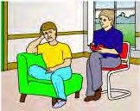Privacy

Disabled people have the right to a private life and no one should interfere with or get in the way of that.

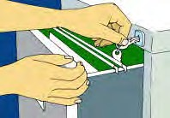
Countries must make sure that personal information about disabled people is kept confidential or private the same as everyone else’s.

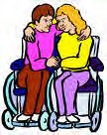Respect for the home and the family

Countries must make sure that disabled people have equal rights to marriage, a family and personal relationships.

Countries must make sure that:

Disabled people have equal rights to get married and start a family as long as both of the couple want to.

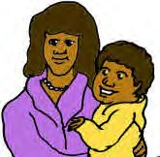
Disabled people have a right to decide how many children they have and when to have them, and not be sterilised against their will.

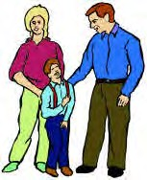
Disabled people have the right to family planning and other information to help them decide these things.

Countries will provide support to disabled people to help bring up their children.

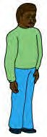Children with disabilities have the right not to be kept apart from their families.
Countries must support disabled children and their families.

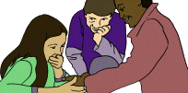
The rights of children come first.

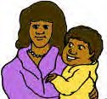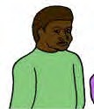Countries will make sure children are not taken away from their parents if they don’t want to be, except when the law says it is in the best interests of the child. Children must not be taken away just because they or their parents are disabled.

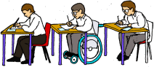
Education

Disabled people have a right to education.

Countries will make sure disabled people have the opportunity to go to mainstream schools and can carry on learning throughout their lives so that:

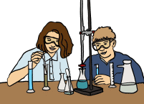
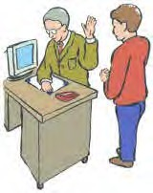
Disabled people are able to develop their skills and abilities and take their place in the world.

Disabled people are not excluded from (kept out of) any sort of education.

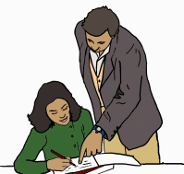
Disabled people can go to good local schools, and don’t have to pay for them, the same as everyone else.

Disabled people have their needs met as far as possible.

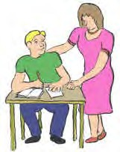
Disabled people get proper support to learn.

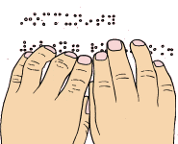
People can learn Braille and other ways of communicating as needed.

Teach people sign language and see it as a language of the deaf community.

Deaf and blind children get the right education and support for them to learn.

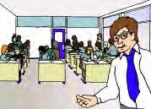
Make sure teachers have the right skills.

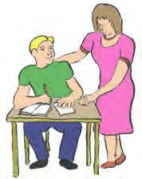
Provide the right support for disabled people to continue their education as adults if they want to.

Health

Disabled people have the right to good health and access to health services including family planning.

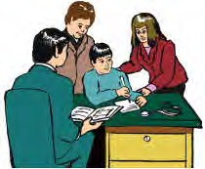
Countries will:

Make sure disabled people have access to the same health services as others.

Make sure disabled people get the health services they need because of their disability.

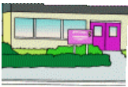Make sure services are near to where people live.

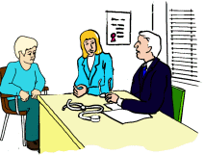
Make sure health professionals give the same service to disabled people as to others.

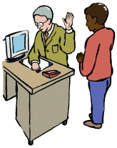
Make sure disabled people are not discriminated against in health and life insurance.

Make sure people are not refused care or treatment because they are disabled.

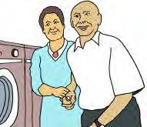
Services to help you recover

Countries will make sure disabled people can lead an independent and healthy a life as possible and will provide support in health, work, education and social services to help that happen.

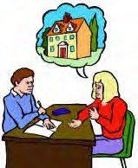
Countries will make sure that they look at disabled peoples’ needs and strengths at an early stage so that disabled people get the support and services they need.

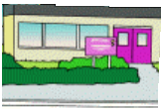These services will be as near to where disabled people live as possible.

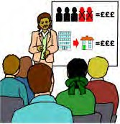
Staff will be trained to do a good job.

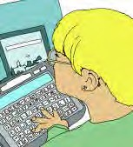
Countries will look at the different aids and equipment made to support disabled people to recover.

Work

Disabled people have a right to work, equal with others.

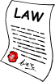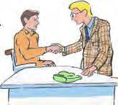Countries will do more to get disabled people work and will help do this by:

Making laws that make sure disabled people are treated equally and fairly at work.

Making sure disabled people have equal job rights and rules and pay.

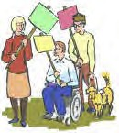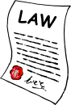Making sure disabled people have a right to join a union the same as everyone else.

Making sure disabled people can go on work programmes and work training.

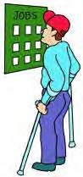
Helping disabled people find and keep jobs as well as get better jobs.

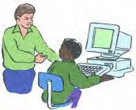
Helping disabled people set up their own businesses.

Giving disabled workers jobs with Government and in places like councils and hospitals.

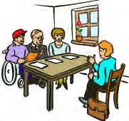
Helping companies give disabled people jobs.

Making sure disabled people have suitable places to work.

Making sure disabled people can try out work.

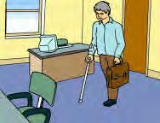
Help disabled people get back to work.

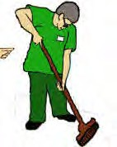Countries must make sure that disabled people are not forced to do unpaid work.

Standards of living

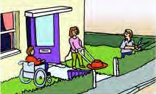
Disabled people have an equal right to a good enough standard of living for them and their families. This includes food, clothing, housing and clean water.

Disabled people should be able to get help to improve their standard of living the same as everyone else.

Countries should make sure that:

Disabled people have the right services and aids for their disability, at a price they can afford.

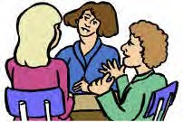
Disabled people especially girls and women and older people, have help to have a good enough standard of living.

Disabled people who are poor get help from the state with the costs of disability.

Disabled people have access to public housing programmes.

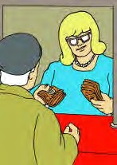
Disabled people have the same chances to get retirement pensions as other people.

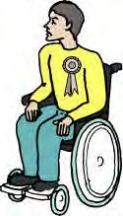
Being involved in politics

Disabled people have the right to take part in politics the same as every one else.

Disabled people have the right to vote by:

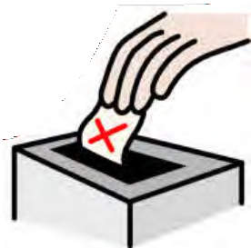
Making sure voting is easy to do and understand.

Making sure voting is secret.

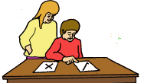
Allowing support to help people vote in the way they want, when needed.

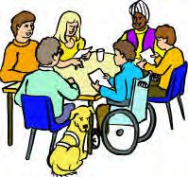
Making sure disabled people can be involved in non government organisations and political parties.

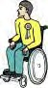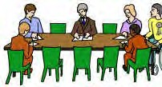Making sure disabled people can join organisations of disabled people.

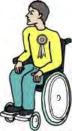
Disabled people have the right to stand for election as MPs and councillors.

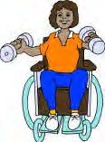
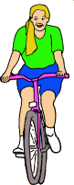
Sport and leisure

Disabled people have the right to take part in sports and leisure as much as anybody else.

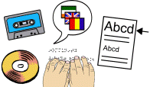
Countries should work towards making sure that:

Things like books are accessible.

Television, films and theatres are accessible.

Disabled people can get into places like museums.
Museum

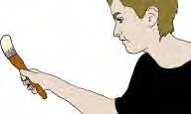
Disabled people have the opportunity to be artists in their own right.

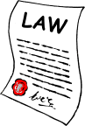
Rules and laws should not make it more difficult for disabled people to access things like books or films.

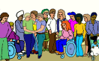
Deaf and other cultures are respected.

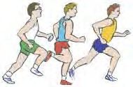
Disabled people are supported to take part in ordinary sports.

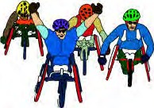
Disabled people are able to take part in disability sports and leisure activities.

Sports and other leisure places are accessible.

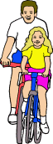Disabled children have equal access as well.

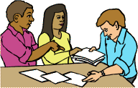
Information

Countries should collect the information they need to help make this agreement happen.

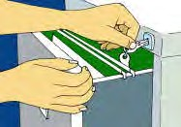
Personal information must be kept confidential and private.

Governments must make sure that disabled people can access the information they collect the same as everyone else.

Countries working Together

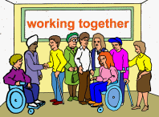
Countries will work together as partners to make this agreement happen.

They should:

Make sure that working together includes disabled people.

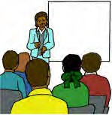Make sure that countries share information, experiences and training so that all people work in the best way.

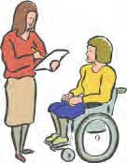
Make sure that countries work together on research and share what they find out.

Making this agreement happen

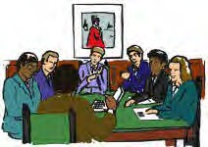
Governments should:

Have one area of Government dealing with making this agreement happen.

Have a way that measures how well the agreement is happening.

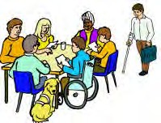
Involve disabled people in looking at how well this happens.

Committee on the rights of disabled people

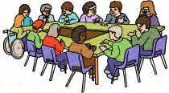
A special committee will be elected by all the countries to make sure this agreement is being followed properly. It will be based at the United Nations.

Reports from Countries involved

Each country will write a report about their work for this agreement and send it to the Committee within 2 years after they agree to join.

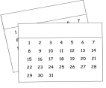After that, each country will send a report every 4 years, as well as extra reports if the Committee asks for them.
4
Years

The Committee will decide what information countries need to put in their reports.

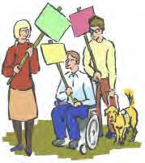
The reports can also be about things that are holding up disabled people’s rights.

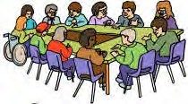What happens to the reports

The Committee will look at the reports and give countries ideas and advice about what to do.
They can also ask for more information.

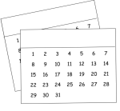If the report is very late, the Committee can warn the country that in 3 months time it will go ahead and look at what is happening there anyway.

3 months

All Countries will be able to see all reports.

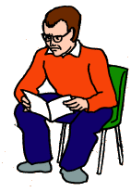
Each Country must make sure that the public can see its report and what the Committee has said about it.

The Committee will send the reports to different departments and organisations to ask for advice or help if needed.

The Committee and Countries working together

Each Country will work together with the Committee and help the Committee members with any information that they need.

The Committee will think about how it can work with Countries to make this work happen in a good way.

How the Committee will work with other organisations

It is important that all countries and organisations work together to make this work happen.

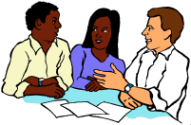
Different departments and organisations will be invited by the Committee to give advice and information about their area of work.

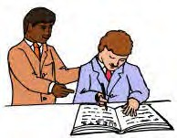The Committee may ask other human rights organisations to write reports about how their work fits into this agreement.

The Committee Report

The Committee will write a report every 2 years for the General Assembly and the Economic and Social Council. It will include ideas from the different countries about what should be done.
2
Years

Meetings for the Countries involved
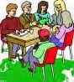
Countries involved will meet often to think about the work of this agreement.

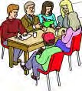The first meeting will be no later than 6 months from the start of this work. The Secretary General will arrange future meetings.

6 Months

Keeping hold of all the reports and information

The Secretary General of the United Nations will hold all the information and reports for this work.

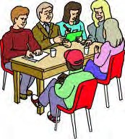

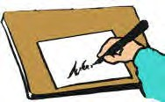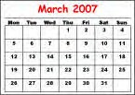Signing the Agreement
30

Countries will be able to sign this agreement from the 30th of March 2007 at the United Nations Headquarters in New York.

Consent and Approval

Countries that have signed this agreement then decide when to join it properly. That is when it starts properly in their country.

Other countries who have not signed it can join it too.

Groups of Countries

Some countries are joined together in organisations, like the European Union.

These organisations can also join the agreement and also have a say when countries meet to talk about the agreement.

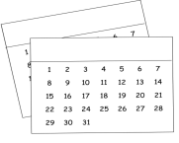When will the agreement start?

30 Days

The agreement will start 30 days after 20 countries have joined it.

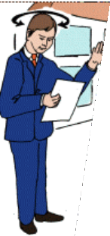
Keeping to the agreement

Countries cannot refuse to sign up to any really important parts of this agreement.

Amendments and changes to the Agreement

Any Country can ask for changes to the agreement. They can do this by writing to the Secretary General who will tell the other Countries.

The Countries will decide if they need a meeting to talk about the idea and if it should be agreed.

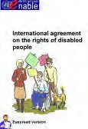If a Country wants to get out of the Agreement

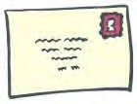
A Country can get out of this agreement by writing to the Secretary General. They will stop being part of the agreement 1 year after the letter has arrived.

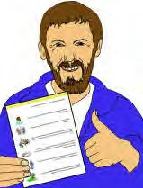
Accessible Information

This agreement will be available in easy to understand formats.

This Agreement in other languages

This agreement will be printed in Arabic, Chinese, English, French, Russian and Spanish and will be equal in these languages.

Credits

This paper has been written, designed and produced for Department for Work and Pensions by the ‘EasyRead’ service @ Inspired Services Publishing Ltd. ISL366/07. November 2007.

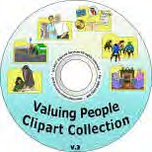
Artwork is from the Valuing People Clipart Collection and cannot be used anywhere else without written permission from Inspired Services Publishing Ltd.

www.inspiredservices.org.uk

This paper may be copied without formal permission or charge for personal or in-house use.

What is in this paper

Page
- This agreement 1

What the words mean 1
?

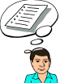
- The basic ideas agreed 2

- What countries should do 4

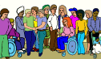
- Being equal 7

- Women with disabilities being treated equally 7
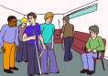
- Children with disabilities being treated equally 8
- Giving people information about disability 8

What is in this paper continued

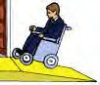
Page
- Accessibility 10

- 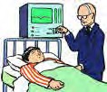Right to life 12

- Emergencies 12

- Being treated equally by the law 13

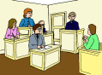
- 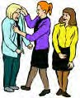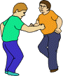Getting justice 15

- Being free and safe 16

- Not being tortured or treated cruelly 17

- Not being used or abused 18

What is in this paper continued

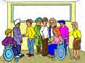
Page
- Treating disabled people as people
first 19
- 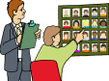Moving around 20

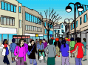
- Independent living and being a part
of the community 21
- Getting about 22

- Saying what you want and access
to information 23
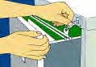
- Privacy 24

- 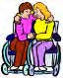Respect for the home and the family 24

- Education 26

- Health 29

What is in this paper continued

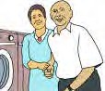
Page
- Services to help you recover 30

- Work 31

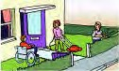
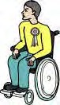
- Standards of living 34

- Being involved in politics 35

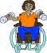
- Sport and leisure 37

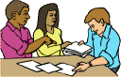
- Information 39

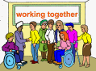
- Countries working together 39

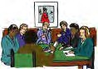
- Making this agreement happen 40

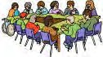
- Committee on the rights of

disabled people 41

What is in this paper continued
Page
- Reports by Countries involved 42
? 36. What happens to the reports 43
- The Committee and Countries
working together 44
- How the Committee will work with
other organisations 44
- The Committee Report 45

- 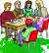Meetings for the Countries involved 45

- 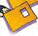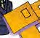Keeping hold of all the reports and information 45
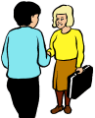
- 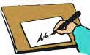Signing the Agreement 46

- Consent and Approval 46

What is in this paper continued

Page
- Groups of Countries 46

- 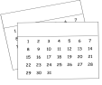When will the agreement start? 47
?

- Keeping to the agreement 47

- Amendments and changes to the Agreement 47

- 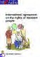If a Country wants to get out of

this Agreement 48

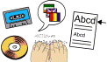 49. Accessible Information 48

50. This Agreement in other languages 48

Credits 49

