ESCAP Facility Accessibility Assessment
Jim Harrison and Greg Alchin

Contents

1. Contents 2
Table and Figures Table of Contents 6
2. Revision history 7
3. Executive Summary 8
Section A: Introduction and Context 10
4. Introduction 11
4.1 Site and context 12
4.2 Reviewed documentation 13
4.3 Understanding disability 15
4.4 The building complex and its users 16
4.5 Universal design 17
4.6 Design for dignity 21
5. Methodology and strategy 22
5.1 Built environment methodology 22
5.2 ICT environment methodology 23
5.3 Services environment methodology 23
5.4 Survey and user feedback methods 23
Section B: Built environment 25
6. Built environment - Legislation and international standards 26
6.1 International Perspective 26
6.2 Analysis of international accessibility standards – Main issues 30
6.3 Thailand Perspective 31
6.4 Australian and other codes: A perspective 32
6.5 National Construction Code / The Building Code of Australia 33
6.6 Disability Discrimination Act 1992 (Cth) (Dda) 34
7. Access to premises standards – General 36
7.1 Access to premises standards – New Work. 36
7.2 Access to premises standards – Affected Part 36
7.3 Access to premises standards – Toilet Concession 37
7.4 Standards and universal design 37
7.5 Summary: responding to increasingly higher standards 37
8. Built Environment Accessibility Assessment 39
8.1 Thailand Legislation 39
8.2 Compliance with Thailand Legislation 39
8.3 Australian Legislation Requirements (BCA) 41
8.4 Compliance with Australian Legislation: External Spaces (BCA) 42
8.5 Compliance with Australian Legislation: Interior Spaces 45
8.6 User feedback on built environment 52
8.9 Additional accessibility considerations 55
9. Case Studies: Clients’ and Consultants Proposals discussed 58
9.1 Clients’ proposals 58
9.2 Consultants’ proposals 61
9.3 Conclusions 69
10. Building guidelines to assist the next stage of design of the refurbishment of the UNESCAP buildings. 70
10.1 Introduction 70
10.2 Using the Guidelines 72
10.3 Key Universal Design Factors of Generic Elements: 73
10.4. Building by Building 81
10.5 Secretariat Building 90
10.6 Service Building 92
10.7 External spaces 95
Section C: ICT environment 97
11. ICT - Legislation and international standards 98
11.1 Web Content Accessibility Guidelines / ISO/IEC 40500:2012 99
11.2 International Perspective on WCAG 2.0 100
11.3 Accessible procurement of ICT 101
11.4 Disability Discrimination Legislation and ICT 101
12. ICT environment accessibility assessment 103
12.1 Online systems 103
12.2 Non-web based digital content 106
12.3 Procurement of ICT 108
12.4 Personalisation of ICT 109
12.5 UNCC Facilities 109
Section D: Services 115
13. Services - Legislation and international standards 116
14. Services accessibility assessment 118
14.1 Customer service 118
Safety and Security - Evacuation procedures 123
14.2 Human Resources 124
Section E: Conclusions and Recommendations 127
Built Environment Recommendations 128
ICT Environment Recommendations 128
Services Recomendations 130
Quick Wins 132
Section F: Appendices 133
15. Appendix A Charts 134
CHART 1: Item non- conformance 135
CHART 2: Item order of importance 136
CHART 3: Item order of impact 138
CHART 4: Costings 140
16. Appendix B: Site analysis results 143
17. Appendix C: Inclusivity Survey 144
18. Appendix D: Tenant Accessibility Survey 146
19. Appendix E: Accessibility Assessment on-site 147
WEEK OF 19-23 147
WEEK OF 26-30 148
WEEK OF 3-7 July 149
20. Appendix F: Ministerial Regulation Prescribing accessible facilities for persons with disabilities and the elderly. 2005AD (B.E.2548) 150

1.1 Table and Figures Table of Contents

Revision history
Table 1: Revision history of this document
Revision No. | Prepared by | Description | Date
00 | Jim Harrison Greg Alchin | DRAFT for client review | 08 August 2017
01 | ESCAP Accessibility Working Group | Client Feedback Provided | 30 August 2017

Disclaimer
This report has been prepared based on the available time allocated to conduct the review, and all reasonable attempts have been made to identify key compliance matters with regard to accessibility.
The information provided within this report is relevant to this project and the documentation referenced. As such the information provided may not be transferred to other projects.
No responsibility is accepted for any loss suffered as a result of any reliance upon such assessment or report other than providing guidance to alleviate access barriers in the built, ICT and services environments.

Executive Summary
As part of A/71/333 Proposal for the seismic mitigation retrofit and life-cycle replacements project at the Economic and Social Commission for Asia and the Pacific premises in Bangkok an accessibility assessment of the facility was conducted. The assessment of the accessibility of UNESCAP facilities is based in the principles of Universal Design, including persons with disabilities among others covering the following areas of accessibility:
- built environment,
- service accessibility,
- Information and communication technologies
The project addresses proposals for the refurbishment of the UNESCAP buildings in Bangkok with the aim of identifying aspects of the buildings, including their communication systems and services, where accessibility can be improved to bring these to comply or exceed current standards. Following comprehensive assessment of these areas, as well as obtaining valuable feedback from the occupants in various ways, this report investigates aspects of accessibility, with particular emphasis on universal design principles. It then identifies priorities, relative cost outlay and advantages to be gained in terms of user-friendliness, and proposes strategies and guidelines to maximise access within the buildings not only for people with disabilities but for all occupants.
The United Nations (UN) has developed a broad framework for accessibility within development that addresses the provision of universal design. The overall goals of the UN with respect to accessibility have been addressed in UNESCAP Project, with the emphasis on inclusion of all users of the building. The buildings under scrutiny were constructed several decades ago and although some refurbishment has gone some way to improving accessibility, there are many areas in which these are not compliant with current codes and standards. With the aim of making the UNESCAP Complex become an example of best practice in this field, international accessibility standards have been compared as a part of this report to ensure that recommendations made for the proposed refurbishment accord with best practice measures concerning accessibility and reflect the progressive nature of accessibility legislation.
The report reviews:
- building standards and codes from various countries to establish the most suitable of these to use for the UNESCAP Refurbishment, based on achieving an international best practice approach to accessibility.
- ISO/IEC standards on web and information design to benchmark UNESCAP information systems and digital ecosystem to those systems and content are accessible to people with disabilities.
- International ICT Procurement guidelines to support non-discriminatory recruitment and retention practices in line with ST/SGB/2014/3 “Employment and accessibility for staff members with disabilities in the United Nations Secretariat” as well as,
- Guidelines and codes on service delivery to create a positive and dignified experience to persons with a disability in line with ST/SGB/2014/3.
The requirements for major accessibility issues such as wheelchair manoeuvring spaces and room dimensions within four countries are reviewed, as well as other international standards for accessibility. From this study it is recommended that, in most instances, the Australian building codes and standards on accessibility issues should be adopted where appropriate, as these are regarded as being more exacting than other countries and their application will achieve an international best practice approach to universal design in keeping with UN frameworks and policies. Specific elements of each building and external space are tabulated, comparing compliance of the existing buildings to both local Thai access requirements and also to those considered to be best practice, namely Australia and Singapore.
Case studies and recommendations are given on particular situations in the existing building and clients’ future proposals, with consultants’ outline suggestions where comprehensive refurbishment would accord with universal design principles. The Report also includes Guidelines, using building-by-building analysis of the existing complex to identify aspects where improvements are called for, not only for compliance with international standards but also to embrace universal design principles of inclusion of all users. The Guidelines are written with the aim of informing the lead architects of the project when they make further design proposals, particularly in improving the standards of access and safety for both delegates and staff, whatever their abilities.

Section A: Introduction and Context

Introduction
As part of A/71/333 Proposal for the seismic mitigation retrofit and life-cycle replacements project at the Economic and Social Commission for Asia and the Pacific premises in Bangkok an accessibility assessment of the facility was conducted. This report documents a comprehensive review of the proposed project documentation with consideration to all aspects of accessibility to the site and throughout the development and with reference to the Building Code of Australia (BCA), Disability (Access to Premises – Buildings) Standards 2010 (Premises Standards), and relevant Australian Standards as they relate to access to premises. Other international disability access legislation has also been considered in the preparation of this report.
Reference is made throughout this report to a comparable study undertaken by architects Conrad Gargett for Africa Hall, Addis Ababa in February 2017 and the consultants would like to acknowledge the value of this work in completing their study, based on the available time allocated to conduct the review, and all reasonable attempts have been made to identify key compliance matters with regard to accessibility.
This report has been prepared with the aim of providing reasonable recommendations in regards to improving the accessibility of UNESCAP facilities based in the principles of Universal Design, covering physical accessibility, Service accessibility (for coordination and incorporation with support consultant), and Accessibility to communication and information (ICT) (for coordination and incorporation with support consultant) to benefit both persons with disabilities and people of all abilities.
This assessment describes the areas where accessibility is not in conformance with international standards and should be upgraded to meet the needs of the United Nations for conference facilities and for improved working conditions for staff.
Recommendations are provided in accordance with the governing documents, particularly to
Article 1: Purpose and Article 9: Accessibility from the United Nations document titled: “Convention on the Rights of Persons with Disabilities and Optional Protocol”.
The primary goal of the project is to identify where accessibility within the UNESCAP Building Complex is lacking, comparing this to both local and international codes. As well this systematic analysis, the report then proposes realistic ways in which this can be improved up to and beyond current standards in both the physical environment and communication. Strategies to maximise access not only for people with disabilities but also users of every ability within the site and premises are set out in regard to i) their potential efficacy for the buildings’ users, ii) the priorities for any programme of improvement and iii) indications of the costs involved in the various works.
A ‘Road Map’ suggesting in outline the sequence and scale of any programme of upgrading is included in the report and a comprehensive set of Guidelines, relating the consultants’ proposals for upgrading both physical and ICT to current best-practice design codes, is set out with the intention of providing reference and rationale on aspects of universal design for the Lead Architects who will be appointed to carry out the proposed work. Charts are given to identify the main areas where the buildings are not compliant with accessibility standards, priority areas for remedying these problems and to demonstrate the impact that any upgrading will have on the disabled building users. Approximate cost estimates are also charted to demonstrate the relative outlay to bring both the built and the virtual environments up to best practice standards.
Every endeavour has been made to clearly identify each issue of concern with respect to the building element and with reference to relevant legislation and guidelines, as well as indicators of priority, efficacy and relative cost in achieving best practice with respect to the principles of universal design.
Matters that fall outside the scope of this report include structure or installation methods.

4.1 Site and context
The site of the United Nations Economic Commission for Asia and the Pacific Buildings occupies approximately 18,600sq metres is located on the junction of Rajadamnern Nok Road and Krung Phadung Krungkasem Road. The Conference Centre is the most dominant building but access to this from the street is necessarily limited by security restrictions, so the main approach, by vehicle or on foot, is from the south eastern corner of the site from Rajadamnern Nok Avenue, A service entrance, which also accesses the UNDP offices, is located on the Northern corner of the site on Krung Phadung Krungkasem Road. Both entrances have security gates for vehicles and for pedestrians.
The site is flat but at an elevation of up to 1 metre above street level, so that the approach for both pedestrians and vehicles is by short ramps at each entrance.
The existing buildings comprise three distinct blocks:
- The 15 Storey Secretariat tower, built in the early 1970s
- The Service Building also constructed in the 1970s
- The Conference Centre (UNCC) constructed at a later date incorporating original Conference Hall (now Conference Room 3) built at the same time as the Secretariat tower.
These buildings are connected to one another by two corridors at Ground Floor level and at First Floor level by three enclosed bridges. There are also exterior and interior spaces which connect these buildings which are found within the compound, as well as the entry points of the facility. Car parking is currently provided at Ground Floor level, both open and enclosed (at the Service Building) and at two Basement levels, with total spaces for 640 vehicles. Basement car parking occupies the two lowest levels of the Conference Centre and part of the basement of the Service Building, approached by a series of ramps.
Three key proposals by the clients for extension and renovation projects are also included in the assessment. These are:
- New library facility,
- New security entry point, and
- Conference Room 3 Audio Visual Upgrade Project in the UNCC.
In addition, this Report describes in outline seven other areas suggested by the consultants where comprehensive refurbishment and some new construction, in accord with universal design principles, would enhance the accessibility, safety and imageability of the UNESCAP building complex, for both staff and conference delegates.

4.2 Reviewed documentation
In preparation for the site inspection conducted July 2017, the following background documentation was reviewed by the consultants.

Supplied by ESCAP
- ESCAP Facilities Management Unit (FMU)
  - 2004 Disability Assessment of the UN Compound: an ADA assessment of all 3 buildings,
  - List of renovations to-date post 2004 ADA assessment noted above
  - The existing building drawings (available in AutoCAD and Revit)
  - Proposed new library building – drawings, specifications, project timeline
- ESCAP Conference Management Unit (CMU)
  - The Conference Room 3 – Pilot Project Report - an explanation of the audio and visual features added to this conference room to renovate the space to accommodate visually and audibly impaired, and
  - New Conference Room 3 - Audio Visual System – drawings, specifications, project timeline
- ESCAP Division of Safety and Security (DSS)
  - Proposed New Security Entry Point – drawings , specifications, project timeline
  - Emergency Evacuation Plan. UN Building Bangkok Security and Safety Section UN August 2016
- ESCAP Social Development Division (SDD)
  - 2017 DRAFT Guideline for accessibility for ESCAP conference and meetings
  - UNICEF Accessibility Guideline
  - Guideline for People with Disabilities (WHO) 1989
- ESCAP Information Management Communication Technology Section (IMCTS)
  - General technical specifications for hardware
- Governing Documents
  - United Nations’ Convention on the Rights of Persons with Disabilities and Optional Protocol. (referenced throughout this report as the Convention or CRPwP)
  - Incheon Strategy’ to “Make the Right Real” for Persons with Disabilities in Asia and the Pacific
  - E/ESCAP/70/6
  - ST/SGB/2014/3 Employment and accessibility for staff members with disabilities in the United Nations Secretariat
- Other UN Offices and Reference Documents
  - UN Headquarters, New York – Accessibility Centre
  - Un Economic Commission for Africa (ECA) Conference Hall – Example Project: The report on Accessibility for the United Nations facility, Africa Hall, in Nairobi
  - UN Office in Geneva (UNOG) - Guideline (unofficial) for Conference Room Design considering Accessibility
- International Labor Organization (ILO)
  - ILO Accessibility Handbook 2005 Clarifying disability

External documentation
- Thai Codes 2005
- Singapore Code on Accessibility in the Built Environment 2013
- Australian Building Codes
- ISO/IEC 40500:2012 - Information technology -- W3C Web Content Accessibility Guidelines (WCAG) 2.0
- EU Standard - EN 301 549 - Accessibility requirements suitable for public procurement of ICT products and services in Europe.
- Design for Dignity Retail Guidelines

4.3 Understanding disability
There is a misconception that disability is just a personal health attribute. It is embedded in the stereotypical images of people in wheelchairs, deafness and blindness. Whilst this may have been the definition that was prevalent in the 1980s, our understanding of disability has moved on considerably since that time away from a medical to a social view. The UN Convention on the Rights of Persons with Disabilities redefined disability in the following way: “Persons with disabilities include those who have long term physical, mental, intellectual or sensory impairments which, in interaction with various barriers, may hinder their full and effective participation in society on an equal basis with others”.
Since then, the World Health Organization has clarified and distilled that definition to one of, “Disability is not just a health problem. It is a complex phenomenon, reflecting the interaction between features of a person’s body and features of the society in which he or she lives.”
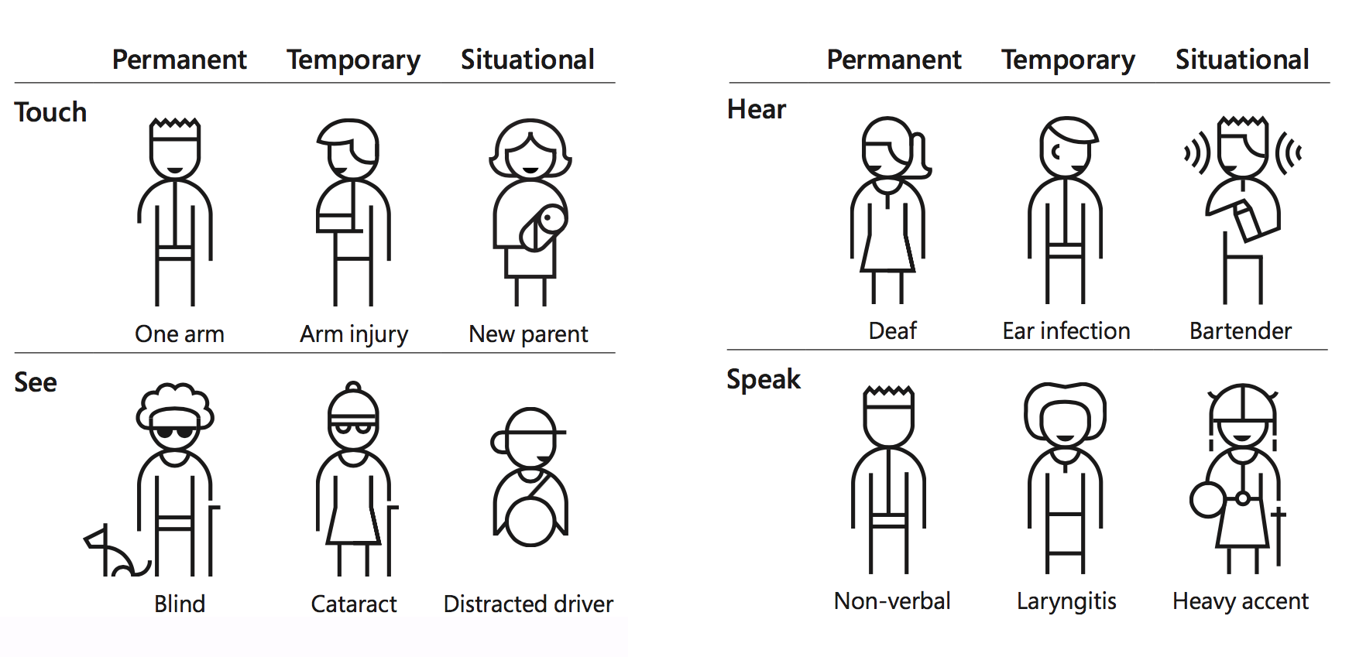
Figure 1: Persona spectrum of disability
By clarifying disability as a mismatch in human Interactions in any given context, it recognise that:
- Disability is designed. As any environment (built, ICT and services) can include and enable or exclude and disable individuals.
- Disability is universal and dynamic. It is traversing across a spectrum of permanent, temporary, and situational disabilities and ages.
- Disability solutions inspire innovation. A solution for someone with a permanent disability, easily benefits people with a temporary or situational limitation.

In the United States, 26,000 people a year suffer from loss of upper extremities. But when we include people with temporary and situational impairments, the number is greater than 20M.
Source: United States Census Bureau, Limbs for Life Foundation, Amputee Coalition, MedicineHealth.com, CDC.gov, Disability Statistics Center at the UCSF
Developing a deeper understanding of disability requires a shift in institutional thinking. We must recognise that at some time in our lives everyone will have a disability. As such, the economic and social costs of inaccessible environments highlight the business case for designing inclusive and accessible environments.
The United Nations has had a long-held commitment to the full participation and equality of person with a disability through such resolutions as A/RES/37/52 (1982), A/RES/48/96 (1994), A/RES/61/106 (2006) and A/RES/70/170 (2015). What the W.H.O definition of disability does in relation to these resolutions is:
- Strengthen the cases and commitment for those resolutions and
- Provides an unequivocal business case for the reasonable accommodation as outlined in A/RES/70/170
- Clearly articulates the need to move away from the reactive mind-sets of reasonable accommodation and implement a proactive strategy of universal design.

4.4 The building complex and its users
As part of this study, reference has been made to the range of potential users of the different buildings, to understand the variety of real needs that should be addressed in the improvement of any building or its services, now and in the future.
One thing that is apparent is that, by their very nature, the separate buildings must cater to different sets of users, of whatever ability. The Secretariat and Service buildings are both used by staff and some visitors, who will become familiar with the layout and facilities in their daily occupation of the premises. The Conference Centre, on the other hand, must also cater to a different clientele, delegates who will use it not only on a short-term basis, but will have expectations of this as a venue of quality, fitting to the importance of the event that they are attending.
The nature of this review is to assess the usability of the premises for people of different, and often limited, abilities. This might include people with mobility impairment, who may use assistive devices such as wheelchairs or crutches, as well as people with limited sensory or cognitive ability. Statistics on the proportion of any population who might be classed as disabled vary according to how this is defined in various places (respecting WHO definitions). This said, the proportion of staff currently working in or visiting these buildings is probably not truly representative of the situation, but as more people with disability are able to achieve higher levels of education through better access to primary and secondary education, one may expect to see an increase in the number of such people within the workforce. In addition, as standards of health increase, retirement ages will also increase. But an older workforce will also require better facilities for the places that they occupy. Even if an older person still has the mental ability to continue to work, he or she may well have a degree of physical or sensory limitation that is not unexpected with advancing age, but nevertheless they should still be able to use the workplace in comfort and safety. As well as accessibility, the principles of universal design also embody safety and convenience as imperatives for everyone’s environment and acknowledge that integration of such important access elements are an intrinsic part of the aesthetic quality of a satisfying and non-discriminatory environment.

4.5 Universal design
The concept of Universal Design was first promoted in the latter part the last century as an approach to making the built environment, product design, ICT and services associated with these all more inclusive. In this respect, it extended the established standards of barrier-free and accessible design and broadened their scope to include not only people with disabilities but, to the greatest possible extent, all users. This acknowledges that, at some time in our lives, we all experience some loss of ability which would not actually be classed as a disability. Through extending the range of people who may benefit from universal design to include, among others, older people, expectant mothers or someone with a heart problem, a critical mass is established which justifies higher standards in design.
The seven principles of universal design, set out by the late Ron Mace in 1980s. Are that the design of buildings, products and services should include:
- Equitable Use - The design is useful and marketable to people with diverse abilities.
- Flexibility in Use - The design accommodates a wide range of individual preferences and abilities.
- Simple and Intuitive Use - Use of the design is easy to understand, regardless of the user's experience, knowledge, language skills, or current concentration level.
- Perceptible Information - the design communicates necessary information effectively to the user, regardless of ambient conditions or the user's sensory abilities.
- Tolerance for Error - The design minimizes hazards and the adverse consequences of accidental or unintended actions.
- Low Physical Effort - The design can be used efficiently and comfortably and with a minimum of fatigue.
- Size and Space for Approach and Use - Appropriate size and space is provided for approach, reach, manipulation, and use regardless of user's body size, posture, or mobility.
Within these principles there is also the implicit regard for safety and the removal of hazards through considerate design. Many aspects of the built environment present potential dangers to everyone. Even people with perfect vision walk into unmarked glazed doors, or in bright sunlight they may not notice steps that are undefined and consequently take a fall. For many people such an occurrence may cause permanent injury or disablement, all because one aspect in the built environment was missing. Reduction of hazard, which may involve such diverse elements as handrails, visible warning signs or consideration of escape in emergency, surely must rate as one of the key priorities when making decisions relating to accessible design.
It is important to note that Universal design is also a key element within the Convention on the Rights of Persons with Disabilities. In Article 4 of the Convention expressly requires State Parties, “to undertake or promote research and development of universally designed goods, services, equipment and facilities, …. which should require the minimum possible adaptation and the least cost to meet the specific needs of a person with disabilities, to promote their availability and use, and to promote universal design in the development of standards and guidelines;
An inclusive approach to design is taken in the assessment and recommendations for the refurbishment of the UNESCAP building complex with particular emphasis on connectivity and integration. This is particularly true in considering how people move through a building to carry out their activities. In a new building this can be relatively straightforward, through an understanding of how the elements within an accessibility code are applied in an integrated way. In refurbishing an existing building, however, constraints such as structure or usable space may make this more difficult to apply and require a consistent strategy in the design proposals. Codes and standards can only require individual elements to be compliant, and will only go so far in creating such a desired integrated design outcome, so that the services of designers experienced in this field is always recommended.
The intent of universal design is to improve life for everyone by making the design of products, communications and the built environment safer and more usable for as many people possible at little or no additional cost. In many instances, if well-considered, universal design solutions can actually prove to be more economical, since they can avoid duplication of elements. A building designed to have a floor level accordant with the level of external approach will avoid the need for a flight of steps at the threshold and thus no ramp will be needed, proving saving in cost.
In the physical and built environment Universal Design Principles numbers 6 and 7 are perhaps the most significant. ‘Size and Space’ are vital for those using wheelchairs, whilst the advantages of ‘Low Physical Effort’ are appreciated by many, including the elderly or infirm. When using a door with an automatic closer, for instance, many users will find this difficult owing to the force required to open it.
Principle number 5: ‘Tolerance for Error’, also includes many aspects of reducing such hazards as not seeing a step or change in level and tripping over, or
Principle number 3: ‘Perceptible Information’ is not confined to the realm of ICT. Wayfinding and communication are essential elements of the design of any public building, so that signage is not just for convenience but also for emergency escape routes or utilizing lift controls. For blind users the inclusion of audible or tactile information is vital for access and usage of the building’s facilities.
In determining how these principles have been incorporated into UNESCAP Building Refurbishment, the following is noted.
Table 2: Application of the principles of Universal Design on the ESCAP campus
Universal Design Principle | Measurable | Comments
Equitable Use | Where a ramp or a lift is provided as well as stairs ensure they start and arrive at a similar position. | Although a wheelchair cannot go up steps, most ambulant people will be able to use the same ramp or lift. These should not be hidden or located in service areas but
 | Provide accessible reception counters and space beneath desks. | An accessible reception counter is proposed at the Conference Registration at Ground Floor in UNCC, Counters to the snack bar on the 2nd Floor, the Post Office, and the Pass Issuing Counter in the Secretariat will be modified to include an accessible area.
 |  | Seating in Conference Halls and Meeting rooms will allow wheelchairs to fit under desks.
Flexibility in Use | Provide large-print signage | Signage throughout the UNCC should include large, colourful/textured and easily distinguishable pictograms/signage
 | Provide adjustable height furniture. | Height-adjustable desks recommended for the Secretariat fit-out, with standing desks, also fully adjustable.
 | Websites are mobile friendly | ESCAP online systems use a responsive design that reflows for device size and orientation.
Simple and Intuitive Use | Signage must include the use of pictograms. | Signage proposed in UNCC includes the use of pictograms.
 | Paths of travel must be identified through the use of luminance contrast. | Luminance contrast has been used to identify doorways throughout the buildings, and contrasting skirting boards are introduced in corridors to assist people with vision impairment distinguish between the floor and wall surfaces.
 | Entrances must be clearly identified. | Conference Hall and Meeting Room Doorway should have well defined signage legible from a distance.
 | All interface forms, controls, and navigation are operable. | All content (text, images, audio and video) and information systems) to meet Web Content Accessibility Guidelines 2.0 Level AA.
Perceptible Information | Provide a minimum 30% luminance contrast between operable components and the background colour – switches, button, door handles, etc | Selections of items such as door hardware should consider this requirement.  Lift panels and doors should have information in tactile letters, Braille as well as well-defined numbers.
 | Wayfinding(signage) in the UNCC Foyers through signage design and ICT beacons | A range of methods to provide information is proposed: signage, disaplay screens, tactile maps and colour coding, as well as ICT Beacons.
 | Provide content and systems in formats that are available to the senses - sight, hearing, and/or touch. | All content (text, images, audio and video) and information systems) to meet Web Content Accessibility Guidelines 2.0 Level AA.
Tolerance for Error | Provide non-slip floor and surface finishes. | Floor surfaces will be of a non-slip nature. Handrails allow for errors of judgement in movement
 | Safety issues should be incorporated throughout. | Circulation paths are provided both externally and internally with handrails, kerbs and visual indicators.
Low Physical Effort | Ramps to be as gentle as possible. | Reducing friction on ramps by specifying non-slip materials, rather than carpet, reduces effort needed for a manually-propelled wheelchair.
 | Provide automatic doors to reduce the effort needed to open them. | Fire doors are not required to comply with codes on door pull strengths, but specifying electro-magnetic closers or motorized doors can be beneficial.
 | Content is easy to read and navigate. Content is easily searchable | All content to follow ISO/IEC 40500:2012
Size and Space for Approach and Use | All pathways and ramps to be a minimum of 1800mm wide to allow people to pass. | Circulation spaces throughout the existing buildings are generous.
 | Wheelchairs turning circles for important. | Accessible toilets and lift cars of adequate dimensions are specified.
 | Maneuvering space besides doors is vital. | It can be difficult to use outward opening doors using a wheelchair.

4.6 Design for dignity
The design philosophy of ‘design for dignity’ goes beyond simple ‘compliance’ and builds upon the elements of universal design to examine how all aspects of environment work together in a consistent way to deliver a positive experience. In this context, ‘a positive user experience’ is where staff and visitors feel equally welcomed and their basic needs are met so that they can work and participate with dignity and respect.
The Australian Network on Disability (AND) defines an environment as being designed with dignity if it meets there four key criteria:
- Independent access to premises, goods and services: it doesn’t assume that assistance is required.
- Equitable or fair access: it doesn’t take longer or make you go further.
- Participation of people experiencing a disability as a natural and expected thing.
- A place where people feel at-ease, safe and connected.
These four criteria provide a simple quality benchmark with which to assess the dignity of any environment.
AND’s ‘Design for Dignity’ guidelines deliver a more productive and inclusive retail and workplace environment as they require consideration of the totality of the user experience. In the ESCAP campus it is when the elements of the built, ICT and services environments seamlessly work together that any and all users (staff and visitors) can experience a positive and dignified experience which in the process aligns with the key mandates such as the Convention and the Incheon Strategy
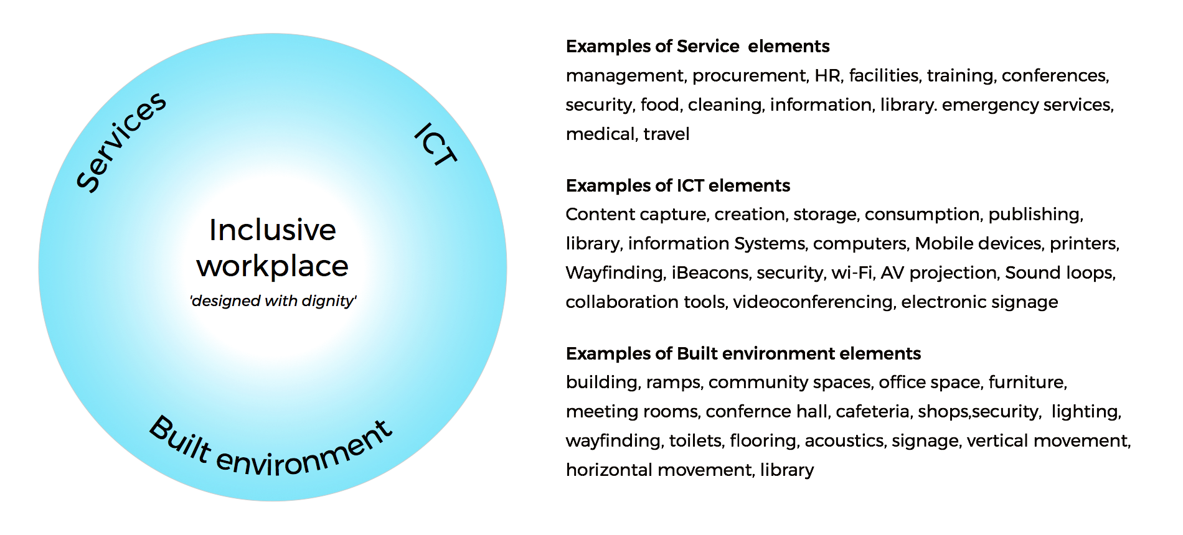
Figure 2: Relationship between elements of an inclusive workplace

Methodology and strategy

5.1 Built environment methodology
This report aims to make achievable recommendations related to the provision of access to premises based not only on current access legislation, from Australia, Singapore and UK and other sources, but on best practice options based on universal design principles, anticipating ever-increasing standards in both the built environment and in information and computer technology, enabling independent, equitable and functional access for all.
Accessibility is paramount in providing inclusive environments, both physical and virtual, for all users. This report looks beyond basic compliance issues to ensure that all users are offered the opportunity to participate in society. The principles of Universal Design have been considered throughout the preparation of this report, providing a holistic approach in the provision of access for people with disabilities.
The United Nations (UN) has developed a broad framework for accessibility within all development that addresses the provision of universal design, as discussed in following sections of this report. The overall goals of the UN with respect to accessibility are addressed in the assessment of the accessibility of UNESCAP facilities project with the emphasis on inclusion of all users of the building.
As the building works associated with the UNESCAP Building Complex are largely within existing buildings, the focus has been on improving accessibility. While compliance is the ultimate goal, in some instances due to the existing building conditions, this may not be achievable without extensive structural or other constructional work being involved. In such cases, where it might prove to be unnecessarily expensive or disruptive, a ‘performance based’ approach to accessibility has been adopted to ensure the design outcome is still inclusive and the same outcome is achieved, both functionally and experientially. The Australian Code actually anticipates this situation in refurbishment projects (see Section 4.4 of the Premises Standards - Access to premises standards – Lift Concession)
Apart from allowing for the dimensional constraints imposed by the existing lift shaft, all other access features within the lift must be provided and are not subject to the concession.
In a similar way, Section 4.5 of the Premises Standards includes a concession for existing accessible sanitary facilities, stating that certain existing accessible sanitary facilities located within a ‘new or modified part’ or an ‘affected part’ are not subject to upgrade if, the existing facility complies with the circulation and fit-out requirements of AS 1428.1 (2001)

As a major part of this report a review of international accessibility standards has been conducted to ensure recommendations made for the UNESCAP Building Complex concerning accessibility are in keeping with international best practice measures and reflect the progressive nature of accessibility legislation, in both the built and virtual environments.

5.2 ICT environment methodology
To meet the mandates of the ST/SGB/2014/3, CRPD and goals of Incheon Strategy from the perspective of accessible ICT each Division and Section need to ensure their
- information systems
- web and non web based digital content workflows including staff capacity to create and curate accessible content and
- ICT procurement strategies
comply with the technical benchmarks and utilise the techniques of ISO/IEC 40500:2012 and WCAG2ICT. This report will critically evaluate ESCAP level of compliance against these two international standards and recommend remediation strategies to achieve compliance.

5.3 Services environment methodology
Similarly, to meet the mandates of the ST/SGB/2014/3, CRPD and goals of Incheon Strategy from the perspective of accessible service delivery each Division and Section needs to ensure their day to day protocols and practices include and enable staff and visitors with a disability to participate on the same basis. To ascertain to what extent ESCAP has achieved this goal, the Australian Network on Disability’s (AND) Design for Dignity – Retail Guidelines which references the Australian Disability Discrimination Act will be used as the reference point to critically evaluate services and recommend remediation strategies to improve the delivery of inclusive services.

5.4 Survey and user feedback methods
“Consult the user” is a phrase often quoted in designing for accessibility. Through feedback and observation, the designer can find where priorities lie and even how cultural or regional differences may affect the users’ expectations of their built environment. As part of the assessment of the UNESCAP buildings the consultants gained such insights through a variety of methods. As well as successive walk-through visits to the buildings, a number of interviews, questionnaire responses and anecdotal evidence allowed the assessors to gain useful insights about the buildings’ design shortcomings as well as the limitations of its current communication systems.
Table 3: User feedback sources
Consultative meetings | Feedback via survey | Inclusivity Review
ESCAP Accessibility Working  Seismic Mitigation Project Team  Facilities Management Unit  Safety and Security Section  Social Development Division  International Labour Organization  Information Management Communication Technology Section  Conference Management Unit  Human Resources  Strategic Communication and Advocacy section | UNAIDS Regional Support Team & Thailand Country Office  UN Women region Office for Asia and the Pacific  UN Environment Divisions  UNOCHA  United Nations Population Fund, Asia and the Pacific  International Labour Organisation | Simulated attendance at a conference and fire drill conducted with persons with disability who were representatives from Non-Government Organisations (NGOs).  Open meeting for staff to provide feedback.

Remarks made by a number of users, both occupants who have experienced the buildings over a number of years, as well as invited individuals from disability-related NGOs visiting for the first time – including simulated fire drill to test routes. One staff member, who uses a powered wheelchair as well as crutches, prepared a report of his own experiences in accessibility in the UNCC and Secretariat Building and shared his experiences with the assessors.
Valuable anecdotal information was also supplied by members of the security staff regarding particular problems with entry and hazards for less able visitors. In the course of a short visit, a number of representatives of NGOs concerned with various forms of disability were observed and their feedback was elicited.

Section B: Built environment

Built environment - Legislation and international standards

6.1 International Perspective
The following analysis of the international perspective and Australian legislation and code is directly referenced from the Conrad Gargett’s Africa Hall Report, 2017 as this provides full and current coverage of the information which pertains to both the Africa Hall work and the UNESCAP Refurbishment.
Disability access legislation has its roots in human rights legislation. Initiating the disability rights movement was The Declaration on the Rights of Disabled Persons, made at the General Assembly of the United Nations (UN) on the 9 December 1975.
Although the Declaration it is not binding on member nations, it forms a framework that may be drawn on for the purposes of international and domestic law. It consists of a lengthy preamble and thirteen proclamations that broadly promote the rights of people with disabilities.
Since the Declaration was made, the UN has developed an international policy framework based on The World Programme of Action Concerning Disabled Persons that was established in 1982. This framework guides the provision of accessibility in new building work and has an ultimate goal of full participation and equality for people with disabilities, adopting the social model for disability. It is well recognised that accessibility is essential to achieving the aims of this framework.
1981 to 1992 was the UN "Decade of Disabled Persons". In 1987, a global meeting of experts held to review progress recommended that the UN General Assembly should draft an international convention on the elimination of discrimination against persons with disabilities. Many government representatives argued that existing human rights documents were sufficient. Instead, non-compulsory "Standard Rules on the Equalisation of Opportunities for Persons with Disabilities" were adopted by the General Assembly in 1993. In 2000, leaders of five international disability organisations issued a declaration, calling on all governments to support a Convention. In 2001, the UN General Assembly established an ad hoc committee to consider proposals for a comprehensive and integral convention to promote and protect the rights and dignity of persons with disabilities, based on a holistic approach.
The Standard Rules on the Equalisation of Opportunity for Persons with Disabilities (1994) identified accessibility of the physical environment as a target area to ensure equalisation opportunities. The Convention on the Rights of Persons with Disabilities (2006) further strengthens the above mentioned international framework for the advancement of the rights of persons with disabilities. The Convention offers a definition of accessibility as a cross cutting issue that enables persons with disabilities to live independently and participate fully in all aspects of life.
In 2006 the Convention on the Rights of Persons with Disabilities was officially adopted and went into force in 2008. This convention is an international human rights treaty of the UN intended to protect the rights and dignity of persons with disabilities. Parties to the Convention are required to promote, protect, and ensure the full enjoyment of human rights by persons with disabilities and ensure that they enjoy full equality under the law. The Convention has served as the major catalyst in the global movement from viewing persons with disabilities as objects of charity, medical treatment and social protection towards viewing them as full and equal members of society, with human rights. It is also the only UN human rights instrument with an explicit sustainable development dimension.
The Convention follows the civil law tradition, with a preamble, in which the principle that "all human rights are universal, indivisible, interdependent and interrelated". There are eight guiding principles that underlie the Convention:
- Respect for inherent dignity, individual autonomy including the freedom to make one's own choices, and independence of persons
- Non-discrimination
- Full and effective participation and inclusion in society
- Respect for difference and acceptance of persons with disabilities as part of human diversity and humanity
- Equality of opportunity
- Accessibility
- Equality between men and women
- Respect for the evolving capacities of children with disabilities and respect for the right of children with disabilities to preserve their identities.
With regard to accessibility, the Convention stresses that persons with disabilities should be able to live independently and participate fully in all aspects of life. To this end, State Parties should take appropriate measures to ensure that persons with disabilities have access to the physical environment; transportation; information and communications technology; and other facilities and services open or provided to the public.
As such, accessibility can be grouped into three main groups –
- physical accessibility;
- service accessibility; and
- accessibility to communication and information.
Under the Convention on the Rights of Persons with Disabilities (2006), member states have a general obligation to undertake or promote research and development of universally designed facilities which require the minimum possible adaption and the least cost to meet the specific needs of people with disabilities and promote universal design in the development of standards and guidelines.
The UN paper titled Good Practices of Accessible Urban Development – Making urban environments inclusive and fully accessible to ALL, released in 2016, summarises the key concepts that should be adopted in the provision of accessibility in the urban context. This sets the tone for The New Urban Agenda referred to in UN policies and papers.
This document states that, by 2050, it is expected that 6.25 billion people will be living in urban centres. Of these people, it is estimated that fifteen per cent will have a disability. Therefore, the promotion of the principles of universal design and disability inclusion are a high priority when considering urban development. To achieve truly inclusive environments, a high level of commitment including urban policy, regulatory norms and standards, universal design planning, allocation of necessary resources and a broad based partnership that involves and engages all community members including people with disabilities, is needed.
Realisation of accessibility can be achieved through following universal design principles and is not beyond the reach of low-economic countries. It is estimated that in economic terms, the additional cost of providing universally designed facilities is minimal.
The UN has developed the following findings and recommendations to promote accessible and inclusive design principles in urban development.
- Promoting accessibility as a collective good and a key component in urban policy, design, planning and development is critical to the success of the New Urban Agenda.
- Accessible housing and built infrastructures are key elements for sustainable and inclusive cities.
- Accessible transportation, public spaces and public services will promote inclusivity for persons with disabilities
- The implementation of accessible information and communication technologies is critical for building inclusive, resilient and smart cities and communities.
- Full and active participation of persons with disabilities and broad-based multi-stakeholder partnerships for advancing inclusive and accessible urban development needs to be realised.
Legislation such as The Americans with Disabilities Act (ADA) and the Disability Discrimination Act (DDA) – Australia and United Kingdom – embrace human rights legislation, making it unlawful to discriminate against a person on the grounds of disability. They are complaint-based laws that allow people who believe they have been discriminated against on the grounds of their disability to lodge a complaint with the appropriate organisation and ultimately hold the discriminator liable for their actions.
Building standards and codes approach the responsibility to ensure that the built environment is not discriminatory in a more defined way. Legislation can determine standards on the physical form of building works, in planning, detailing and specification of components. Following the example of the Report (February 2017) on the UN Africa Hall buildings in Addis Ababa, the following analysis of international best practice approaches to accessibility was carried out to determine the most suitable codes. Both the Australian legislation and similar building codes in the region, particularly the Singapore Code on Access in the Built Environment 2013, were scrutinized for this UNESCAP Building assessment. The building standard requirements for main accessibility issues within four countries have also been reviewed, as having comparable international standards for accessibility. The results are tabulated as follows.
The highlighted sections of the table represent the most onerous requirements for the listed accessibility issue.
Table 4: Building compliance comparison
 | Australia AS1428.1 (2009) | UK BS 8300  (2010) | USA  ADA Standards (2010) | Singapore Accessibility Code  (2013) | International Standard ISO 21542  (2011)
Wheelchair footprint | 800x1300 | 900x1400 | 760 x 1220 | N/A | N/A
Carparking | 2400+2400  shared space | 2400+  1200+1200 | 2440+1525  (car) | 3600x5400 | 3900x5400
Accessway | 1000 wide, 1200 preferred | 1500-1800  dependent on use | 915 wide | 1500-1800  dependent on use | 900 wide
180 Turning Space | 1540x2070 | 1800 dia | 1525 X 1525  T-shape | 1500x2000 | 1500x1500
Passing Area | 1800x2070  at 20m intervals | 1800x2000  at 25m intervals | 1525 X 1525  at 61m intervals | 1800x1800  at 50m intervals | 1800x2000  at 25m intervals
Door Opening  Width | 850 | 800/825 | 815 | 850 | 800  (850  recommended)
Door Circulation | av. 530 at latch side | av. 300 at latch side | av. 455 at latch side | av. 300 at latch side | av. 600 at latch side
Step Ramp Gradient | 1:10 | 1:12 | 1:8 – 75 rise  1:10 – 150 rise | 1:10 | 1:12
Ramp Gradient | 1:14 | 1:20 | 1:12 | 1:12 | 1:20
Ramp Length | 9m | 10m | 9.125m | 9m | 10m
Accessible  Toilet  Dimensions | 1900x2300  +  handbasin | 1500x2200  +  handbasin | 1525x1500  + handbasin | 1750x1750 | 1700x2200
Ambulant Toilet Dimensions | 900-920x  1650min | 800x1500 | 890-940x 1525 | 900x1750 | 900x 1650min
Lift Dimensions | 1100x1400  up to 12m rise  1400x1600  over 12m rise | 1100x1400  one user  2000x1400  multiple users | 1065x1370 | 1200x1400 | 1100x1400
Signage Requirements | Braille & Tactile | Braille & Tactile | Braille & Tactile | Braille & Tactile | Braille & Tactile

6.2 Analysis of international accessibility standards – Main issues
Standards in the Countries shown above are determined towards the same end, so that while differences in some particular detail requirements do exist, these do not necessarily make the outcome less satisfactory. Best practice in universal design goes beyond merely complying with each item separately. To achieve an integrated design solution it is important that the designers understand the underlying principles of why they are required to comply with standards. For this reason, some of the codes are rather less practically useful than others in the actual design process, even though they may be more thorough in their detail. The Singapore “Code on Accessibility in the Built Environment 2013” and Ireland’s “Building for Everyone” are two documents that go the extra mile to explain and illustrate examples of how the standards can be most effectively applied in practice in a consistent way. In the design process it is far better that the designer fully understands the importance of connecting all the necessary elements to a workable whole than merely ticking the boxes for compliance.
In most respects, the Australian Building Standards (BSA) are considered to be more exacting than those of other countries for most accessibility issues and so these will be used as a benchmark to achieve an international best practice approach to accessibility in keeping with UN frameworks and policies. In some instances, reference is made to other legislation where it provides worthwhile achievable standards that match or exceed the Australian standards. These are referenced and explained in each case.

6.3 Thailand Perspective
Although buildings within the UNESCAP site are not legally required to comply with local Regulations on accessibility, it is incumbent on designers to consider and respect these. In practice the recommendations made within this report will well exceed the Thailand code, which was enacted in 2005 and hence less up-to-date than the codes and standards of those countries to which reference is made throughout the assessment
Unlike international disability legislation such as the ADA and DDA, there is no human-rights-based disability legislation applicable in Thailand. Accessibility within the built environment is addressed through building standards as in Ministerial Regulation Prescribing accessible facilities for persons with disabilities and the elderly. 2005AD (B.E.2548)
In translation, the Regulation addresses issues in the form of Chapters and Clauses. The full scope is found in Appendix F. In summary, the Regulations cover:
Clause 1 states the legal standing of the Regulations and Clause 2 comprises legal definitions.
Clause 3 categorises buildings to have accessible facilities as prescribed in this Ministerial Regulation in areas accessible by the public:
Hospital, healthcare facilities, office of government, state enterprise, and government organization established under provision of law, educational, library and museum buildings, public transport facilities;
(2) Office, theater, hotel, auditorium, stadium, mall, and department store with area accessible by the public of any part of a building greater than 2,000 square meters.
Summary of Ministerial Regulation Prescribing accessible facilities for persons with disabilities and the elderly. 2005AD (B.E.2548)
Chapter 1: Accessible facility signage
Chapter 2: Ramp and Lift:
Ramp: dimensions (length, width) landings, surfaces, level changes, slope gradient and handrails.
Lift: applicability, signage and tactile indicators, dimensions, (car, door widths, control button panel heights), handrails, audible announcement, alarm warning lights for deaf users, emergency phone, escape in power failure.
Chapter 3: Accessible Stairs
Dimensions, tread, landings, handrail location and profile, risers and tread characteristics, signage
Chapter 4: Parking
Number and proportion of designated spaces, signage, level access path, dimensions of bays, surfaces
Chapter 5: Building entrance, walkway between buildings, and passageways.
Levels and surfaces, drainage, grating dimensions, handrails, tactile ground surface indicators, overhead obstructions
Chapter 6: Doors
Ease of opening, threshold chamfer dimensions, opening widths, handle heights, markings on glazed doors, locks and latches. Exceptions for fire door or automatic door.
Chapter 7: Accessible toilet
Wheelchair turning circle, door opening, floor level and material, toilet dimensions and location, backrest, handrail dimensions (fixed and swingdown), location, audible and light alarm signal, wash basins, handrails for ambulant disabled toilets.
Chapter 8: Tactile surfaces
Warning at change of level, top and bottom of stairs and ramps, platform edge
Chapter 9; Auditorium (as defined in Clause 3)
Wheelchair spaces per 100 seats, dimensions of furniture

6.4 Australian and other codes: A perspective
Note: sections of the following text, up to and including ”Access to Premises Standards”, is quoted from the 2017 Equitable Access Report on The Africa Hall, for which the authors acknowledge the work of Conrad Gargett Architects.
In the development or revision of its own building code, a country will generally look towards other countries of similar or higher levels of development and determine their own standards as they see appropriate. Australia was one of the first signatories to the United Nations Convention on the Rights of Persons with Disability, ratifying the Convention on 18 July 2008.
Australia also signed the Optional Protocol which allows individuals to place a complaint of breaches to Australia’s obligations under the Convention directly to the United Nations Committee on the Rights of Persons with Disability, once the individual has exhausted all domestic remedies.
Singapore’s ‘Code on Accessibility in the Built Environment 2013’ is similar to that of The Building Code of Australia. As such, both this and the Building Code of Australia have been used as an assessment tool to ensure the concepts of accessibility, inclusion and universal design will be identifiable in any future upgrading or additions to the built form. We note also, that the Building Code of Australia is listed by the UN as an acceptable code to provide an accessible environment in keeping with their over-riding frameworks and policies.
From a review of international building standards specific to accessibility, it has been determined that Australian requirements in most cases are more exacting than other countries in terms of dimensions of wheelchair manoeuvring areas and overall room dimensions.

6.5 National Construction Code / The Building Code of Australia
The National Construction Code (NCC) comprises the Building Code of Australia (BCA) and the Plumbing Code of Australia (PCA). NCC is all encompassing and contains Volumes One, Two and Three; The Guide; and the Consolidated Performance Requirements. Details of these are as follows:
- Volume One contains the requirements for Class 2 to 9 (multi-residential, commercial, industrial and public) buildings and structures (BCA).
- Volume Two contains the requirements for Class 1 (residential) and Class 10 (non-habitable) buildings and structures.
- Volume Three contains the requirements for plumbing and drainage for all classes of buildings.
- The Guide is a companion manual to Volume One. The Guide provides clarification, illustration and examples for complex NCC provisions.
- Consolidated Performance Requirements provides a compilation of all NCC Performance Requirements and the supporting General Requirements in a single document.
The primary classification for the proposed UNESCAP building work pursuant to the BCA is as follows:

Table 5: ESCAP buildings classified using Building Code of Australia
Building | Proposed Use | Building Classification
Secretariat | Administration Offices and facilities | Class 6
Services Building | Administration Offices, library and other facilities | Class 6
UN Conference Centre | An Assembly Building | Class 9b
Part D3 of the BCA and Premises Standards prescribes the minimum requirement for access to a building. Access for people with disabilities is required through the principal pedestrian entrance and throughout the building in accordance with Table D3.1.The following table outlines the general building access requirements for this project:
Table 6: Access requirements by class building
Class of building | Access requirements
Class 6 | To and within all areas normally used by the occupants
Class 9b
An assembly building not being a school or an early childhood centre | To wheelchair seating spaces provided in accordance with Part D3.9  To and within all other areas normally used by the occupants, except that access need not be provided to tiers or platforms of seating areas that do not contain wheelchair seating spaces
The Building Code of Australia makes reference to a number of Australian Standards. These Standards are published documents setting out specifications and procedures designed to ensure products, services and systems are safe, reliable and consistently perform the way they were intended to. They establish a common language which defines quality and safety criteria. It is these standards that provide the technical information, such as dimensions, to achieve compliance with the BCA.

6.6 Disability Discrimination Act 1992 (Cth) (Dda)
The accessibility assessment process covers all aspects of the infrastructure (premises), to the extent required to meet the objectives of the Disability Discrimination Act 1992 (Cth), including, however not limited to, Section 23 which relates to access to premises and facilities which the public may enter or use.
The Act is enforced primarily through a complaints mechanism, which allows individuals who have directly or indirectly experienced unlawful discrimination to seek a conciliated outcome through the Australian Human Rights Commission and, in the instance of unsuccessful conciliation, to bring an action in the Federal Magistrates Court or the Federal Court of Australia.
The DDA requires reasonable adjustments to accommodate the needs of people with disabilities. This allows for adequate management of access and enables implementation of future modifications to ensure that a person with a disability does not experience discrimination. Adjustments may include:
- Modifications to premises and/or equipment;
- Changes to job design and work practices;
- Providing additional training or other assistance as appropriate.

Access to premises standards – General
In contrast to building regulations, the DDA is not prescriptive. The implementation of the Premises Standards in 2010, and corresponding changes to the BCA, is a significant step towards achieving equal access to premises and is crucial to justice and social inclusion for people with disabilities.
It is noted that the Premises Standards are limited in scope, covering aspects of building compliance applicable under the BCA. It is acknowledged that the Premises Standards could address a broader range of accessibility issues including considerations to accessibility of parkland, playgrounds, transport vehicles, interior fit-out of buildings, and fixtures and fittings.
It is important for a designer to have an understanding of the rationale behind any piece of legislation that affects the design outcome. By applying these within the principles of universal design the designer will be able to integrate the elements to which these apply in an intelligent and connected whole. Compliance with the regulations on the design of any element is referred to as “deemed to satisfy”, but in the refurbishment of an existing building it may be difficult to comply with codes and standards due to limits on space or structural form. Using the logic behind the other form of legislation, the Disability Discrimination Acts, it may be possible to arrive at a workable design solution in producing the same positive results, even if it does not comply with the detail of the legislation. This “Performance Specification” approach is increasingly useful as technology and ICT allow alternative solutions to accessibility

7.1 Access to premises standards – New Work.
Where new work that requires building or construction approval is undertaken on an existing building, such as an extension or refurbishment, there is a requirement to ensure the new or modified part of the building complies with the Premises Standards.

7.2 Access to premises standards – Affected Part
In addition to the new work requirement, there is a requirement to provide an accessible path of travel from the principal public entrance, to the new or modified part of an existing building. This is referred to as the ‘affected part’ of a building (Subsection 2.1(5) of the Premises Standards).
Areas outside of the new work and the affected part work do not have any access requirements imposed by the Premises Standards.

7.3 Access to premises standards – Toilet Concession
Section 4.5 of the Premises Standards includes a concession for existing accessible sanitary facilities, stating that certain existing accessible sanitary facilities located within a ‘new or modified part’ or an ‘affected part’ are not subject to upgrade if, the existing facility complies with the circulation and fit-out requirements of AS 1428.1 (2001) Access to premises standards – Lift Concession
Under Section 4.4 of the Premises Standards, there is a concession from the requirements of Table E3.6 (b), which do not apply to an existing passenger lift that is in a new part, or an affected part of a building if the lift:
- Travels more than 12m; and
- Has a lift floor of not less than 1100mm (width) X 1400mm (depth)
All other access features within the lift, including however not limited to the control panel, audible information, lift landing controls and handrail, must be provided and are not subject to the concession.

7.4 Standards and universal design
It is important for a designer to have an understanding of the rationale behind any piece of legislation that affects the design outcome. By applying these within the principles of universal design he or she will be able to integrate the elements to which these apply in an intelligent and connected whole. Compliance with the regulations on the design of any element is referred to as “deemed to satisfy”, but in the refurbishment of an existing building it may be difficult to comply with codes and standards due to limits on space or structural form. Using the logic behind the other form of legislation, the Disability Discrimination Acts, it may be possible to arrive at a workable design solution in producing the same positive results, even if it does not comply with the detail of the legislation. This ‘Performance Specification” approach is increasingly useful as the application of new forms of technology and ICT allow alternative solutions to accessibility to be considered.

7.5 Summary: responding to increasingly higher standards
At the time of their construction the UNESCAP buildings were designed with accessibility in mind in accordance with standards then prevailing. Since then such standards have increased significantly, embracing the inclusive principles of universal design and going beyond simply making environments barrier free, thus widening the scope of accessibility and benefitting users within a wider and more diverse range of abilities. The needs of people with vision or hearing impairment as well as cognitive limitations are now increasingly addressed. With greater accent of the rights of the individual, the influences of health and safety and the increasing advantages of ICT in communication and wayfinding in the built environment, codes and standards are ever more stringent, to good effect.
Although few areas of the UNESCAP building complex are actually inaccessible from a mobility point of view, most of the significant elements that are covered in access codes now fall short on compliance in many detailed respects. Ramps, for example, that were designed to previous standards are now considered to be too steep for safety and the specification for accessible toilets has become more exacting in detail. Contrast in colour and tone is now incorporated into aesthetic schemes, making life easier for people with sight impairment by defining significant edges, such as floor and wall junctions, and edges of steps.
Having identified where the shortfalls lie in the existing buildings the consultants’ recommendations have applied universal design principles towards creating a seamless and integrated environment that does not discriminate against any of the buildings’ occupants, either staff or visiting delegates. A number of the proposals focus on safety issues, as a matter of priority, particularly for the more vulnerable users, by removing potential hazards. The significant public spaces, particularly in the Conference Centre, also require a more holistic design approach to improve their ‘legibility’ to assist delegates in wayfinding and access to information. The introduction of ICT elements and a comprehensive interior design strategy to address these issues will improve not only the accessibility but also the visitor experience for everyone in this prestigious venue.

Built Environment Accessibility Assessment
The following section is a tabulated assessment of the proposed building refurbishments against the relevant applicable deemed-to- satisfy provisions, firstly for the relevant Thai Regulations and then for the BCA and Premises Standard Access Code. Each line item provides a summary description of the compliance requirement and comments on the status of compliance.

8.1 Thailand Legislation
Thailand Regulations
Ministerial Regulation Prescribing accessible facilities for persons with disabilities and the elderly, dated 2005 AD (B.E.2548 in the Thai Calendar)
Clause 3: The following types and categories of buildings shall have accessible facilities as prescribed in this Ministerial Regulation in area accessible by the public:
(1) Hospital, healthcare centre, public health centre, primary health care centre, office of government, state enterprise, and government organization established under provision of law, educational institution, library building and public museum, public transport terminal, such as airport, train station, bus station, and wharf with area accessible by the public greater than 300 square meters;
(2) Office, theatre, hotel, auditorium, stadium, mall, and department store with area accessible by the public of any part of a building greater than 2,000 square meters.

8.2 Compliance with Thailand Legislation
Table 7: Compliance with Thailand Legislation
Thailand Code | Elements | UNESCAP Buildings Compliance | Notes
Chapter 1  Accessible Facility | Signage for accessible facilities | Yes
Chapter 2  Ramp & Lift | Ramp:  - Dimensions  - surfaces  - level changes  - gradients  - handrails | Partial Compliance | Handrails non-compliant  Some gradients too steep
 | Lift:  - Signage/tactile  - Dimensions  - Control buttons  - Handrails  - Announcements/alarms  - Emergency provision | Partial Compliance | No tactile indicator at entrance  No handrails  Height of control buttons not to standards
Chapter 3  Accessible stairs | Dimensions, materials  - Width, going  - Landings  - Handrail  - Tread characteristics  - Contrast | Partial Compliance | Handrails not on both sides  Some slippery surfaces  No tactile or visual signages
Chapter 4  Parking | Spaces:  - Number and Proportion  - Signage  - Access and surfaces  - Bay dimensions | Not compliant | For 100 lots – 2 spaces, plus 1 per 100 additional  (700 = 2 + 6 = 8)  Lot sizes too small
Chapter 5 Entrance, Walkways & passageways | Levels and surfaces  Drainage / gratings  Handrails  Ground surface indicators  Overhead obstructions | Not Compliant | Open gratings in driveways  Slippery surfaces on terrace  No tactile warnings  Overhead obstructions (escalator)  Kerb ramps missing  No handrails in places
Chapter 6 Doors | Ease of opening  Dimensions  Handle heights etc  Markings on glazed doors  Locks and latches  Fire /automatic doors | Non Compliant | Hard to open (fire doors)  Some dimensions non compliant  Not all glazed doors have markings  Swing doors not compliant  Outward opening doors
Chapter 7 Accessible Toilets | Spatial:  - Wheelchair turning circle  - Door opening  - Toilet dimensions  Fittings:  - Backrest  - Grab rails & Handles  - Alarm signals  - Basins (height, taps) | Partial Compliance | Some cubicles too small  Toilet seats too low  No backrest
 | Ambulant disabled  Handrails | Non Compliant | No ambulant disabled urinals
Chapter 8  Tactile Surface | Change of level warnings | Non Compliant | No tactile warnings
Chapter 9 Auditorium | Wheelchair spaces  dimensions | Non Compliant | 1% requirement

8.3 Australian Legislation Requirements (BCA)
Introduction - general building access requirements
Section D3 requires suitable access be provided to and within all areas of the building normally used by the occupants.
Note accessibility requirements within the BCA that apply to this building include:
- D3 for general access for people with a disability.
- E3.6 and Table E3.6 for accessibility design to passenger lifts.
- F2.4 for accessibility design to sanitary facilities.
Note: The Disability (Access to Premises – Buildings) Standards 2010 (Premises Standards) need to be considered. These are generally in keeping with BCA requirements unless otherwise stated.
In addition to the BCA the owner of a building, project manager or user of a building may wish to take into account requirements of the Disability Discrimination Act (DDA). Refer to later sections of this report for further discussion.

8.4 Compliance with Australian Legislation: External Spaces (BCA)
KEY C = Compliant N/C = Non Compliant (largely) P/C = Part Compliant
Table 8: External Spaces and Entrances
Element | BCA Requirement | Compliant | Remarks
B1 External Pathways and Walkways | The minimum unobstructed width of all pathways and walkways is to be 1000mm (AS1428.1 (2009), Clause 6.3). 1200mm is preferred for compliance with AS1428.2 (1992). no lip or step at joints between abutting surfaces. AS1428.1(2009).  The maximum allowable crossfall of pathways and walkways is to be 1:40. The surfaces of an accessible path of travel are be slip-resistant.  Maximum allowable gradient of the walkway is 1:20 and maximum length between landings to be 15m (for 1:20 gradient). Landings to be a minimum 1200mm in length (where no change in direction). | C  N/C  N/C | Some marble ramps in external spaces have slippery surface  Main staff entrance ramp is non; no landings-compliant  No changes in direction
B2 Kerb Ramps | Kerb ramps to comply with AS1428 (2009) Amendment 1, Clause 10.7.  Maximum gradient of the kerb ramps to be 1:8 and maximum length to be 1520mm (providing a maximum height of 190mm).  Kerb ramps to have a non-slip surface as required by AS1428. | C  C  N/C | Few kerb ramps on site: in front of UNCC main door  Slippery marble surfaces
B3 Step ramps | The configuration of the step ramps to comply with the requirements of AS1428.1, Clause 10.6.  Maximum gradient of the step ramp is to be 1:10 and maximum length to be 1900mm (providing a maximum height of 190mm).  Provide landings at the top and bottom of the step ramp to comply with AS1428.1, Clause 10.8.2.  Step ramp to be enclosed on both sides (minimum height 450mm) or a kerb and handrail to be installed. Height of kerb rails less than 65mm or greater than 150mm above the finished surface level of the ramp. | N/C  N/C  N/C | Doors from UNCC to terrace have non-compliant step ramps  No landings  No kerb rails
B4 Accessible Ramps | Ramps are to comply with AS1428.1 (2009) Clause 10.3. Maximum allowable gradient of the ramp is 1:14, minimum clear width to be 1000mm and maximum length between landings to be 9m (for 1:14 gradient).  Accessible ramp are to have a maximum rise of 3.6m (BCA Part 3.11).  Externally, ramps are required to be set back a minimum 900mm from the property boundary.  (2009), Clause 10.3 (f)) allows tactile indicators and handrail extensions to be provided and not protrude into the corridor area.  Provide handrails, with extensions, to both sides of the ramp (AS1428.1 (2009), Clause 12) to have external diameter 30-50mm - on both sides of the ramp to cater for left and right handed disabilities.  Where a ramp is not enclosed, kerb rails to be in accordance with AS1428.1 (2009) - height to be less than 65mm or greater than 150mm above the finished surface level. Provide tactile indicators at the top and bottom of the ramps to comply with  BCA Part D3.8 and AS1428.4.1 (2009) Tactile indicators are to be detectable, durable, non-slip and have a minimum 30% luminance contrast to the background colour. Tactile indicators at the top and bottom of the ramps to be 600-800mm deep across the width of the ramp, set back 300mm from the edge of the ramp (refer AS1428.4 (2009),  Tactile indicators required at a mid-landing where the ramp is not continuous. Where the handrail is continuous along both sides of the mid-landing, tactile indicators are not required. | P/C  C  N/C  N/C  N/C  N/C  N/C | Some ramps in garden/terrace not compliant in width.  Gradients of some ramps too steep (Ramps ????)  Set backs do not comply (Ramps to street level and driveway are hazardous)

Note on Tactile Ground surface Indicators
While Australian requirements for tactile ground surface indicators (TGSI) are quite onerous, being required at stairs, ramps, escalators and travellators, this is not reflected at the international level.
There is currently much debate about the effectiveness of TGSI, especially with regard to the general safety issues regarding slipping and tripping for members of the public that do not have vision impairment. There is also concern that people with mobility impairments that use an aid such as a walking frame or wheelchair find it difficult to traverse TGSI.
Regular ongoing maintenance is required to ensure TGSI remain in their as-installed state and in many instances, this does not occur causing TGSI to lose their effectiveness as a way-finding tool.
At the international level, the British and American building standards referenced earlier in this report have no requirement for the provision of TGSI.
The Singapore standard offers the provision of TGSI as optional and dependent on site circumstances, suggesting their installation should be minimised.
ISO 21542 includes an appendix on TGSI installation advising that they are generally used by people travelling alone. It also advises that installation and patterns vary from country to country and that luminance contrast is the important factor, more so than the tactile contrast.
Given the international perspective it is the consultants’ opinion that the provision of tactile indicators within the ESCAP Buildings refurbishment is not essential and would not greatly benefit orientation and way- finding. This is based on the following:
- Visitors to the site will generally be escorted. If assistance is required, this can be addressed as a part of the Accessibility Management Plan.
- Luminance contrasting nosing strips are proposed on all stairs to highlight each tread.
- Many people attending site are staff and therefore part of a controlled user group who are familiar with the Campus. They would be aware of stair locations.
- There are a series of lifts provided throughout the buildings that can be used in lieu of the stairs by people with vision impairment who are uncomfortable using the stairs.
As many nationalities are likely to use the UNESCAP buildings it is difficult to ascertain which set-out of TGSI is most appropriate. The set- back dimension of TGSI from the hazard varies and it is this dimension that is critical to the safety of the user. As such, we recommend that other land methods be implemented to identify stairs and ramps throughout the Refurbishment.

8.5 Compliance with Australian Legislation: Interior Spaces
KEY C = Compliant, N/C = Non Compliant (largely), P/C = Part Compliant, n/a Not Applicable
Table 9: Compliance with Australian Legislation: Interior Spaces
Elements | BCS References | Secretariat | Service Bldg | UNCC | External spaces | Comments
Doors | All doors required to be accessible must fully comply with Section 13 of AS 1428.1 (2009).  Doorways must be provided with circulation spaces in accordance with Clause 13.3 | C | C | C |  | Note circulation spaces at doorways must have a gradient and crossfall not steeper than 1 in 40.
Door Clear Opening Width | Doorways located within a required accessible path of travel for people with a disability must have a clear door opening width of not less than 850mm in accordance with Clause 13.2 of AS 1428.1.  Where a door required to be accessible has more than one door leaf, one of the leaves (the active leaf) must have a clear opening of 850mm) | C | C | P/C |  | Note some smoke and acoustic seals can impact on the clear opening width of a door.  Meeting rooms with double doors are not compliant
Door Controls | All doors required to be accessible must be provided with controls and related hardware that fully comply with Clause 13.5 of AS 1428.1  (2009). | P/C | N/C | P/C |  | Door controls must be capable of being unlocked/opened by one hand and prevent the hand of a person who cannot grip from slipping whilst operating the latch.  Door handle design should take into consideration the following requirements, including but not limited to:  Clearance of 35mm to 45mm between handle and back plate Height between 900mm – 1100mm.  Touch controls (security) located 500mm from internal corners
Door Operating Forces | All doors required to be accessible must be able to be operated without exceeding the following:  Force to initially open the door must not exceed 20N.  Force to swing or slide the door not exceed 20N.  Force to hold the door open between 60 and 90 must not exceed 20N. | N/C* | N/C* | N/C* |  | *Note: does not apply to fire doors or smoke doors where a door closer is fitted.  Door pull strengths are problematic for many users.  Suggest automatic doors in cases where feasible.
Luminance Contrast for Doors  . | Clause 13.1 of AS 1428.1 requires all accessible doorways to have a minimum luminance contrast of 30% equivalent to a 50mm band between the door and the door frame or adjacent walls. Refer to Clause 13.1 of AS1428.1 for further clarification where luminance contrast is required | N/C | N/C | N/C
BCA D2.15 Door Thresholds | The threshold of a doorway must not incorporate a step or ramp at any point closer to the doorway than the width of the door leaf. | C | C | N/C | N/C | UNCC Confernece Room 3 fire escape doorway to UNCC Terrace does not comply
Internal Paths of Travel | Access ways complying with AS 1428.1 (2009) must be provided to and throughout areas of buildings required to be made accessible, including:  Minimum corridor widths of not less than 1000mm;  Passing spaces with a minimum width of 1800mm and minimum length of 2000mm to be provided in corridors at maximum 20m intervals  Where a direct line of sight is not available turning spaces of minimum 1540mm width and minimum 2070mm length to be provided within 2m of the end of corridors and at maximum 20m intervals. | C  C  C  C  C | C  C  C  C  C | C  C  C  C  N/C
Floor Finishes | The following applies to interior finished and surface materials:  D3.3 of the BCA requires where carpet or any soft flexible materials are used as flooring material, the pile height or pile thickness is to be no greater than 11mm and the carpet backing to be not more than 4mm thick.  Clause 7 requires matting recessed within a continuous accessible path of travel to have a surface level difference to surrounding materials not more than 3mm for vertical and 5mm for rounded or bevelled edges.  Clause 7 specifies grates are to have openings no greater than 13mm in diameter and any slotted | C  C  C  N/C | C  C  C  N/C  _ | N/C  P/C  N/C  N/C | N/C  N/C | Carpets on ramps in Link bridges and outside Conf Rm 3 do not comply  Loose doormats hazards. Replacement to comply  External Gratings with wide gaps at entrance drive and terrace space
Stairs – Non Fire Isolated Stairs | All stairways, excluding fire- isolated stairs, must be designed and constructed in accordance with AS 1428.1. In particular:  Clause 11.1(b) – Setback requirements at intersections at internal corridors.  Clause 11.1(c) – Risers of opaque construction.  Clauses 11.1(d) to (g) – Design of stair nosings including profile and identification strip.  Clause 11.1 (h) – Tactile ground surface indicators (also AS1428.4.1).  Clause 11.2(b) – Handrails to both sides of stair.  Clause 11.2(c) – Handrail to have no vertical sections.  Clauses 11.2(d) to (f) - Extension of handrails at top and bottom of flight.  Clause 12 – Design and construction of handrails. | C  C  N/C  N/C  P/C  P/C  P/C  P/C | C  C  N/C  N/C  C  N/C  N/C  P/C | C  C  N/C  N/C  P/C  N/C  N/C  N/C | N/C | Stair nosings generally non-compliant – shape, materials, contrast  See note regarding Ground Surface Indicators, based on Singapore Code  Handrail sections do not comply
Stairs - Fire Isolated Stairs | Fire-isolated stairs must be designed and constructed in accordance with AS 1428.1.  In particular Clause 11 (f) and  (g) - Design of stair nosings including profile and identification strip. | N/C | C | N/C
D2.17 – Handrails | As per BCA Clause D2.17 (vi), handrails within the fire isolated stairways are required to comply with Clause 12 of AS 1428.1 (2009). The height of handrails is to be between 865-1000mm and be consistent along the length of the stair. | C | N/C | N/C |  | Heights comply , but some profiles and configurations do not.
D3.11 Ramps | All ramps, excluding fire-isolated ramps used for emergency egress purposes only, must be in accordance with Clause 10.3 of AS1428.1 (2009)  Maximum allowable gradient 1:14, minimum clear width to be 1000mm and maximum length between landings to be 9m (for 1:14 gradient).  Accessible ramp are to have a maximum rise of 3.6m (BCA Part 3.11).  Provide handrails, with extensions, to both sides of the ramp (AS1428.1 (2009), Clause 12) to have external diameter 30-50mm - on both sides of the ramp to cater for left and right handed disabilities.  Tactile indicators required at a mid-landing where the ramp is not continuous. Where the handrail is continuous along both sides of the mid-landing, tactile indicators are not required. 1428.1 (2009). | n/a  P/C  C  N/C  N/C | P/C  P/C  C  N/C  N/C | N/C  N/C  C  N/C  N/C | N/C  N/C  C  N/C  N/C | All ramps have elements that do not comply.
AS1428.1 – Abutment of Surfaces | The abutment of surfaces to have a smooth transition: Clause 7.2. Note construction tolerances are provided for:  0 ±3mm for vertical edges  0 ±5mm for edges with a bevelled or rounded to reduce the likelihood of tripping | C | C | C | P/C
D3.6 Signage | Braille and tactile signage is required to be provided throughout any building required to be made accessible in accordance with BCA specification D3.6 and AS1428.1 (2009) and must identify:  - Each sanitary facility  - Any space with a hearing augmentation system  - Accessible unisex facilities and indicate whether the facility is suitable for left or right handed use  - Ambulant accessible sanitary facilities on the door of the cubicle  - Where an entrance is not accessible, directional signage to identify nearest accessible entrance  - Where a bank of sanitary facilities is not provided with an accessible sanitary facility, directional signage to identify nearest accessible sanitary facility.  - Each door required by Part E4.5 to be provided with an exit sign and state “Exit” and “Level” followed by either the floor level number, the floor descriptor or combination of these. | P/C  N/C  N/C  P/C  P/C  P/C | P/C  N/C  N/C  P/C  N/C  P/C | P/C  N/C  N/C  P/C  P/C  P/C | N/C  N/C | Signage is not visible in foyer spaces, below standards – complete re-design recommended  There is no hearing augmentation system installed  Toilets not designated left or right handed in any building. No signage  No ambulant disabled facilities  Banks of toilets have accessible unisex toilet adjacent  No tactile and Braille signage  Doors required to be compliant need to be  Identified on site
D3.7 Hearing Augmentation | Where an inbuilt amplification system is installed (other than one for emergency purposes only) a hearing augmentation system must be provided:  In a room in a Class 9b building; or  - In an auditorium, conference room, meeting room or room for judicatory purposes; or  - At a ticket office, tellers booth, reception area or the like, where the public is screened from the service provider.  - Induction loop- 80% coverage required.  - Infrared system or the like - 95% coverage required. | N/C | N/C | N/C | N/C | Receivers to be provided in the following ratios in each room or space served by an inbuilt amplification system (BCA Clause D3.7 (b) (ii) and Premises Standards Part D3.7 (2) (b)):  Up to 500 :1 receiver for every 25 persons or part thereof, or 2 receivers whichever is greater  More than 500 persons, but not more than 1,000 persons: 20 receivers, plus 1 receiver for every 33 persons or part thereof in excess of 500 persons  More than 1,000 persons, but not more than 2,000 persons: 35 receivers, plus 1 receiver for every 50 persons or part thereof in excess of 1,000 persons  More than 2,000 persons: 55 receivers, plus 1 receiver for every 100 persons or part thereof in excess of 2,000 persons
D3.8 Tactile Indicators | Tactile ground surface indicators (TGSI) are required to warn people who have a vision impairment they are approaching a hazardous location, such as  - Stairways (other than fire isolated stairways)  - Escalator  - Passenger or moving walk  A Ramp other than:  - A fire isolated ramp  - Step ramp  - Kerb ramp or  - Swimming pool ramp.  An accessway meeting a vehicular way adjacent to any pedestrian entrance to a building, excluding a pedestrian entrance serving and area referred to in D3.4, if there is no kerb or kerb ramp at that point. | N/C  N/C  N/C | N/C  N/C  N/C | N/C  N/C  N/C | N/C  N/C  N/C | While Australian requirements for tactile ground surface indicators (TGSI) are stringent, being required at stairs, ramps, escalators and travellators, this is not reflected at the international level.  See note above on TGSI (pp?)  No tactile or visual markers are present in the UN buildings. Future refurbishment should consider current understanding on their use before committing to laying these.
D3.9 Wheelchair Seating in Class 9b Assembly Buildings | Wheelchair seating areas are required to be provided within Class 9b assembly buildings as per BCA Part D3.9.  For up to 150 spaces, 1 single space and 1 group of 2 spaces is required.  For 51- 800 spaces, not less than 1 single space; and not less than 1 group of 2 spaces; and not more than 5 spaces in any other group. Is required  For 801-10,000 spaces, not less than 2 single spaces; and not less than 2 groups of 2 spaces; and not more than 5 spaces in any other group; and the location of spaces is to be representative of the range of seating provided. | n/a | n/a | N/C |  | Currently there are no compliant wheelchair spaces in any of the Conference Rooms or meeting Rooms  Se ‘Guidelines’ for further reference.
D3.12 Glazing on an Accessway | On an accessway, where there is no chair rail, handrail or transom, all frameless or fully glazed doors, sidelights and glazing capable of being mistaken for a doorway or opening, must be clearly marked in accordance with AS1428.1.  A solid contrasting line is required by BCA, but suggest Singapore Code is more applicable in this case. | N/C | N/C | N/C |  | Major hazard: many doors and screens (including security barriers) have no markers
E3.6 Passenger Lifts | E3.6 has specific requirements for type of lift that can be used.  Passenger lifts suitable for people with a disability are provided in Table E3.6a, but each type of lift has some limitations for its use.  Each type of lift also requires the provision of accessible features listed in Table E3.6b. Note this includes but is not limited to:  - Handrails  - Lift car size  - Door opening width  - Control buttons | P/C  N/C  P/C  C  P/C | P/C  N/C  P/C  C  P/C | P/C  N/C  P/C  C  P/C |  | See “Lift Concessions” (PP?) re: size of cars in UNCC and Secretariat slightly smaller than standards, but structural difficulty to change lift shaft in existing structure  Call buttons in lobbies too high.
F2.4 Sanitary and Other Facilities | For Class 6/9 buildings the following accessible facilities are required:  1 x Accessible unisex sanitary compartment on every storey containing sanitary compartments.  1 x Accessible unisex sanitary compartment at not less than 50% of the banks of toilets in the building.  1 x ambulant sanitary compartment for use by males and females at every bank of toilets, where an accessible unisex facility is provided at that bank.  1 x accessible shower for every 10 showers provided in the building | C  C  N/C | C  C  N/C | C  C  N/C
AS1428.1 – Design of Unisex Accessible Sanitary Facilities | All unisex accessible sanitary facilities to fully comply with AS 1428.1 (2009) Clause 15 and 16, including but not limited to  - Location of sanitary fixtures and fittings  - Location, profile and dimension of grab rails  - Clear width of the door opening  - Circulation spaces to doorways, fixtures and fittings  - Requirement for a shelf  - Lever taps  - Toilet seat 30% luminance contrast  - WC back rest details  - Door lock. ‘In use’ indicator and bolt or catch. Any snib catch handle to have minimum length of 45mm | N/C | N/C | N/C |  | No ambulant Accessible Sanitary Fittings in any of the buildings

8.6 User feedback on built environment

General Comments from users
User feedback was collected through consultation with both internal stakeholders and external stakeholders.
- Internal stakeholders feedback was collected through:
  - meetings with Accessibility Working Group, ESCAP Tenants,
  - consultations with division and section and individuals.
  - Division of Administration Accessibility Survey
- External stakeholders (visitors from peak disability groups) was collected through
  - individual and small group feedback.
  - Direct observation when participating in site walk through and simulated fire drill.
Responses received from various users and user-group representatives including:
- Ambulant (crutches), wheelchairs (powered, self-propelled), blind and partially sighted, deaf.
- Cognitive disabilities, limited mobility (arthritis etc).
Reference given to changing workforce in discussion (ageing, maternity, medical. incontinent, etc.)

Parking and access to office floors
- Routes and signage not clear. Arthritic staff member unaware of existing lift to car park.
- Entry process – routes to venues
- Lobby and counters not accessible.

Wayfinding
- Problematic, even for habitual users.
- Escape route signage not always visible – hazardous if an emergency.

Signage
To conference, meeting venues, facilities (eg toilets), emergency escape routes not clear.

Toilets
- Lack of signage,
- Floor surfaces
- Shiny and slippery (marble), carpet tiles on ramps impede wheelchair users
- No demarcation of change in level, foot/top of stairs etc)
- Lack of emergency audio and visual emergency notification capability

Ramps
- Gradients too steep
- Length of incline (no landings)
- Surfaces (e.g. Carpet pile increases resistance)
- Threshold/step ramps (esp. Related to proximity to doors)

Stairs
Marble surfaces slippery when wet
- Carpet (no visual contrast)
- Handrails (lack of provision both sides, profile, continuity/run out at top and bottom)

Doors (solid)
- Heavy opening
- Fire doors (inward/outward opening)
- Handles (awkward shape, height)
- No vision panels
- Doors (glazed)
- Few visual markers (hazard)

Lifts
- Number of designated accessible lifts – waiting time increased for wheelchair users
- Door closing speed
- Call button height
- Control panel visibility

8.9 Additional accessibility considerations
The following provides a summary of additional accessibility issues that can be incorporated within a building to promote an inclusive environment and maximise accessibility. These are items that are generally not encapsulated by building codes and therefore form part of best-practice approach to accessibility.
No | Item | Recommendation
1. | Fire egress for people with disabilities | In an emergency, all users should be provided with a means of egress from a premises to a place of comparative safety. This ensures people with disabilities to be provided with the same level of protection as other premises users or building occupants.  We recommend that as a part of the emergency evacuation plan for the building, egress for persons requiring assistance be addressed in the form of a Personal Emergency Egress Plan (PEEP).  In the multi-storey Secretariat tower it is recommended that, for the purposes of emergency egress for people with disability and others who may be unable to descend up to 14 flights of stairs, that one Evacuation chair be located on each floor in the protected lobby. As part of the management Plan, all staff should be apprised of how these should be used.
2. | Reception counters | We recommend the provision of accessible reception counters designed in accordance with AS1428.2 (1992), Part 24.1. Height of the counter is to be between 750mm (±20) and 850mm (±20) above the finished floor level and have foot and knee clearance under the counter as outlines in Figure 25. The minimum width of the accessible counter and clearance below is 900mm.  The level of access to be provided may be dependent upon the level of interaction intended, such as high level interaction, minimal and verbal and visual interaction only.  We recommend the provision of Induction Loop Communication at all Registration and Reception counters as well as security and Post Office
3. | Seating to public areas | Where seating is located within public areas, a proportion of accessible seating should be provided offering compliance with AS1428.2:1992 Clause 27.
4. | Signage  Integration | Signs and symbols should be provided to inform all users.  This signage package offers simple and intuitive information as discussed throughout his report.
5. | Desks and Workstations | Consideration should be given to the provision of accessible staff workstations within the building. Height adjustable workstations which can be adjusted by the user are highly recommended, with an adjustment capability between 610 and 760mm from the floor (AS 4442:1997 Clause 2.2.2 (b).  Where provided, fixed height workstations to be provided at a height between 700 and 720mm (AS 4442:1997 Clause 2.2.4).  Adequate space below worktops must be allowed for wheelchairs.  Currently there are no international standards or member states legislation available on Standing workstation. That said, there is considerable evidence on the health benefits of this top of furniture. As workplaces become more flexible, the work area itself needs to accommodate different people more easily. This can be achieved through three ,  - Adjustable desks (Standing desks)  - Adjustable ergonomic chairs  - Vesa Mounts to adjust computer monitor height  This may form part of an Accessibility Management Plan and associated operational procedures relating to individual facilitation of employees with temporary or permanent disabilities.  This may form part of an Accessibility Management Plan and associated operational procedures relating to individual facilitation of employees with temporary or permanent disabilities.
6. | Luminance contrast | Luminance contrast is the light reflected from one surface or component, compared to the light reflected from another surface or component. A luminance contrast of 30% between two surfaces is generally accepted as a minimum when considering it as a navigational / way-finding tool for people with vision impairment.  In this regard, we recommend that the provision of a minimum 30% luminance contrast between surfaces be adopted in the following instances to assist people with Vision impairment negotiate the built environment:  Provide luminance contrast between walls and doors.  Generally, contrasting wall and floor surfaces should be provided. At a minimum, skirting boards which provide suitable contrast to the floor surface assist people with low vision in identifying perimeters of corridors and accessible spaces.  For joinery, Counters or benches to achieve a minimum 30% luminance contrast with the counter / bench face to which it is viewed. Additionally, Counter / bench surfaces to have a matte or low sheen finish;  For handrails and grabrails, provide a luminance contrast between the rail and the wall colour;  For signage, provide luminance contrast so that message can be conveyed – luminance contrast required between the information in the sign and base sign colour.  Luminance contrast has been included in the design to assist people with vision impairment as documented throughout this report.
8. | Nursing Mothers’ Room | The future workforce, as well as visitors or delegates, may well include mothers with infants. Currently new developments in many cities include a dedicated private and comfortable room for these needs, with changing facilities.
9. | Adult Diaper Changing Rooms | Anticipating a more diverse range of users, including a more elderly workforce as retirement ages are increased, provision should be made for a room where a person, and helper if needed, can change diapers  The upcoming Singapore Code (2017) under revision, will include requirements for such space. It is expected that this provision will be in the form of a room, 2m x 2m minimum, based on current accessible toilet standards but will include a clinic-type bench at a suitable height, large enough to accommodate a prone adult.  It is recommended that such a space be located on the Ground Floor of the UNCC in close proximity to the Medical Centre. Space within an existing cleaners store adjacent to the Theatre and existing toilets was identified as a possible location.
10 | Acoustic Ceilings | In the Cafeteria and also in the narrower corridor spaces of the UNCC Foyers, particularly outside Meeting Rooms, noise levels can become intolerable, reaching over 80dB from voices. A recommendation is made to hire specialized consultants to investigate this problem and suggest ways to lower the reflectivity and reverberation time through the installation of a noise deadening material on the ceiling, either in the form of acoustic tiles or a fabric ‘acoustic cloud’.

Case Studies: Clients’ and Consultants Proposals discussed

9.1 Clients’ proposals

Clients’ Proposal 1. New Conference Registration Building
(Described as CHECKPOINT LOCATION B - REF TO DRAWING A-02 (10.11.2016) Sketch design by Amhold AS, Tallin
In order to facilitate more effective entry and registration to conference delegates, a new building is proposed in front of the UNCC Building. A taxi drop-off point will be demarcated at street level and entry will be by both a ramp and steps to the finished floor level approximately 700mm above pavement level.
The current design incorporates an internal ramp but the clients have expressed a wish that this should be external, protected by a canopy. Suggestions to use revolving doors or turnstiles should be reviewed as to their barrier-free potential. Automated doors would prove a better solution.
In order to create an external ramp to BCS standards at 1: 20 this will need to be at least 14 metres long, so that a landing with a 1800mm turning will be necessary, with handrails and visual markers at all changes of level. The design of the doors and the manoeuvering space should accord with standards regarding the height of registration counters and the design of queuing barriers which should take into account the needs of wheelchair users and person with vision impairment. As user delegates will be unfamiliar with the building signage and enhanced wayfinding are important elements to consider and the registration counter must be equipped with induction loop communication for hearing aid users.

Clients’ Proposal 2. New Library Building
Although the location of the proposed new Library and cafeteria extension is identified, the actual design is still conjectural. So that that the project (or any other new construction project on the ESCAP site) is accessible and inclusive its designers should ensure that:
- Building design complies the Australian building standard AS 1428 and Building codes of Australia
- All new ICT comply with Australian Standard AS EN 301 549To ensure that both are
Standards pertaining particularly to its detail design include:
- shelving of appropriate heights that are reachable by a wheelchair user with space between rows, and worktops and counters with space beneath.
- Adjustable ergonomic chairs
- Adjustable desks
- Adequate lighting for the work being undertaken
- Unobstructed path of travel to/from the work station
- Sufficient and appropriate desk space and depth
- Computer height that is adjustable
- Ease of use of equipment such as desk phone and power points

Clients’ Proposal 3: Upgrading of Conference Room 3 (Pilot Project)

Built environment
Conference Room 3 is the oldest part of the Conference Centre and is a building and interior space of character. It is less accessible that current standards and the communication systems are outdated and below standard for such an important venue.
The provision for wheelchair access is not compliant in a number of major respects. Firstly, there are no spaces allocated for wheelchairs, either at the delegates’ desks or in the seating behind these. Although the delegates’ desks have movable swivel chair seats there is neither turning space beneath the desktop nor manoeuvring room between the desk and the fixed seats behind. Vertical clearance beneath the desktops at designated spaces can be simply achieved by removing the lower shelf, giving a clearance of 760mm clearance from floor to underside of the desktop.
Both of these matters were addressed in the L&O 2004 ADA Compliance Review: 3.04(f) drawings EX06-09 and PO6-11. These proposals were made to ADA standards then extant, but no action appears to have taken on these.
To comply with BCA standards the number of allocated spaces for wheelchairs in Conference Room 3, which has 269 seats should be 6. These should be distributed to comply with D3.9 which details how they should be distributed through the room, having not less than 1 group of 2 spaces;and not more than 5 spaces in any other group. These would be at the ends of rows.
It is also recommended that where these are located the desks should be modified to allow wheelchair users to sit there. Where wheelchair spaces are designated, the fixed seats immediately behind these should be removed (or replaced by movable chairs) to allow a 2 metre turning circle.
At least one of the desks on the podium / rostrum should also be modified, as this does not preclude any delegate from sitting there. The podium is currently not wheelchair accessible but there is adequate space for a short ramp to be provided at the left hand side to BCA standards
(Note also that proposals for wheelchair spaces in the other Conference Rooms were also made in the 2004 Review)
Another important issue that needs to be addressed in Conference Room 3 is access to the front row of the delegates’ seats, which now has a step down of 120mm. Rather than creating a ramp, which would be a difficulty for ambulant disabled users, it is recommended that the central section of the floor could be raised flush with the level of the floor at entry, reinstating the existing desks and preserving the aesthetic quality of the space. This would also have the advantage of allowing wiring for the upgraded communications system to be run more effectively below it.
As in other parts of the Conference Centre, the doors at the acoustic lobbies require a pull of more than the recommended force, but as fire doors these are exempt from compliance. It is recommended that, in the refurbishments, alternative ways of providing self-closing mechanism for one of the doors should be investigated, so that it is easily operable by people with disability.
Additional aspects that should be addressed are the thickness of the pile of the carpeted floor, which is difficult for wheelchair access and the presence of protruding power sockets in the floor, which are a potential trip hazard.
The single emergency escape route is via a double leaf door, which has a clear opening of only 420mm. This needs to be increased to 850 mm in accordance with AS 1428.1. Outside this door there is a horizontal threshold of only 600mm before the top step of the escape stair, which has shiny marble treads without contrasting nosings or warning surfaces. These are non-compliant and should be rectified in any refurbishment.

ICT environment
It is noted that, the Conference Management Unit (CMU) has sort of received a consultant’s report on the renovation of the audio-visual (A/V) systems within Conference Room 3 (CR-3). From a strict technological perspective, the recommendations provided are certainly within scope.
The recommendations can be enhanced by including accessibility perspectives into the scope of works. A detailed commentary about procurement, conference/discussion systems, listening unit systems and hearing augmentation systems in larger meeting rooms can be found on ICT assessment of UNCC Facilities (pp100).

9.2 Consultants’ proposals

Consultants’ Proposals 1. Foyer Space Outside Conference Room 3
Problem
Immediately outside the entrance to Conference Room 3 there is a landing which is higher that the floor level of the 1st Floor Foyer, due to these having been built at different times to difference datum levels, which presents problems of access compliance.
The floor change level is currently accessed by two wide flights of steps, with insufficient provision of handrails, carpeted treads without visual contrast, and on the narrower flight, there is a glazed screen without markings at one side .To comply with BCA standards both stairs should have handrails on both sides and, on the wider flight, a central rail too with handrail profiles as required.
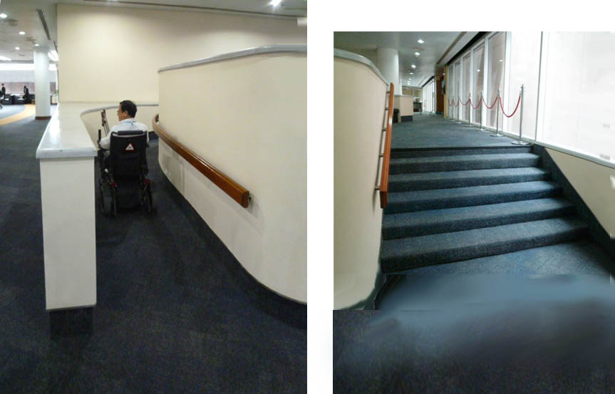
Figure 3: Analysis of wheelchair approaches
For wheelchairs, there is a curved ramp at a gradient of 1:12, with crossfall. The surface of the ramp is carpeted, making it difficult for a self-propelled wheelchair user to ascend. There is a handrail on one side only, but as the ramp is minimum width, it would not be possible to put one on the other side without making it too narrow. In addition, the curved ramp and its enclosing wall make it impossible for a user to see if another wheelchair is coming in the opposite direction.
As well as remedying both the stairways the consultants recommend removing the curved ramp and replacing it with a low-rise platform lift, to AS 1735.14. as there is insufficient space to realign and extend a new ramp within that space without structural alterations.
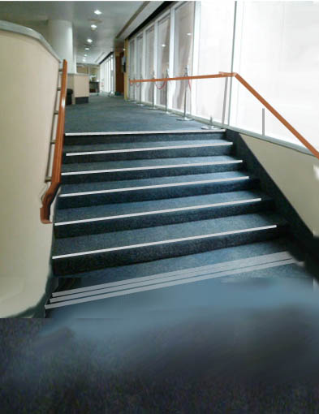
Figure 4: Mock-up of improved stairs, with visible nosings, compliant handrails both sides continuing as protective rail for glazing.

Consultants’ Proposal 2. Staff And Visitor Entrance From Street [Outside Pass Zone]

Problem
At present the main gate for pedestrian staff and visitors is an unattractive and, for some, quite inaccessible entry point to an otherwise impressive building complex. The topography from drop-off point at street to threshold involves a change of level that requires ramps and steps, but many of the elements of the existing route do not comply with accessibility standards on these. Proposals made in the ADA Compliancy Review 2004 to improve this situation were not implemented, but even had they been, would not have been of an acceptable standard today.
Motor vehicles entering the UNESCAP site must pass through a manually operated security gate. Disabled visitors who are without permits are not allowed entry, however, nor are taxis carrying disabled staff or visitors but must be dropped off in the street.
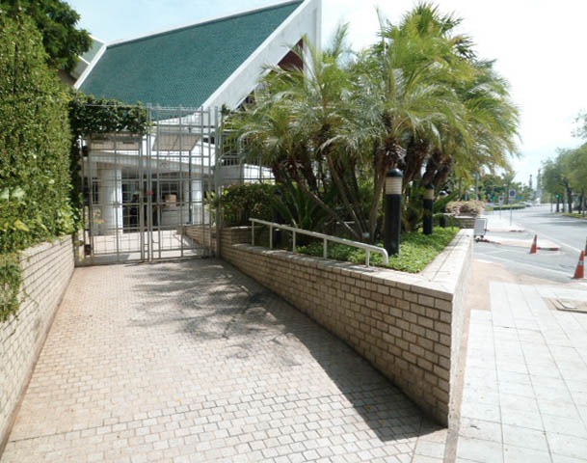
Figure 5: Steep and non-compliant ramp at pedestrian entrance. To make this accessible a more radical design solution is necessary.
The UNESCAP Complex is made up of prestigious buildings, to which the entrance should be worthy of its status. Currently the principal pedestrian entry point is via a short and steep ramp from the pavement of Rajadmnern Nok Avenue, through a security gate, continuing up the ramp (at 1 : 14) to the Entrance to the Security lobby for bag inspection. This is unsatisfactory and a more accessible and compliant solution should be designed and constructed. Proposals were made in the 2004 Report (see Drawing PO2 – 01) but now these do not comply with current BCA standards.
With a gradient of 1:14 and crossfalls of up to 1:30 this ramp is not compliant with AS1428.1 (2009), Clause 10.8 which requires for external ramps a maximum allowable gradient of the walkway of 1:20 and maximum length between landings of 15m (for 1:20 gradient). Landings must be a minimum 1200mm in length where there is no change in direction and where there is a change in direction of 180º, landings to be 1540mm in length.
The ramp also starts immediately at the site curtilage without the required set back from the pavement. It has no landing at the point where the security gate must be negotiated. For a mobility-impaired person, particularly if they are in a wheelchair, this is a very unsatisfactory and potentially hazardous arrangement, as they could very easily roll backward and onto the roadway whilst trying to negotiate the gateway. Detailed specification of a new security gate should consider wheelchair access, which may obviate the use of turnstiles.
At the top of the ramp a flight of 3 steps (non compliant) lead down to the vehicular driveway. (Security guards reported that accidental falls have occurred here, possibly as there is a handrail on one side only and no visual contrast on the nosings)
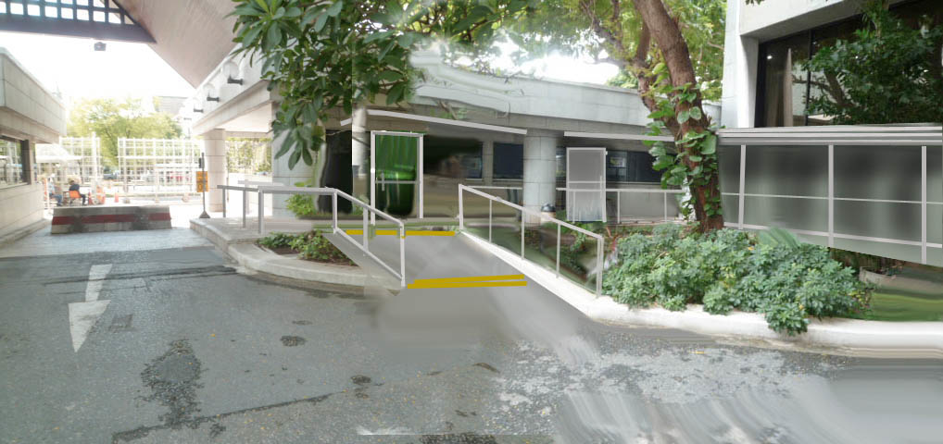
Figure 6: Schematic view of proposed accessible link via ramps from disabled car parking space to security lobby and new covered link to Secretariat entrance lobby. (see sketch plan below)

Proposal
In order to provide a suitable ramp of compliant gradient it is necessary for it to be longer than at present, but site dimensions restrict this so that a more radical solution should be adopted which could also improve accessibility to the Secretariat building for all staff via an external covered walkway to the existing front door and lift lobby. This would also have the benefit of freeing up office space on the Ground Floor level and improve the visitor experience when approaching the Pass-issuing counter.
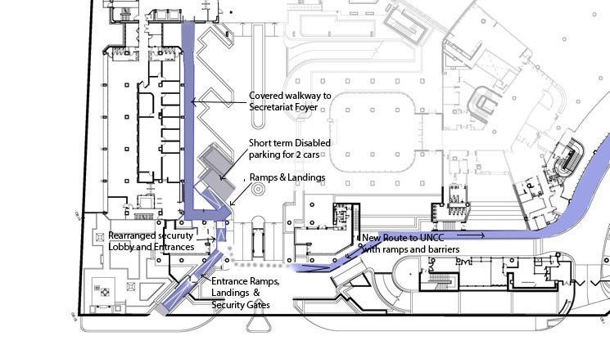
Figure 7: Sketch Plan of Proposal for Pedestrian Entry Ramps to Secretariat and UNCC (Not to scale)
By rearranging the location and dimensions of the doorway to the existing security lobby it would be possible for visitors to proceed through security to pass counters whilst staff could bypass this point and continue to the main lift lobby of the Secretariat following a level covered walkway.
2 parking spaces for drivers with disability are located immediately to the right of the vehicular entry gates, but currently there is no access route into the Secretariat Building security check area or Pass Issuing Counter. The proposed ramp and walkway
By building the proposed external covered walkway, from the top of the entrance ramp to the secretariat Lift lobby, valuable interior office space will be freed up on the Ground Floor, currently taken up by a corridor.

Consultants’ Proposal 3, Connecting Walkway from Staff Entrance and Security Post to UNCC Main Entrance

Problem
Some visitors and staff may need to register at the pass counter and then proceed to the UNCC Building for conferences and meetings without passing through the Secretariat Building lobbies, which need a pass to operate the barriers. Currently the route for this is to walk across the vehicular driveway and either to ascend stairs or a steep (and non-compliant in other ways) ramp to the Foyer door beneath the Conference Hall 3 or to follow the road to the right that leads to the Crescent-shaped entrance drive. For wheelchair users and persons with limited mobility the existing pavement to the left of the roadway is inaccessible, having a high kerb without a kerb cut, and is also too narrow for a wheelchair to pass the columns that partially occupy the space.
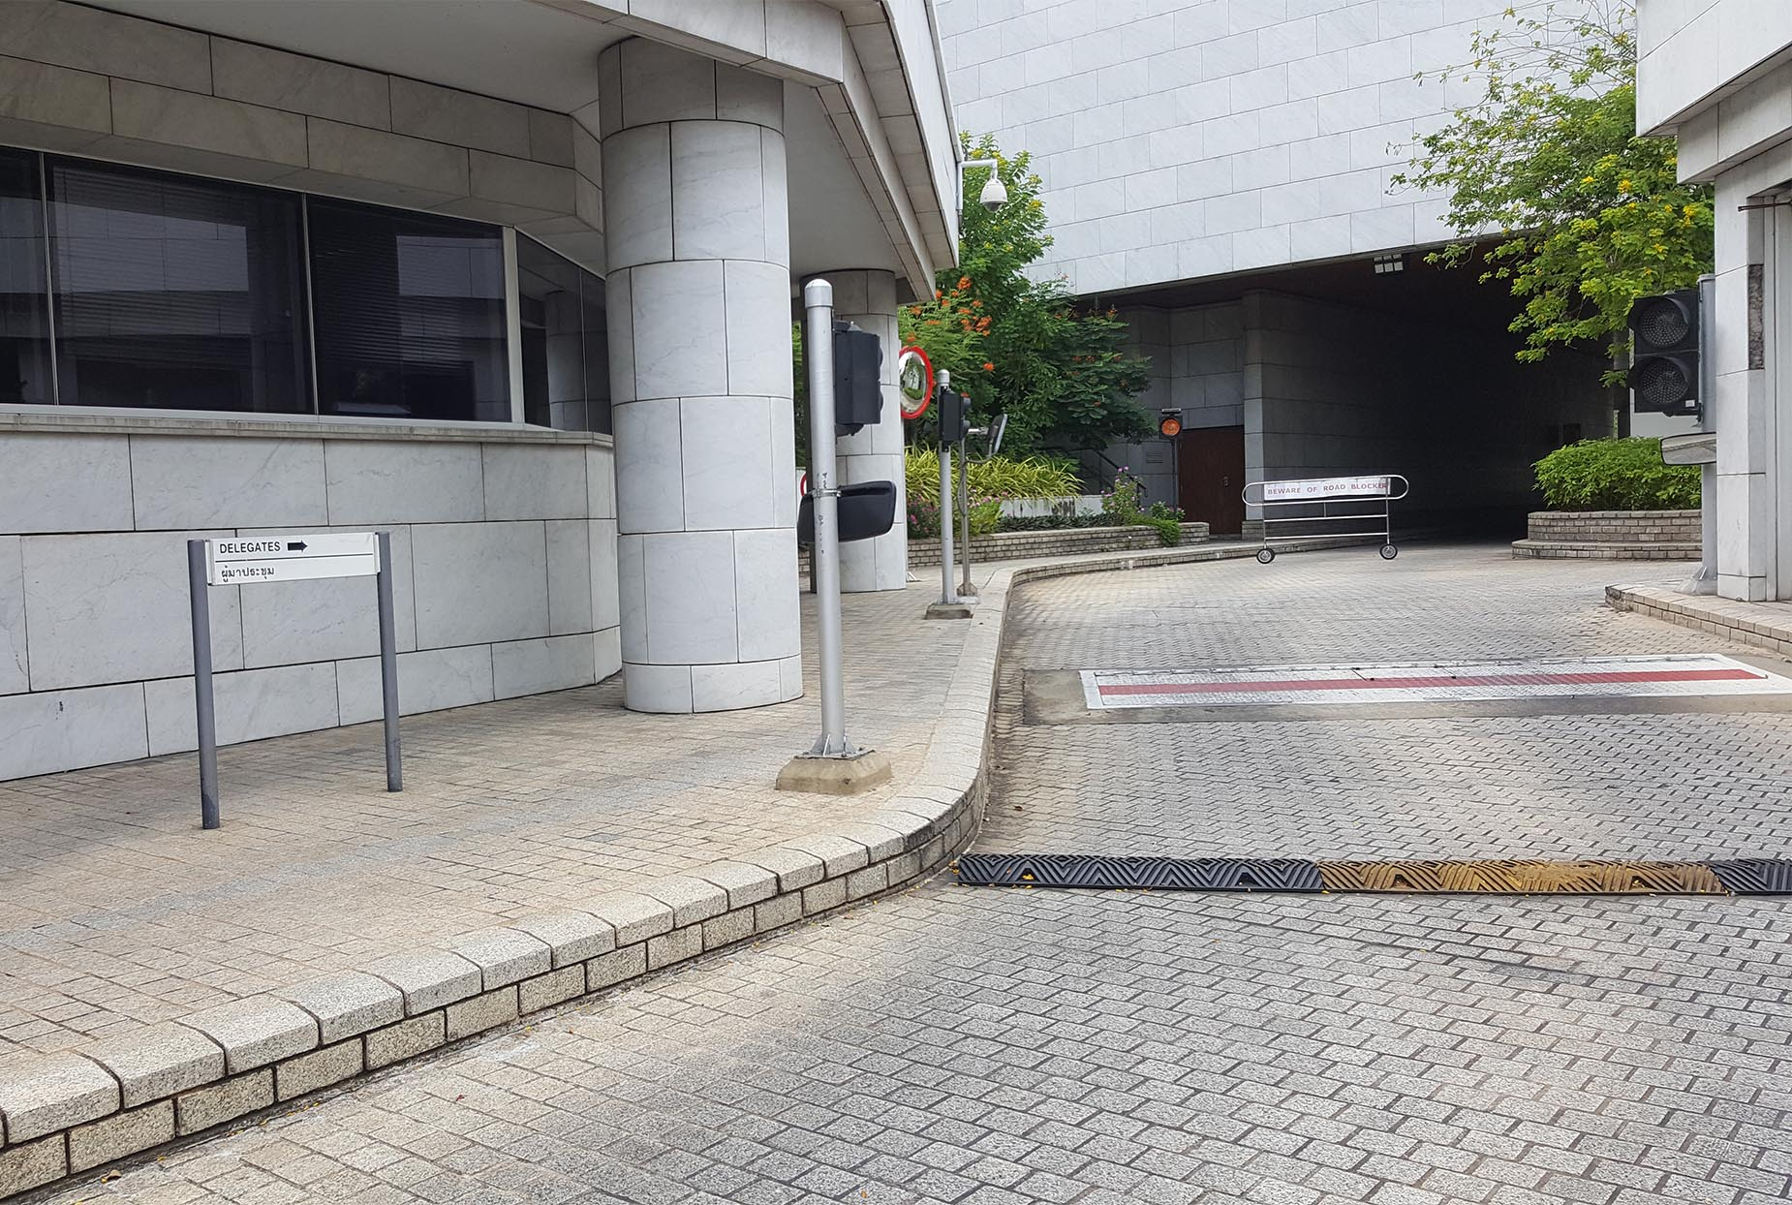
Figure 8: Existing hazardous route for delegates to UNCC
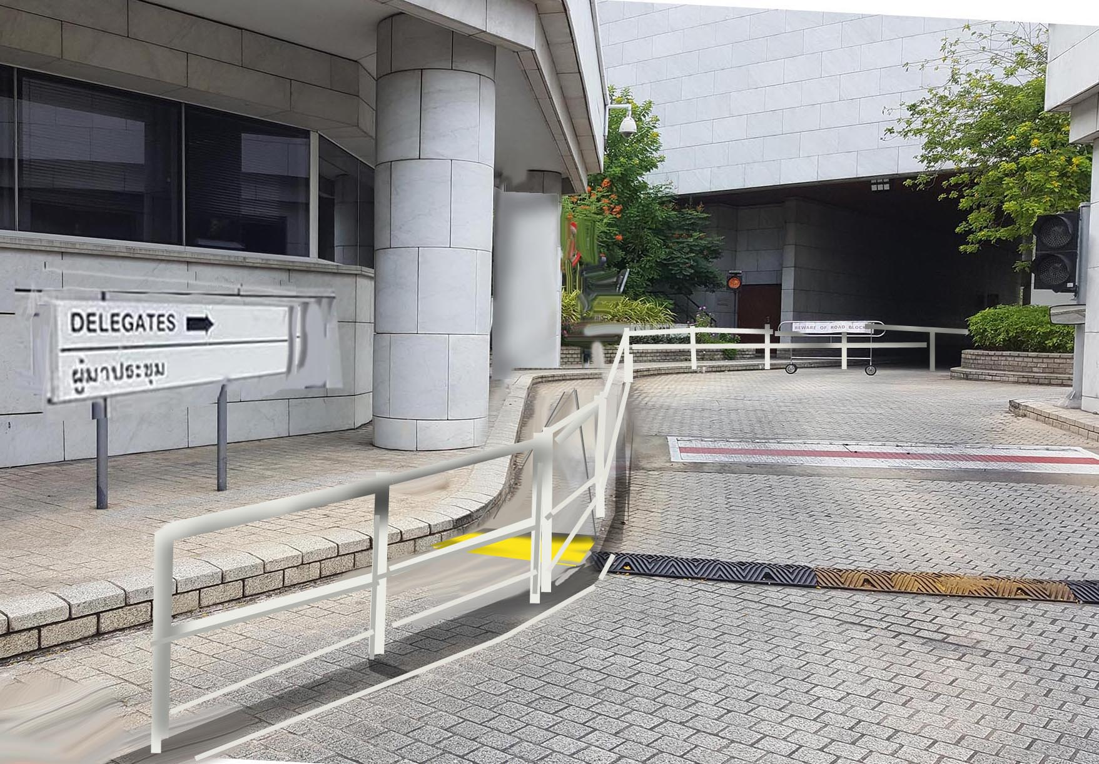
Figure 9: Proposed creation of protected walkway and gentle ramp, designed to BCA standards with passing places and tactile markers at changes in level.

Proposal
By lowering the existing pavement at the left hand side to the same level as the roadway and erecting a handrail barrier between the path and the road, a safe and accessible path can be formed, gently sloping up to the terrace outside the main UNCC entrance door.

Consultants’ Proposal 4. UNCC Foyers (Ground Floor, Levels 1 And 2)

Problem
The foyers to the United Nations Conference Centre are impressive spaces and form a very central experience to visiting delegates, but they are currently quite confusing for anyone who is not familiar with the building, particularly if they have a disability of any kind. This could leave a poor impression and may tarnish the reputation and marketability of the Centre as an attractive place to hold an event of World-Class standard.
The construction of the Proposed new Conference Registration Hall directly outside the main front of the UNCC building will improve matters to some extent, but should be complemented by a complete and integrated re-design of the foyers at all 3 levels, not only to ameliorate their current shortcomings in simply improving the various non-compliant elements, but to create an integrated and aesthetically attractive venue that integrates improved wayfinding for delegates of all abilities.

Proposal
It is the consultants’ strong recommendation that the clients source and appoint interior designers for this area who have a proven track record in integrating wayfinding with lighting, signage and cutting-edge ICT applications into aesthetically attractive spaces. As well as looking at exemplars of successful conference facilities, parallels with some of the best international airport terminals may show the possibilities of combining functional signage and furnishings with attractive décors whilst successfully handling large numbers of transient visitors.
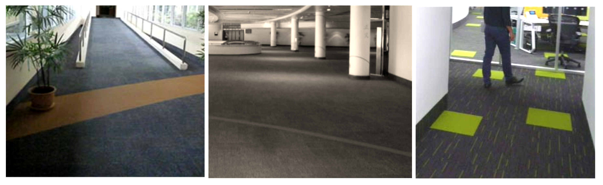
Figure 10: Carpet analysis
Figure 11: In these examples in the UNCC, carpet recently laid in the First and Second Level Foyers and in the Learning Centre, and also on the bridge between the UNCC and Service building, incorporates bands or rectangles of contrasting colour for decorative purposes. However, these serve no purpose other than for decoration, although accessibility standards require tone contrast to help people with low vision to distinguish changes in level, wall/floor junctions and edges of elements. For users with such disabilities these contrasting strips are simply confusing. How much better it would have been to make the same materials serve a purpose, such as marking the top and bottom of the ramp, or becoming a colour-coded wayfinding route to a particular venue.

Consultants’ Proposal 5: Garden, Café Terrace and Surface Route from Secretariat to UNCC Building

Problem
Currently the external route from the ground floor lobby of the Secretariat to the UNCC is used by many staff to access facilities in that building (Café, medical centre, post office). For some users the route is potentially hazardous, having steep ramps and steps with are not compliant with access standards. The surfaces also pose hazards, being of either polished marble or sealed concrete. Indications of their slipperiness are evident in the application of proprietory carborundum tape to increase friction. However, these have the effect of being confusing to the partially sighted, making it hard to see where there is a step or change in level.
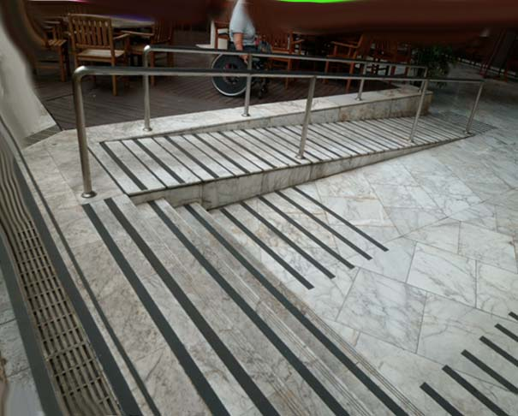
Figure 12: Ramp on Terrace Garden route. Tape to reduce slippery surface actually makes it confusing for visually impaired people

Proposal
The elevation of the garden though attractive, presents problems of mobility and safety, but is there to create depth for planting boxes for trees and shrubs. The concrete slab which forms the roof of the car park below is actually flat, so it would be possible to remove part of the mound to create a level walkway between the buildings, whilst retaining some of the planting boxes, accessing the garden by new ramps that conform to standards. Such work could be undertaken at the same time as the construction of the New Library and Cafeteria, which will encroach on this area.
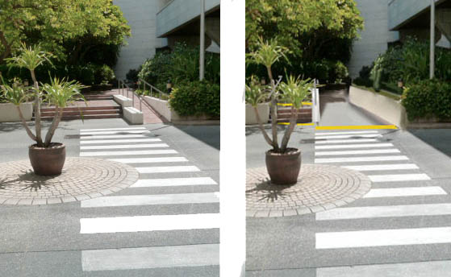
Figure 13: By levelling the route from the Secretariat to the Café Terrace there will be no need for staff to use ramps. Access to the gardens can be by ramps constructed to relevant standards.
The existing terrace outside the Café and Ground Floor lobby of the UNCC Building is a popular place for relaxation and refreshment. The floors are of polished marble which present a hazard, particularly when wet. The whole terrace also drains inwards towards the building with approximately 150mm fall, making it necessary to have short ramps to the two glass doors that are problematic for wheelchair users and others. There is also a drainage grating with bars spaced at wide intervals, which could be dangerous for mobility impaired users with crutches or wheelchairs. It is suggested that the terrace could be raised at the building side to avoid this change in level and the resulting step ramps.

Problem

Consultants’ Proposal 6. Acoustic ceiling to Cafeteria, Level One
High noise levels (over 81dB) from voices are common in both the cafeteria and in the more confined corridor break-out spaces outside Meeting Rooms. This ambient noise is not only stressful on those with average hearing but has particular disadvantages for the hard of hearing and hearing aid wearers.

Proposal
The installation of “Acoustic Cloud” or absorbent panels or ceiling tiles is recommended to cut down sound reflectivity and reverberation times. The services of acoustic design specialists should be sought to provide a suitable solution incorporated into the wider upgrading scheme for these areas.

Consultants’ Proposal 7 Parking for Disabled Staff and Visitors

Problem
The UNESCAP building complex has 640 car parking spaces and currently 6 designated lots have been identified: 2 at Basement UL, 2 at Service Building Ground Floor level, plus 2 short term parking spaces immediately to left of vehicle security entry gate. (see also Consultants’ Proposal 2 regarding connection to building entrances)
This situation does not comply with comply with BCA D3.5 or AS/NZS2890. These require that there should be a minimum of 14 spaces constructed to the specified dimensions. A proposal was made, but not carried out, in the 2004 ADA Compliancy Review (ref PO7-01) to group all these at the Ground Floor level of the Service Building (2 already exist at this level). However, in interview, some users expressed concern at all disabled parking being at Service Building, preferring to access higher levels by lift to Conference Centre.

Proposal
Subject to Clients’ views on this we suggest a distribution of a minimum of 8 spaces at this level and retain and also upgrade the existing 2 short term spaces adjacent to the site entrance (see above) plus 4 spaces at UL Basement adjacent to accessible lift serving this level and UNCC Foyers above (n.b. 2 already exist at this point). This last point would also entail making doors, corridors and signage accessible for wheelchair users at Basement level.

9.3 Conclusions
The documentation available to date has been reviewed with respect to Thailand’s ‘Ministerial Regulation Prescribing accessible facilities for persons with disabilities and the elderly’, dated 2005, The Building Code of Australia 2016 and the Australian Disability Access to Premises Standards. The application of the principles of universal design has also been a factor in reviewing how accessibility and inclusion within the existing buildings may be significantly improved in any refurbishments.
The proposed development is capable of achieving a high level of access for people with disabilities and meeting all the relevant standards. An Accessibility Management Plan will be implemented to ensure accessibility is maximised where existing conditions are seen to compromise compliance.
To ensure consistency of compliance across the whole of the ESCAP campus, all Tenant agency contracts should align with the requirements of the Accessibility Management Plan.

Building guidelines to assist the next stage of design of the refurbishment of the UNESCAP buildings.
These Guidelines are intended as an integral part of the Report, using building-by-building analysis of the existing complex to identify aspects where improvements are called for, not only for compliance with international standards but also to embrace universal design principles of inclusion of all users. The Guidelines are written with the aim of informing the lead architects of the project when they make further design proposals, particularly in improving the standards of access and safety for both delegates and staff, whatever their abilities.

10.1 Introduction
Although the buildings of the Bangkok UNESCAP complex are largely accessible in basic ways, the design of many of the elements now falls well below present day standards in detail and provision. When the buildings were originally constructed the particular emphasis was on creating a barrier-free environment. This was particularly scaled to physical accessibility and wheelchairs on the basis that, if a wheelchair can move through a building, then it can be considered accessible. Since then, universal design principles have greatly extended the range of people and ability sets benefiting from inclusive design and, most significantly, address issues of safety and independence for everyone. The design of stairs and ramps, for instance, acknowledges that not only should the wheelchair user be able to access different levels, but also that a person with some degree of sight impairment might not recognize the changes in level and injure themselves in a fall, so that visually contrasting floor finishes are included in the specification.

Designing for Disabilities
A well-designed building should enable all its users, regardless of their abilities, to go about their lives in safety and comfort and without unnecessary barriers. This is the basis of universal design which goes beyond mere compliance with building regulations. To the designers an understanding of the range of disabilities is important, as well as appreciating those features of a building that make it enabling, accessible, safe and comfortable for all its users, whatever their abilities.

Physical impairment includes:
Paralysis, paraplegia, affecting the lower part of the body, or one side (hemiplegia), loss of limbs etc limiting movement, reach, mobility in diverse ways. This may also involve loss of stamina – an older person with a hip replacement or someone with heart problems may be capable of walking unaided, but faced with stairs or a long ramp, would find this a problem.
But design for physical impairment can also concern details, though at first these could seem trivial. For a person with arthritic hands, for example, it might be critical or even fatal if that person loses their step on a staircase and is unable to grip the handrail in an emergency, or is unable to turn a doorknob to open an escape door. Loss of balance and slow reaction times are also major causes of falls, especially in older people.

Vision impairment
Sight loss is another major factor to be considered in design, not least because, if not well integrated, it will have a negative effect on the overall aesthetic quality of a space. Of the many people who may be classed as blind, in fact only a relatively small proportion of these people have no vision at all. To those with some degree of vision impairment including many other people, particularly the elderly, good contrast of tone is essential in being able to identify edges and features. For this reason, skirting and wall edges, changes in level at top and bottom of ramps and other important elements should be visible as warning or for guidance.
Equally, very shiny reflective surfaces, particularly floors, can cause glare or and be intimidating, confusing or challenging. Glass doors or full-height glazed panels may not be visible to partially sighted people, particularly if there is glare behind. Even people with 20-20 vision are known to walk into glass panels or doors that do not have markers at the correct height. Many such accidents that do not cause severe injury go unreported, but for an older or frail individual, a fall can cause serious and permanent disability.

Hearing Impairment
The needs of those with hearing impairment are more difficult to appreciate, but enhanced ICT is constantly improving communication in diverse ways. Obviously alarms and announcements, which are audible elements, need to be complemented by some form of visual signal, and these should include warning lights as well as display panels in lifts for information on floors and other announcements.
Many people with hearing impairment use hearing aids with a dedicated “T” waveband allowing them to receive audible information when in proximity of a hearing loop. For service counters, conference facilities and even exhibitions, these are important elements and are a requirement in building codes.

Cognitive impairment
For users with a range of cognitive disabilities the ability to find one’s way through a building and to identify the important facilities, routes, toilets or emergency escape stairs, is vital. Again, advances in technology and the widespread adoption of ICT are improving the situation all the time. In a strange environment, and in another language zone, diverse methods of communication can be very helpful. For staff members and visitors, a user-friendly environment should be a given for a productive workplace.

Assistive Devices
One aspect that the designer needs to appreciate is that, for many people with disability, assistive devices play an important part in achieving mobility, safety or recognition. Their own personal assistive device, be it wheelchair, crutches, white cane or hearing aid will be complemented by those elements that are built into the built or virtual environment.
But an assistive device is only as useful as the immediate environment allows it to be. An appreciation of the dimensions and turning circle of a wheelchair and its other limiting factors allows the designer to make the right decisions, such as space in the toilet, the easier gradient on a ramp and so on. It is because of this interface between the user’s own assistive device and what the building can provide that the regulations are so important in being able to provide definite dimensions and other data; heights of handrails, controls, door handles, or the proportion, visual quality and shape of steps are all significant details in this.
But connectivity of these, such as a well-defined accessible route so that a wheelchair users does not waste energy in trying to find the way or identify the facilities or the destination point of his journey. In this way, universal design thinking helps to appreciate how those useful and supportive elements of a a building work more effectively when designed as a whole, rather than just each individual element complying with the code in isolation.

10.2 Using the Guidelines
In order to explain important recurring factors in accessible design rationale, the following summary is ordered with reference to the consultants’ perceived priorities and relating to topics in regulations. These general points are amplified in the full text and, reference to legislation through Hyperlink connections to specific clauses of relevant codes and standards. This is considered to be more actively usable than attempting to quote each related part of the legislation in the text, which then would become very lengthy.
Following explanatory notes and references to key items of regulations from various sources, the Guidelines then focus on specific areas of the three constituent buildings and their external spaces, both to identify the problems and to suggest how an understanding of the universal design principles and knowledge of best practice can assist the designer to improve the overall environment.
The Guidelines start by explaining the requirements and rationale behind some of the more recurring elements, such as stairs, doors and the like, in their relative order of importance, and then go through the three buildings and their connecting routes and external spaces within the site, identifying and expanding on those elements that need to be improved in any refurbishment programme. This is based on successive walk-through, interviews and observation by the consultants of users in situ and they reference the appropriate regulation where necessary.
In order to apply the standards with understanding of the logic behind the specific legislation, designers are recommended to refer not only to the Australian BCA regulations, but also to the Singapore “Code on Accessibility in the Built Environment” and Ireland’s “Building for Everyone”. Both are downloadable and contain useful explanatory notes, examples and illustrations of elements applied in practice. The pdf version of “Buildings and Facilities Checklist for Outcome 2 and Outcome 7” is also a very useful guide to assessing designs or existing buildings against Australian Codes and Standards.
Some of the areas of attention are already covered in the section on “Clients’ and Consultants’ Recommendations” in the previous section of the Report, which explains more radical and holistic approaches as case studies towards solving some of the more outstanding problems of accessibility in the buildings and the external spaces. Reference is made to these to avoid repetition.

10.3 Key Universal Design Factors of Generic Elements:

Entrances and Foyer Spaces

Horizontal Access and Circulation
Key aspects of accessible design of all areas of circulation include:
- Corridor widths, passing spaces, particularly for wheelchairs.
- Space at side of doors for a wheelchair user to manoeuvre when opening the door towards themselves.
- Visual contrast between floor and wall or skirting and at changes in floor level that are important for vision-impaired people.
- Surfaces that are non-slippery, or without deep pile carpets or matting to impede a wheelchair.

Vertical Circulation

Stairs
Any step or change in level presents a possible tripping hazard to users of any ability set. Accessible design takes into account:
- dimensions and ergonomics of the stair tread / riser related to the human foot
- the visibility of the steps (top, bottom and individual nosing) through contrast
- the friction of the nosing and tread, preventing slipperiness, especially when wet
- the shape of the edge of each step – the nosing – which can cause the user’s toe to catch and cause tripping. Open treads are particularly hazardous and regulations limit their use
- the user’s reach and the location of handrails; many people have balance or motor difficulties, or fear a fall, and so need to take hold of the handrail before they start to ascend or descend the stairs. For this reason handrails should be continuous around landings and should start and finish with a horizontal section that extends beyond the stair itself.
- the profile of the handrail should be capable of being gripped by an arthritic hand, so a round section of not more than 40mm is required. The brackets fixing this to the wall or balusters should not obstruct the hand when moving up or down. Similarly if the handrail is against a wall there should be sufficient gap of 50 mm minimum so that the user’s knuckles are not scraped.
Although not in the codes on accessibility, compliant BCA Parts 3.9.1 and 3.9.2, AS 1170 require that the gaps between balusters should not exceed 125 mm

Ramps (external and internal)
Ramps may be regarded as a compromise, to allow sloped barrier-free access between different levels without steps or kerbs. In new build or a comprehensive redesign of an existing building it may even be possible to avoid the use of ramps or steps at all by matching internal floor levels to external ground levels. (see Consultants’ Recommendation No 5 on Café Terrace)
For ease of use by wheelchairs the gradient of the ramp is critical, as is the surface material. Note that many older or ambulant disabled people may find a ramp less easy to use than a staircase, but handrails of the correct dimensions will be a requisite feature for such users.
Safety considerations for ramps are paramount in relation to:
- the gradient and length of the ramp to prevent fatigue or runaway wheelchairs
- provision of landings at top, at regular intervals and at the bottom, especially where meeting a road or walkway
- surfaces to be of material that is non-slip, or if carpet is specified, it should be low-pile to reduce friction in ascent
- height, configuration and profile of handrails, as with stairs, to assist ambulant disabled users
- visual contrast at each change in level to warn everyone, especially the vision impaired
- kerbs to prevent wheelchairs running off the ramp

Lifts
The number of cars designated for disabled users may be limited Although one car out of four may be designated as wheelchair-friendly, it can also be used by everyone else in the building. Consequently many wheelchair users have to wait considerably longer (or rely on other passengers to press higher buttons for them). To this end it is recommended that all lift cars are brought up to standard by providing a reachable control panel.
Main considerations for lifts include:
- Size of cars, door widths
- Lobby call button height
- In-car controls, panel height and design
- Information legibility (tactile, Braille) on controls and call buttons inside and outside lift car
- Mirror at rear of car: important when a wheelchair user needs to back out of the car when other people are using it
- Handrails for ambulant disabled people.
- Audible and visible warnings and announcements, emergency phone
- Closing speed of doors and infra-red beam cutout.
Note that: “Under Section 4.4 of the Premises Standards, there is a concession from the requirements of Table E3.6 (b), which do not apply to an existing passenger lift that is in a new part, or an affected part of a building if the lift:
- Travels more than 12m; and
- Has a lift floor of not less than 1100mm (width) X 1400mm (depth)
All other access features within the lift, including however not limited to the control panel, audible information, lift landing controls and handrail, must be provided.
Fireman’s Lift and ‘Area of refuge’ in emergencies and are not subject to the concession, which may need explanation.

Safe Rooms (Fireman Elevators)
UNESCAP Emergency Evacuation Plan 2016 states:
“An elevator in every building has been designated as “Fireman Elevators”. These elevators are to be controlled by the fire men during evacuations, to transport those who have a medical condition or disabilities…. and need special assistance to these fireman elevators and place them on the elevator to the Ground Floor where security personnel will further evacuate”.
With reference to the three UNESCAP Buildings the following are designated “Fireman Elevators”:
Buildings | Elevators
Secretariat | Freight elevator
Service Building | Freight elevator
UNCC | Elevator no. 4

Platform Lifts
It is recommended that Platform lifts (rising vertically) should replace existing Stairlifts on Level 3 (Learning Centre / Interpreters’ Rooms). This is because stairlifts cannot be operated independently by the disabled user, but require an assistant.

Wayfinding and Signage
In a complex and multi storey building such as the UNCC many users will be entirely unfamiliar with the layout. When several functions are taking place at the same time, with large groups of participants, finding the right venue and knowing the location of other facilities, especially toilets, is essential. For such a prestigious venue any lack of consistency will have a negative impact on the image of the Conference Centre.
Good design must be able to integrate signage and other waymarking elements (tactile strips, colour coding, directional floor patterns or electronic screens or lights) so that these do not appear to be an afterthought. This is particularly true for aspects of safety, including:
- Recognizable signage for emergency escape routes (including low level signs in case of smoke-filled spaces) is mandatory
- Identification of amenities: toilets (accessible unisex for the wheelchair users, male / female), lifts, stairs, etc.
- Clear directional indicators to venues, conference and meeting rooms
- Electronic information boards for notice of events, announcements etc.
All these elements should be supported by current digital technologies, such as electronic beacon systems.

Sanitary Facilities

Wheelchair accessible toilets:
n.b. in multi-story buildings the plan of the toilet should be ‘handed’ at different floors, allowing for hemiplegic users who are paralysed on one side, to choose the cubicle most suitable for their personal needs.

For the toilet cubicle:
- correct logo and signage in corridor and on, or to the side of, the door, whichever is the most legible – even when the door is open.
- outward opening doors, of correct clear width. Note: outward opening doors serve a double purpose - they allow more space for a wheelchair to move, but also a facilitate rescue if a person collapses on the floor behind the door
- reachable handles and locking mechanisms of appropriate design and configuration; bar handles to be vertical on outside, horizontal on inside
- easy pull to open, self-closing door
- flat threshold at doorways
- adequate turning circle and manoeuvering space for wheelchair user to approach, turn and reach all facilities.

For the toilet pedestal and fittings:
- height of toilet seat (in all cases in the ESCAP buildings the heights of the seats are non compliant)
- backrest
- layout and dimensions of foldable and fixed grab bars for different transfer methods
(Note: regulations recognize that wheelchair users’ methods of transfer from wheelchair to toilet seat vary according to their impairment. The configuration and spacing of grab bars and seat height must be optimal, based on extensive research, and is a crucial factor for this essential but often very challenging action).

For other washroom facilities:
- heights and location of basin (including clear space below), toilet roll holder, soap dispenser, hand drier and mirror, reachable from a wheelchair
- lever taps, for users with limited grip
- alarm button or cord (with alarm response light outside the cubicle). Cord alarm pulls, extending to the floor level, are recommended when there is a likelihood of a person falling and not being able to reach an alarm button.
- light switch at reachable height (if not automatic)
- visual contrast of toilet, basin, drier etc. for vision impairment
Although the aim of design of accessible toilets is to allow independence for the user, consideration should also be given to providing adequate space for a helper (male or female) who might be required to assist the user.

Toilets for Ambulant Disabled Users
As well as those in wheelchairs, many male users will benefit from a toilet that includes a urinal stall with vertical grab bars at both sides to support the user. A 30% contrast in tone between the sanitary fitting and the wall will also define the both the toilet bowl or the urinal for users with vision impairment.
Section 4.5 of the Premises Standards includes a concession for existing accessible sanitary facilities, stating that certain existing accessible sanitary facilities located within a ‘new or modified part’ or an ‘affected part’ are not subject to upgrade if, the existing facility complies with the circulation and fit-out requirements of AS 1428.1 (2001). This may be possible when applied to the refurbishment of the UNESCAP buildings, but in doing so, designers should look to the application of ‘best practice’ in their proposals, rather than cost cutting.

Visual contrast:
At skirtings and door frames, and also for fittings in toilets, AS 1428.1 Appendix B states that “Designers and specifiers shall select various building elements that achieve a high luminance contrast. Where it is required to achieve a minimum luminance contrast of 30%”

Glazing markers
Doors and glazed screens, including the low security entry gates between Secretariat or Service Building and UNCC, can present a hazard, not only for the visually impaired but even for those with 20/20 vision and injuries are caused through people walking into them. These may not be visible, especially where the background is brighter, and so should have markers on them, in the form of engraved, screen printed or taped decals mounted at specific heights, to catch the eye of the approaching person. Regulations (and opinions) vary about whether these should be solid and continuous or partially transparent (sometimes in the form of a logo or pattern). Whilst the Australian Standard is the more exacting, the Singapore Code is often considered to be more appropriate aesthetically as well as practically.

Recommendation: application of visual indicators on glazing
There is a difference in recommendations provided by BCA and COA Singapore. The BCA indicate that there should be a solid contrasting line, full width on the glazing. However, COA Singapore recommend markings or motifs consisting of two horizontal bands, and of contrasting colours to assist visibility. Ref: BCA (2016) and BP1.3 (c)
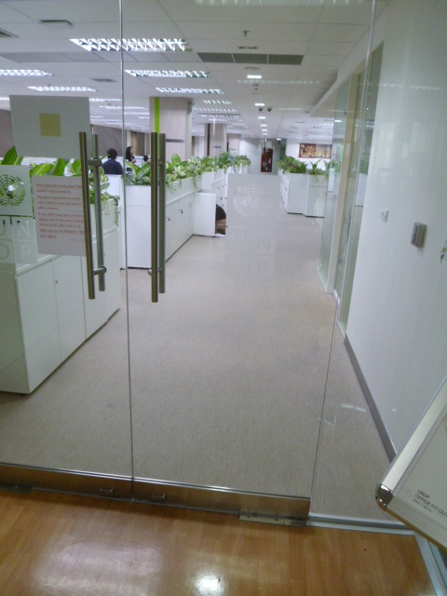
Figure 14: There are many instances in the UNESCAP buildings of doors and glazing with inadequate markings or no markings at all.

Doors
Negotiating a wheelchair through a narrow door can be difficult – and can also result in scratched surfaces. Thus ‘clear opening’ means that the measurement must take into account the minimum dimension where grab rails or ironmongery effectively reduce this opening.
Double doors must to be designed to allow this clear opening even when only one leaf is being used. Note that some of the double doors in UNCC Meeting Rooms do not comply with this standard which can make emergency evacuation more difficult.
Other points that can affect the accessibility of doors include:
- Handles and ironmongery, their ergonomic design and where they are located. The use of doorknobs is not permitted, as an arthritic hand may not be able to grasp this.
- lever handles should be design so that they turn inwards, preventing catching on clothing.
- Visual contrast of frames and handles
- Signage, design and position
- Vision panels in solid doors, at a height to allow a person in a wheelchair to see if anyone is approaching from the othert side.
- Space at the side of a door opening, particularly on the outward-opening side to allow a wheelchair to manoeuvre when opening.
- Doors which are part of an emergency escape route should always open outwards

Heavy Doors
Fire doors are exempt from this requirement so other ways tor educe effort and inconvenience should be sought. Alternatives include:
- Specifying door self-closing mechanisms that can be adjusted to approved pull force whilst still complying with fire codes.
- Using electro-magnetic holders, where it is beneficial to keep doors open during normal working. These are connected to fire alarms and will automatically close in the event of a fire.
- Motorised doors which can be opened either automatically by a sensor mechanism or manually by a touch button, mounted at an appropriate distance and height to allow wheelchair users to operate it with ease.

Flooring
Reduction of glare and slip risk are the two common factors in specifying floor finishes. These should have a high luminance contrast with a minimum of 30%.
To prevent slipping, AS 1428.1 Appendix B states that, “Floor surfaces should comply with the provisions COA (2013) Clause B.6.2.1 or of BCA clause 4.1. Shiny and reflective floors using granite, marble, glazed tiles and the like are not recommended as they could be hazardous especially when they are wet or greasy, or if they have been highly polished”.
Friction can be a problem when operating a self-propelled wheelchair, particularly at a ramp. Carpet tiles are more suitable than thick carpet, still found in some rooms and on staircases in UNESCAP, for wheelchair users. Where carpets or any soft flexible materials are used pile height shall be not more than 6 mm as defined in AS1428.1 (2009) Clause 8.4.1

Sound dampening
High noise levels are recorded in several locations, including the cafeteria and in some of the corridor spaces off the main foyers, outside Meeting Rooms. Aural comfort is important for communication, which is one of the main reasons for breakout spaces for informal discussion. Reflective and disturbing sound is absorbed by softer materials, so ceilings and walls may be lined with acoustic panels or suspended fabric ‘acoustic clouds’ as an intrinsic part of the décor. Advice from specialists may prove to be well taken in such cases. Consultants’ Proposal 6 discusses the use of acoustic panels or ‘acoustic cloud’ fabric sound absorbers to alleviate this problem.

Counters and Worktops for wheelchair users
Counters should be installed with a height of 830–870mm and leg clearance of 800–840mm underneath to AS1428.2—Clause 24.1.1.

Other Facilities
Important factors for wheelchair users include reach heights and visible location of controls and switches for:
- ATM cash dispensers and other similar facilities – including the height and angle of visual display screens and position of buttons
- Telephones
- Drinking Fountains
- Wayfinding aids such as tactile maps or interactive screens

10.4. Building by Building

UN Conference Centre

Entrances and Foyers in General (Ground level, First, Second and Third Levels)

Wayfinding
A recurring major problem in all the UNCC Foyers is that of Wayfinding, which is inadequate and confusing. Delegates need to register at the counters and find various Conference or meeting Rooms on different levels, but this is not easily perceived on entry. Design considerations for Integrated elements include replacement of:
- existing signage or guiding markers to identify key facilities such as lifts and toilets, and also the first aid and medical room, from a reasonable distance.
- digital display screens which are difficult to read, currently mounted at heights causing glare problems.
- small plans of the building attached to the walls which are confusing, lack colour contrast and have very small lettering. Larger tactile maps and other indicators should be considered
- Column mounted display screens that are small and difficult to read, with glare problems
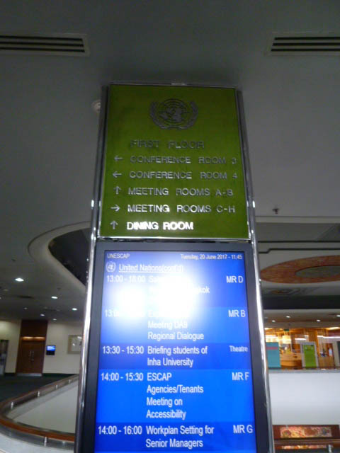
Figure 15: The form, size and positioning of information is important. Glare and reflection make this display difficult to read.
The interior design of all the Foyers should be assigned to practitioners experienced in such work and working with specialized consultants with a proven track record both in the field of accessibility and in ICT and communication on this scale.
Meaningful colour coding, as used in some hospital complexes and airports, should be considered as integral part of the decor, using floor or ceiling stripes as guidance. Illuminated signage, as well as areas of increased luminance can help to direct people to areas of focus. Electronic beacons are also proposed, using delegates smartphone apps to guide them to facilities.

Lifts
There are three lifts to the higher floors of the UNCC, two adjacent to the Registration Counter and one in the Corridor to the south of the Foyer. These are both adequate although not fully compliant dimensionally – (see Lifts Concession. Structural modifications would be costly, for limited benefit)>>>>
Only one of these lifts is designated as being accessible, having a lower reachable control panel. This lift also descends to the Upper Basement level where there are two designated accessible parking spaces. None of the lifts have the additional requirements of mirror or grab bar.
Heights of lift call buttons in lobbies do not all conform to standards (1200mm maximum) and although there are tactile and Braille signage and audible announcements, there are no visual alarms for deaf people in the lift cars.

Stairs in public areas
Two similar staircases lead from the Ground Floor Foyer space to Levels One and Two. These have carpet finishes and are of adequate dimensions, but do not comply either in the design and contrast of the nosings nor in their handrail profile and layout .
There is also another staircase (Stairwell 2) adjacent to the Lift in the South Corridor. This is also an emergency escape route and is in a protected shaft but is currently non compliant. The same shaft brings a similar emergency escape staircase up to the Ground Floor level from the basement car park, but these are not continuous for fire protection reasons. The marble treads of these stairs are slippery when wet and lack contrast. Handrails are also non-compliant in profile and layout.
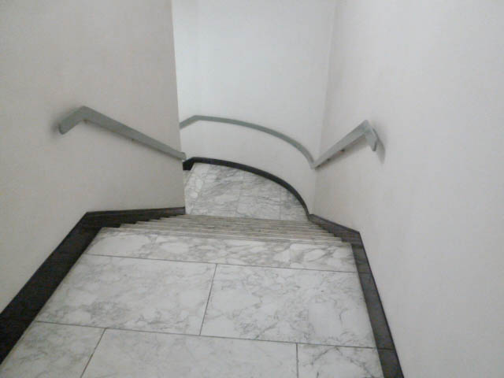
Figure 16: These stairs at Stairwell 2 have potentially slippery treads, lacking contrast and not easily distinguishable from each other. Flat handrails do no afford adequate grip and the gap to the wall is inadequate, so that knuckles may be grazed in use.

Ground Floor Foyer
The main entrance to the Conference Centre is from the curved vehicular drop off point or via a walkway from the pedestrian entry gate.
Doorways are adequate width, but should have recesses for doormats as loose ones are a trip hazard. Automatic glazed doors lack adequate visual markers, as do the extensive full-height glazed screens to both front and rear of the foyer space.
One major problem of this space is the very shiny polished marble floor which can be slippery when wet. Recommendations include replacing this with another material, such low-pile carpet, as in the upper Foyers, or good quality vinyl as in the Service Building.

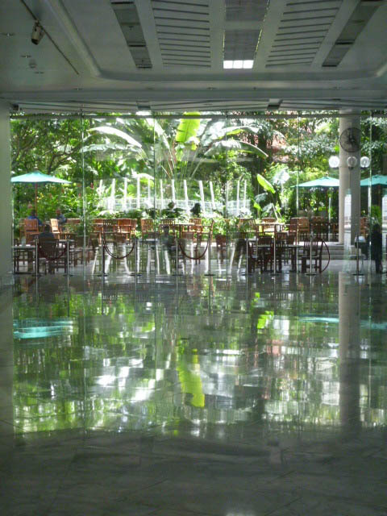
Figure 17: Shiny floors and a brighter exterior can make a very confusing view, especially for those with vision impairment. For a person fearful of falling, the slippery surface is equally as intimidating.
The Registration Counter is at a continuous height and without a lower desk for people of limited height or wheelchair users. Temporary movable cord barriers are used to define the queuing lanes. For a white cane user these are not detectable and hazardous, as there is no ‘tapping bar’ that can be recognized by the blind person at floor level. An alternative design should be investigated, or more permanent information stands be located in strategic positions.
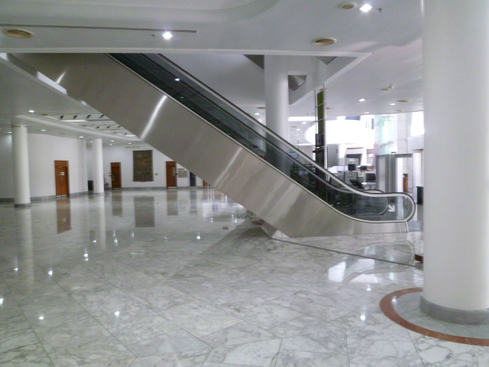
Figure 18: The underside of the escalator presents a real hazard to people with vision impairment as there is no tactile warning or guard rail. Codes require some form of physical barrier to prevent accidents happening
There are two doors to the rear of the Foyer, to Garden Terrace and from Café, one being automatic and the other a two-way swing door, neither have adequate markers or handle contrast.
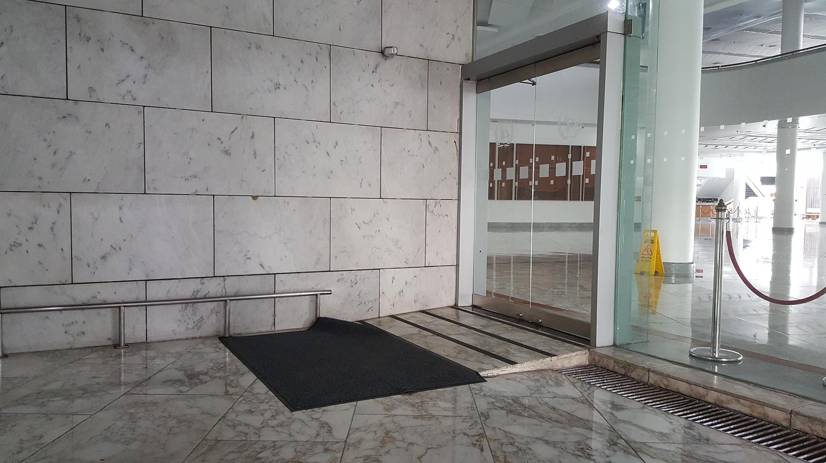
Figure 19: Several accidents waiting to happen: the rumpled doormat presents a trip hazard, while the step ramp immediately at the threshold is non-compliant. It is obviously of the same slippery marble as the floors on either side and so carborundum tape has been applied to give added friction. The abrupt change in level detail at the side of this step ramp is also a hazard.
The door is motorized and is actuated by an automatic sensor. Codes state that there should be a guard rail at the opening side to prevent the door swinging into the path of an approaching person
There are some markings on the door but not on the glazed screens to the side. Note that corded barriers have been placed in front of the glazing to prevent injury.
See ‘Consultants’ Proposal 5’ for more details on solutions to these problems.

Theatre
Off the corridor to the South of the main Foyer there is a small ‘theatre’, which is rather a lecture room with tiered seating for 100. This would require 3 wheelchair spaces. As the rear entrance is only accessed by stairs, these should be arranged at and two one either end of the front row on the level floor. Modifications for this room were included in the 2004 Report, but were not implemented. This also proposed a 1: 12 ramp up to the podium. Since the room has tiered seating, it may be more expedient to remove the podium and thus avoid the need for a ramp.
Hearing loops should also be incorporated into the refurbishment, along with other audio-visual and ICT recommendations.

Post Office
The counters to the Post Office are non-compliant and a lower desk should be installed with a height of 830–870mm and leg clearance of 800–840mm underneath to AS1428.2-Clause 24.1.1.

Level One Foyer
The Conference Halls and Meeting Rooms on Levels One and Two have spacious foyers that can accommodate a full complement of delegates between sessions. Floors have carpet tiles of appropriate pile for wheelchair mobility but confusing pattern (see Note on D.2.2.3)
Comments previously made on issues regarding Doors, Lifts, Stairs and Toilets apply here, as do proposals on Wayfinding. (See ‘Key Universal Design Factors of Generic Elements’)
Stairwell 2 can be entered from the Foyer by a glazed double door which is non compliant, the clear opening between its leaves being less than the 850 mm. As a smoke lobby door it is also very heavy to open and should be replaced with a button operated motorized door. Glazing on the adjacent screens also requires visual markings.
Counter heights at the cafeteria and snack bar are not compliant for wheelchair users. Their height should be between 830–870mm to comply with AS1428.2—Clause 24.1.1.
Cafeteria has a short ramp at the rear exit to the upper terrace, but as with other ramps, lacks visual contrast and handrails.
The noise level problem in the cafeteria is discussed in ‘Consultants’ Proposal 6’.

Ramp and landing to Conference Room 3 (see Consultants’ Proposal 1)
Figure 20: Stairs and Ramp at the landing before Conference Room 3 on Level 1 are non-compliant in several ways and present the following problems:
Ramp is non-compliant in its:
- handrail (incorrect profile, one side only, too narrow to introduce another,
- pile carpet which gives friction in ascent
- the curved form that makes it impossible for an ascending user to see someone coming in the opposite direction

Proposals:
As it would be difficult to straighten this ramp and decrease its gradient, it is recoomended that it should be replaced with a more compact and user-operated platform lift complying with BCA (2016) Clause E3.6a
The stairs are also non-compliant having:
- No contrast on nosings or indicators top or bottom.
- Handrail one side only, with incorrect profile
Glazed window to right: note corded barrier placed by management to prevent accident
Remediation proposal: attach tape glazing markers to Singapore standards

Summary Conference Rooms: general points

Level One Conference Rooms 3 and 4 and Meeting Rooms
Conference Room 3 is signalled as a Pilot Project for upgrading the communication facilities and the recommendations for this will also apply to Conference Rooms One and Two and Four plus the ESCAP Hall. See also ‘Clients’ Proposals No 3’: these comments also refer to other Conference Rooms
BCA Part D3.9 prescribes the number of Spaces for Wheelchairs in auditoria.
All five Conference rooms have similar desks and seating, of 2 types:
- Desk spaces with microphone, movable swivel chairs at desks
  - (Podium seating similar but video screen monitors in desks)
- Fixed seating with audio sockets and headsets/earphones in rear rows
The BCA Code requirement for number of wheelchair spaces in each Conference Room as follows:
- Conference Room 1: 426 seats = 9 wheelchair spaces
- Conference Room 2: 333 seats = 7 wheelchair spaces
- Conference Room 3 : 259 seats = 6 wheelchair spaces
- Conference Room 4: 152 seats = 4 wheelchair spaces
- ESCAP Hall : 902 seats = 18 wheelchair spaces
D3.9 states that these spaces should be distributed through the room in the following way:
- For rooms with between 151 and 800 seats, not less than 1 single space: not less than 1 group of 2 spaces; and not more than 5 spaces in any other group.
- For 801 – 10,000 seats - not less than 2 single spaces; and not less than 2 groups of 2 spaces; and not more than 5 spaces in any other group; and the location of spaces is to be representative of the range of seating provided.
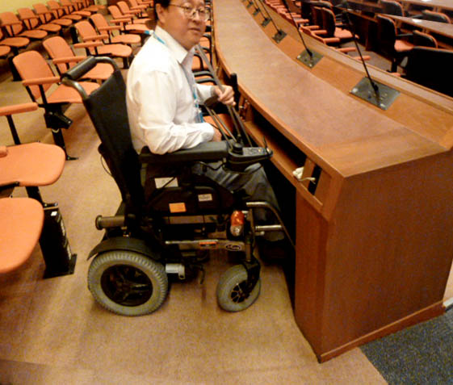
Figure 21: Limited space beneath desks and turning circle can be rectified by removing the shelf below the desk top and removing the fixed seat behind the wheelchair-designated place.

Recommendations:
- Wheelchair spaces; number and distribution in different sized rooms
- Introduction of ICT and audio augmentation
- Floors to be made level, no steps or short ramps - except for:
- Ramp to podium. May be possible to route this behind rear screen wall in store spaces
- Floor finishes: carpet with deep pile to be replaced
- Desks – under top clearance provided by removing shelves
- Bring to compliance all escape routes/stairs (door widths), treads and nosings of fire stairs
- Remove hazardous protruding power/audio socket outlets in floor

Level 2

Conference Rooms 1 and 2 and ESCAP Hall
As Conference Rooms 3 and 4 described above. Signage to locate these Conference Room is poor.
Conference Rooms 1 and 2 and ESCAP Hall open off Level 2 Foyer, which has fewer facilities than level 1. Signage for the lifts and to the toilets at either end is small and not visible from a distance.

Link Bridges and Connecting Corridors (Ground Floor level and Level One)
Ramps in these circulation spaces are code compliant in gradient but lack contrasting strips at changes of slope and should have landings at centre and, in the link between UNCC building and Service Building, a landing before the doorway at the upper end.
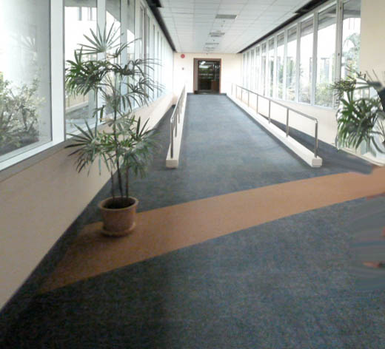

Figure 22: Level One Link bridge from UNCC to Service Building has a ramp, carpet tile finish but no landings at top level or centre, nor any visual contrast at change of level.
Note also that there is a space between the ramp and the window wall. This could be hazardous for a person with low vision who is following the skirting with a white cane. Management is obviously aware of this and placed flower pots as warnings.

Level Three

Learning Centre and Interpreters’ rooms
Two Stair lifts serve half-level changes in the lobby, but as they need to be operated by an assistant they do not allow independent use. Platform lifts to BCA (2016) Clause E3.6a standards would be a better solution.
Currently two stairways lead to the interpreters rooms for Conference Room 2 . making them inaccessible to wheelchairs. As these rooms are only used on certain occasion by a limited number of people it may not be deemed necessary to install platform or stair lifts.

Basements UL and LL
For details on disabled car parking spaces see ‘Consultants’ proposal 7’
Signage in UL Basement Lobbies is inadequate. At the lobby to the stairwell adjacent to the existing disabled parking spaces there is no indication of the direction to the Accessible Lift.

10.5 Secretariat Building
Entry at Ground Floor level into the Security Lobby is through a double leaf door, which is non-compliant with narrow clear openings and no visual markers on the glazing. It is also heavy to open. A motorized automatic opening door should be installed in future refurbishments.
A corridor with a short unmarked ramp leads to the Pass-issuing Counter.
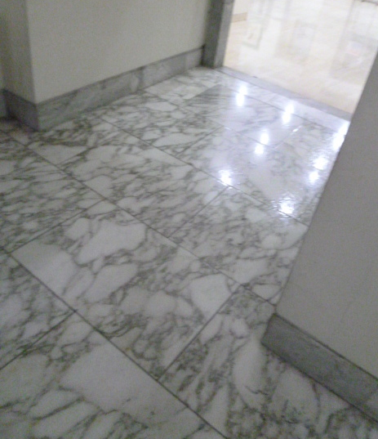
Figure 23: The short ramp between the security checkpoint and the Pass issuing counter has no visual indicators of change of level, no handrails and a potentially slippery surface.
The height of the Pass issuing Counters is too high and not compliant with AS1428.2-Clause 24.1.1.
No audio loops are installed for hard of hearing visitors and signage is not very clear.
Card-operated security gates then lead into a corridor to the Secretariat Lift Lobby. This has different lighting levels, causing glare problems for some users and there is a lack of visual contrast between wall and floor.

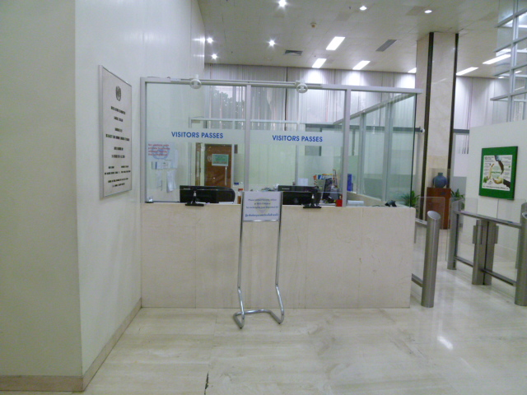
Figure 24: Pass-issuing Counter, which is too high for wheelchair users and has no hearing loop. The information is inconsistent and unclear. Visual contrast is lacking at wall and floor junctions in this area.
The corridor and Ground Floor Lobby have shiny floor finishes without contrast to walls and should be replaced withb less reflective materials.

Floors 1 to 15
The Lift Lobbies on each floor have lift call buttons that are too high but otherwise finction adequately.
Lifts also may be considered under Section 4.4 of the Premises Standards where there is a concession from the requirements of Table E3.6 (b), which do not apply to an existing passenger lift that is in a new part, or an affected part of a building if the lift:
- Travels more than 12m; and
- Has a lift floor of not less than 1100mm (width) X 1400mm (depth)
All other access features within the lift are not subject to the concession. Only one of the lifts is accessible, with a reachable control pane,l, but the recommendation is that all 4 lifts should be brought up to standard.

Stairs
There are 3 flights of stairs in the Secretariat with one main staircase to connect all floors and two fire stairs, one at either end, with secure doors to allow exit only. These are compliant, with handrails at both sides but the stairs are to minimal width. The central stair is mainly compliant but, although not an access issue, the balusters do not comply with BCA Parts 3.9.1 and 3.9.2, and AS 1170 as the gaps between balusters exceed the maximum gap of 125 mm.

Offices
Glazed doors do not have conforming visual markers and the opening force required is generally above the maximum pull allowed in regulations, although these are smoke doors.
Corridor widths and circulation spaces are generous and future furniture specifications should recognize ergonomic factors such as under-desk clearance and the installation of standing desks, adjustable desk and VDU heights.
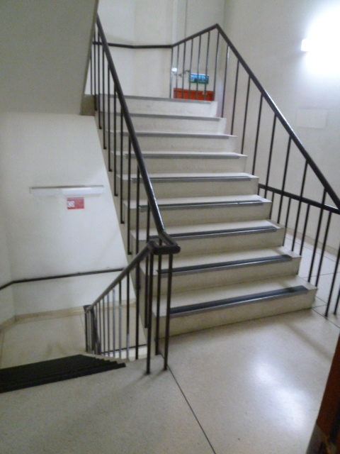
Figure 25: main staircase in secretariat building. The treads nosings and handrails comply but balusters have over-large gaps.
For emergency evacuation purposes it is strongly recommended that one Evac Chairs is located on each floor and that staff are trained how to use these to assist disabled people to exit the building via the stairs in case of an emergency.

Sanitary provision
Accessible toilets in the Secretariat Floors 1 to 15 are partially compliant, although the turning circle is compromised by the L-shaped space caused by the vertical duct. This may be allowable under Section 4.5 of the Premises Standards which includes a concession for existing accessible sanitary facilities, within a ‘new or modified part’ are not subject to upgrade if the existing facility complies with the circulation and fit-out requirements of AS 1428.1 (2001) Access to premises standards.
- The heights of toilet seats are non compliant in all toilets.
- Ironmongery, door and lock handles could be diffiicult to operate and are non compliant
- There is no provision for ambulant disabled toilets on any of the floors.

10.6 Service Building
This block has a total 4 floors including cafeteria and parking at ground floor level, with upper parking at basement level connected to parking at UNCC basements. The Ground Floor has some parking, and a Cafeteria and fitness room. The cafeteria counters are non-compliant in height and doorways and glazed screens lack visual markings.
See Consultants’ Proposal 7, with suggested increased allocation of designated disabled parking spaces at ground floor level. (this was also proposed in the 2004 Report, see Drawing PO7-01)
Upper Levels One, Two and Three. At Level I there are public facilities: bank with ATM cashpoint in the corridor, a travel office, and existing Library. Counters and signage in the Bank, existing Library and other service counters do not make provision for wheelchair users in their heights. There are no hearing loops installed in any of these facilities.

Vertical circulation
Stairs between floors are dimensionally compliant but handrails and balusters are not
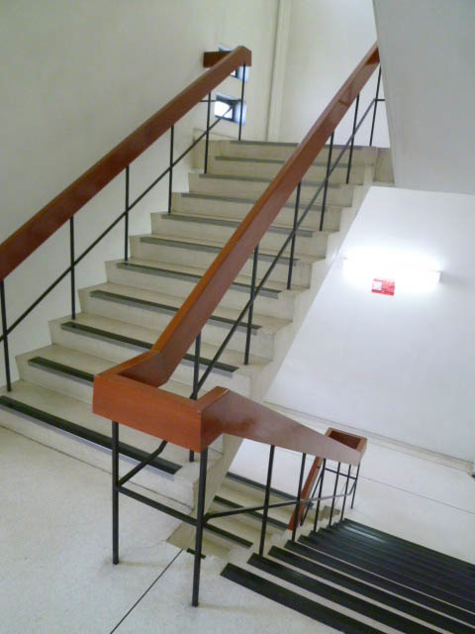
Figure 26: The Service Building staircases are partially compliant, having conforming widths, treads and contrasting nosings, but handrails and balusters have the wrong profile. Gaps in balusters are too wide and could allow a person to slip through. .

Lift Lobbies
On each floor lift call buttons that are too high but otherwise function adequately.
As in the Secretariat, during refurbishments lifts also may be considered under Section 4.4 of the Premises Standards where there is a concession from the requirements of Table E3.6 (b), which do not apply to an existing passenger lift that is in a new part, or an affected part of a building if the lift:
- Travels more than 12m; and
- Has a lift floor of not less than 1100mm (width) X 1400mm (depth)
All other access features within the lift are not subject to the concession. Only one of the lifts is accessible, with a reachable control pane,l, but the recommendation is that all 4 lifts should be brought up to standard.

Sanitary Provision
The existing accessible toilets do not comply in space standards and would need to have walls removed to provide the required turning circle. Comments on fittings, particularly height of toilet seats and grab bars are the same as in the other buildings.

Offices
Offices on all upper floors have clearly defined floor and wall junctions but glazed screens are non-compliant, without visual markers and the opening force required is generally above the maximum pull allowed in regulations, although these are smoke doors.
Corridor and circulation spaces comply and tenants should be required to comply with standards on furniture specifications and on ICT. Workstations should rapply ergonomic factors such as under-desk clearance and the installation of standing desks, adjustable desk and VDU heights.
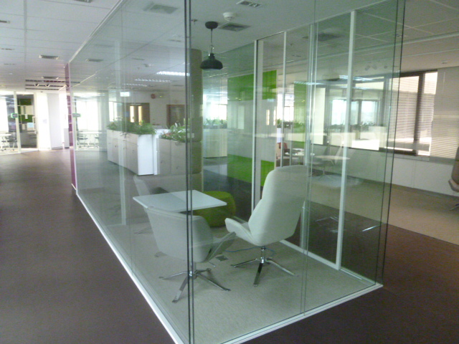
Figure 27: Unmarked glazed screens in Service Building are potentially hazardous and require markers

10.7 External spaces

Terrace and raised garden
See Consultants’ proposal 5 for fuller discussion of appropriate and comprehensive refurbishment relating to the proposed construction of the new Library. The proportions of steps and ramps in this area, as well as their surface materials, demand redesign to current standards, but as any necessary extension in their length to reduce gradients may require the removal of mature landscape, this should be undertaken by expert landscape consultants.
Figure 28: Carborundum tape added to provide better grip also creates visual confusion for sight-impaired users
Existing ramps and steps require comprehensive redesign, referring to Consultants’ Proposal 5 on solutions to the non conforming and potentially hazardous ramps.
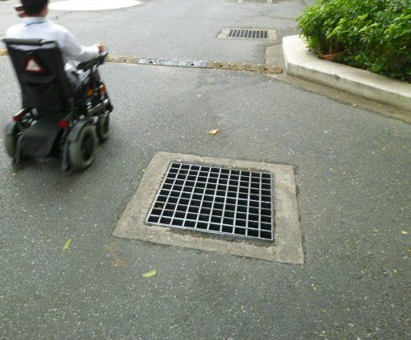
Figure 29: In driveways gratings have wide gaps that could catch a crutch or a heel and cause injury.

Exterior: North Service Entrance to street level
As with the main entrance, the service entrance at the north side is in need of realignment to reduce ramp gradients, as well as to bring stairs and doorways up to standards.
Figure 30: Ramp at service entrance, also used as entrance to tenants’ offices. This is non-compliant and should be redesigned to standards.

Section C: ICT environment

ICT - Legislation and international standards
“The power of the Web is in its universality. Access by everyone regardless of disability is an essential aspect.” - Tim Berners-Lee, W3C Director and inventor of the World Wide Web
Both Article 9 (Accessibility) and Article 21 (Freedom of expression and opinion, and access to information) of the Convention on the Rights of Persons with Disabilities (CRPD) have particular reference to use of ICT.
Article 9 requires that States Parties take: “appropriate measures to ensure to persons with disabilities access, on an equal basis with others, … information and communications technologies and systems, and to other facilities and services open or provided to the public, both in urban and in rural areas. These measures, which shall include the identification and elimination of obstacles and barriers to accessibility, shall apply to, inter alia: ”, … including
- Buildings, roads, transportation and other indoor and outdoor facilities, including schools, housing, medical facilities and workplaces;
- Information, communications and other services, including electronic services and emergency services.
Furthermore that, States Parties shall also take appropriate measures:
- To develop, promulgate and monitor the implementation of minimum standards and guidelines for the accessibility of facilities and services open or provided to the public;
- To ensure that private entities that offer facilities and services which are open or provided to the public take into account all aspects of accessibility for persons with disabilities;
- To provide training for stakeholders on accessibility issues facing persons with disabilities;
- To provide in buildings and other facilities open to the public signage in Braille and in easy to read and understand forms;
- To provide forms of live assistance and intermediaries, including guides, readers and professional sign language interpreters, to facilitate accessibility to buildings and other facilities open to the public;
- To promote other appropriate forms of assistance and support to persons with disabilities to ensure their access to information;
Article 21 requires that States Parties take: “all appropriate measures to ensure that persons with disabilities can exercise the right to freedom of expression and opinion, including the freedom to seek, receive and impart information and ideas on an equal basis with others and through all forms of communication of their choice”, … including
- Providing information intended for the general public to persons with disabilities in accessible formats and technologies appropriate to different kinds of disabilities in a timely manner and without additional cost;
- Accepting and facilitating the use of sign languages, Braille, augmentative and alternative communication, and all other accessible means, modes and formats of communication of their choice by persons with disabilities in official interactions;
What both Article 9 and 21 do, is treat ICT accessibility as an integral part of accessibility rights, on a par with accessibility to the physical environment and transportation. What this means, is that the United Nations in general and ESCAP specifically in this context must do is align their information systems, content creation, curation and publishing processes and products as well as their ICT procurement practices against Articles 9 and 21.

11.1 Web Content Accessibility Guidelines / ISO/IEC 40500:2012
The World Wide Web Consortium’s (W3C) Web Content Accessibility Guidelines (WCAG) provide the technology neutral requirements (success criteria) and techniques to measure and achieve success against Articles 9 and 21.. The first iteration of WCAG was released late last century in 1999, with the current iteration released nearly a decade ago, in December 2008. This version is commonly known as WCAG 2.0 and is the current official version.
WCAG 2.0 shifted the guidelines from a technique-centred model to a principle-centred and future proof model. WCAG 2.0 is based upon four key principles of accessibility
- Perceivable - Available through sight, hearing, or touch.
- Operable - Compatible with keyboard or mouse.
- Understandable - User-friendly, easy to comprehend.
- Robust - Works across browsers, assistive technologies, mobile devices, old devices/browsers, etc. Follows standards.
Underpinning each principle are clear and concise success criteria as well as guidance on how to satisfy those criteria. The criteria are also classified by one of three levels of conformance: A, AA, and AAA. In essence, the higher the level the greater the accessibility. This has led to WCAG 2.0 being steadily adopted by governments around the world as the accessibility standard for their own websites. In 2012, the Web Content Accessibility Guidelines were also published as an ISO/IEC standard: ISO/IEC 40500:2012: “Information technology -- W3C Web Content Accessibility Guidelines (WCAG) 2.0"
The technology neutral nature of WCAG 2.0 has led to W3C applying the guidelines to non-web Information and Communications Technologies (WCAG2ICT) as well as embedding the principles within the Authoring Tool Accessibility Guidelines (ATAG 2.0). The WCAG2ICT standard applies to the creation of traditional content formats such as text based documents, spreadsheets, slide presentations, pdfs, videos and digital books. Whilst ATAG 2.0 applies to tools such as
- web page authoring tools (e.g. editing.escap.un.org/)
- email clients that send messages using web content technologies
- multimedia authoring tools

11.2 International Perspective on WCAG 2.0
As earlier stated WCAG 2.0 has been steadily adopted by governments around the world. Outlined below are a subset of the some of the member states that have adopted WCAG 2.0, ISO/IEC 40500:2012.
Table 10: Adoption of ISO/IEC 40500:2012
Country | Name | Date | Policy Type | Scope | Web Only | WCAG Version
Australia | Disability Discrimination Act 1992 (DDA) | 1992 | Anti-discrimination law | Public sector, Private sector | no | WCAG 2.0
Australia | Procurement Standard Guidance | 2016 | Procurement recommendation | Government | no | WCAG 2.0
China | Voluntary Web Accessibility Standard | 2008 | Recommendation | Government | yes | WCAG 2.0 derivative
European Union | Web and Mobile Accessibility Directive | 2016 | Accessibility law | Public sector | no | WCAG 2.0
Hong Kong | Guidelines on Dissemination of Information through Government Websites | 1999 | Mandatory policy | Government | no | WCAG 2.0
India | Guidelines for Indian Government Websites | 2009 | Mandatory policy | Government | no | WCAG 2.0
Japan | Basic Act on the Formation of an Advanced Information and Telecommunications Network Society | 2000 | Accessibility law | Public sector, Private sector | no | ISO/IEC 40500:2012
New Zealand | Online Practice Guidelines | 2013 | Mandatory policy | Government | yes | WCAG 2.0
Republic of Korea | Act on Welfare of Persons with Disabilities | 2008 | Non-discrimination law | Public sector, Private sector | no | WCAG 2.0 derivative
Thailand | TWCAG2010 Thai Web Content Accessibility Guidelines 2010 | 2010 | Recommendation | Private sector | Yes | WCAG 2.0

11.3 Accessible procurement of ICT
Accessible procurements legislation has been in place in the United States since 1998 as part of the amendments of Rehabilitation Act. Known as Section 508 it was enacted to eliminate barriers in information technology, to make available new opportunities for people with disabilities, and to encourage development of technologies that will help achieve these goals. It was also the impetus for the European Union to implement Standard EN 301 549.
European Union Standard EN 301 549 – “Accessibility requirements suitable for public procurement of ICT products and services” is considered the most comprehensive and current standard. Published in 2014, it was designed to harmonise with the refreshed US Section 508 Guidelines and emphasises the functional requirements of people with disability in the use of ICT. (The Australian Government Standard is a verbatim adoption of EN 301 549.)
EN 301 549 is intended to be used as the basis for an accessible ICT procurement toolkit to assist procurers to identify the requirements for their purchases, and also for manufacturers to employ it within their design, build and quality control procedures. It contains the necessary functional requirements (including WCAG 2.0, WCAG2ICT and ATAG 2.0) and provides a reference document such that if procedures are followed by different actors, the results of testing are similar and the interpretation of those results is clear. The test descriptions and evaluation methodology included in the standard are elaborated to a level of detail compliant with ISO/IEC 17007:2009 [i.14], so that conformance testing can be reliably undertaken.

11.4 Disability Discrimination Legislation and ICT
The Federal Disability Discrimination Act 1992 (D.D.A.) provides protection for everyone in Australia against discrimination based on disability. The Act makes disability discrimination unlawful and promotes equal rights, equal opportunity and equal access for people with disabilities. The provision of information and online services through the web is a service covered by the DDA.
Equal access to information and online services by people with a disability is required by the DDA where it can reasonably be provided. This requirement applies to any individual or organisation developing a website or other web resource in Australia, or placing or maintaining a web resource on an Australian server. The DDA applies to services whether provided for payment or not.
In some (but not all) circumstances, obligations under the DDA to provide equal access are limited by the concept of unjustifiable hardship. Evidence of unjustifiable hardship has to be demonstrated and cannot simply be assumed by content creators and providers. Where issues of unjustifiable hardship have to be decided, section 11 of the DDA requires the courts to consider all relevant circumstances of the case.

ICT environment accessibility assessment
"We believe that technology should be accessible to everyone. The most powerful technology in the world is technology that everyone, including people with disabilities, can use. To work, create, communicate, stay in shape and be entertained. So we don’t design products for some people, or even most people. We design them for every single person." - Apple
Assessment of the ICT environment was conducted using several methodologies. These included, technical audits, specialist consultation with internal stakeholders (sections and individuals), user surveys as well as direct observation. Overall, what characterised the assessment was a willingness of ESCAP staff to better align their practices and processes with the CRPD, however as was expressed and observed there were significant capacity issues (knowledge gaps) on how to undertake the task.
The resolution of many of the “accessibility barriers” in the ICT environment can be easily and quickly rectified by:
- Unpacking existing policy and procedures to examine how they are currently being applied then making adjustments to current practices,
- Provision of training to upskill staff.
- Adopting more accessible protocols moving forward

12.1 Online systems
A preliminary audit of online systems used by ESCAP staff and/ or member states was conducted using the University of Illinois’s Functional Accessibility Evaluator (FAE) 2.0 which analyses web pages for requirements defined by the W3C Web Content Accessibility Guidelines 2.0 Level A and AA Success Criteria. The audits were unable to examine the entirety of each site due to security constraints. The following sites were audited:
A preliminary accessibility audit of online systems used by ESCAP staff and/ or member states was conducted.
Preliminary usability review included readability, site navigation, use persona The accessibility audit analyses web pages for requirements defined by the W3C Web Content Accessibility Guidelines 2.0 Level A and AA Success Criteria. The audits were unable to examine the entirety of each site due to security constraints relating to password access. The following sites were audited:

Accessibility audit results of centrally managed systems
Unite ID 7 Violations 1 Warnings 34 Manual Checks
Umoja 7 Violations 1 Warnings 34 Manual Checks
iSeek Violations Warnings Manual Checks
TRIP 4 Violations 1 Warnings 13 Manual Checks
iNeed 5 Violations 1 Warnings 12 Manual Checks
DCPMS 5 Violations 1 Warnings 12 Manual Checks
Unite Connections 9 Violations 0 Warnings 41 Manual Checks
Unite Docs 6 Violations 1 Warnings 14 Manual Checks
Some of the violations are simple stylistic errors such as those found on the UN HR Portal which violates criteria 1.4.3 Contrast (Minimum) (Level AA). Under this criterion all text and images of text should have a contrast ratio of at least 4.5:1. The exception being for large text - at least 18 point (typically 24px) or 14 point (typically 18.66px) bold which can have a contrast ratio of at least 3:1.
More detailed information about the site analysis results for both the centrally and locally manages sites are located in Appendix D.

Accessibility audit results of locally managed systems
SMS 5 Violations 1 Warnings 12 Manual Checks
Editing unescap.org 9 Violations 4 Warnings 34 Manual Checks
Asia-Pacific Knowledge Platform for Sustainable Development
16 Violations 4 Warnings 36 Manual Checks
Of note, on examination of the authoring workflow for creating or editing content on unescap.org it is apparent that the system lacks functionality to support users to create accessible content. As an example, it lacks the functionality to enable users to include equivalent text alternatives (accessibility descriptions) for images.
In addition, a preliminary usability review of the ESCAP website was conducted. The review included readability, site navigation and responsiveness. It was noted that the site did not have a responsive a.k.a a “mobile friendly” design. Given that mobile phones are the dominant ICT platform throughout the member states, the lack of a responsive design creates a major communication barrier due to poor user experience. Analysis of the readability of the site content indicated a Gunning Fog Index of 15.54 which is equivalent to that required to read academic papers. Based on user experience guideline developed by the Neilsen Norman Group the writing style for the website content should be lowered to a maximum reading age of 12.

01 ICT Mandatory Recommendations: Online Systems
To address these issues, it is recommended that ESCAP:
- Advise owners of centrally managed United Nations online systems to undertake a complete accessibility audit to confirm the level of compliance with ISO/IEC 40500:2012 / WCAG 2.0 and implement a remediation plan accordingly.
- Employ an accessibility consultant to undertake a complete web accessibility audit of all ESCAP managed online systems to confirm the level of compliance with ISO/IEC 40500:2012 / WCAG 2.0 and provide ESCAP with a remediation plan.
- Implement consultant’s accessibility remediation plan to bring ESCAP managed sites up to ISO/IEC 40500:2012 standard.
- The authoring functionality of the authoring workflow of unescap.org be upgraded to Authoring Tool Accessibility Guidelines (ATAG 2.0) standards so that can create accessible web content.

Social Media
As a web based system, social media content created by ESCAP must comply with ISO/IEC 40500:2012: An examination of current social media content identified gaps in creating accessible content. Social media content complies with ISO/IEC 40500:2012 when it applies six key rules:
- Use plain language.
- Add descriptions to images.
- Add captions to Videos.
- Place hastags and links at the end of the content where possible
- Use CamelCase for multiple word hashtags
- Use link shorteners.

02 ICT Mandatory Recommendation: Social Media
To address these issues, it is recommended that ESCAP:
- develop, implement and disseminate to all Divisions and tenant agencies a mandated style guide and professional standards on creating and publishing accessible social media content that with ISO/IEC 40500:2012.

12.2 Non-web based digital content
A high level of staff generated content does not align with guidance and requirements under ISO/IEC 40500:2012 (WCAG 2.0) as applied to non-web Information and communications technologies (WCAG2ICT). A review of digital content highlighted the lack of use of:
- document properties including default language and title. (Doc title is different to file name)
- built-in headings and styles to provide semantic structure as well as readability
- alternative text for all visuals and tables.
- simple table structure, and specification of column header information.
- sufficient contrast for text and background colours.
- meaningful hyperlink text and ScreenTips
- closed captions on videos and
- transcripts for audio tracks.

Office based documents
Staff indicated a strong desire to learn how to create accessible content. ESCAP’s move to Windows 10 and Microsoft Office 365 has made the process of upskilling staff easier as Office 365 includes an inbuilt accessibility checker which helps users identify accessibility issues, explains why they are important to resolves and demonstrates how to resolve them.
Whilst the inbuilt tool offers good support industry experience has shown that there is a higher take up and use of those tools if it is accompanied by short targeted face to face training.

Use of PDFs
The PDF file format has been around since 1992. It was originally created by Adobe to provide a solution for the publishing industry. From a technical perspective, this file format is based upon a subset of the PostScript page description language. Its original purpose was to provide a description mechanism that enabled print bureaus to to receive an exact representation of what the publishers original document looked like. It was all about the layout not the semantic structure of the document.
Whilst the features of PDF file format have grown since its inception, it cannot escape the technical limitations of its desktop heritage. Even though PDFs can be made accessible using W3C's WCAG 2.0 PDF Techniques and can work well in a desktop environment, there are significant skill gaps in staff skills creating and confirming the accessibility of PDFs. Irrespective how accessible a PDF is made, there are serious usability and accessibility problems with their use on mobile devices:
- All major mobile operating systems (iOS, Chrome. Windows Mobile) lack the ability to fully read, interpret and/or communicate the additional information provided in an accessible PDF. This means, if an organisation such as ESCAP or member state publishes any material solely in the PDF format, then material is not accessible for individuals using a tablet or a mobile device.
- The limited capacity to create a responsive PDF that reflows and resizes depending upon device size an orientation. As such, this creates a poor user experience of attempting to navigate and read by constantly pinching and zooming in and out. In effect, the poor usability renders the document inaccessible.
It is the current stated opinion of both the Australian Department of Finance and the Australian Human Rights Commission that the lack of accessibility support for PDF in the mobile environment to be a significant problem. The Australian Human Rights Commission (AHRC) current advice, (February 2014), is that PDF cannot be regarded as a sufficiently accessible format to provide a user experience for a person with a disability that is equivalent to that available to a person without a disability. In fact the AHRC’s Disability Discrimination Act (DDA) Advisory Notes highlight that “…organisations that publish documents only in PDF risk complaint under the DDA unless they make the content available in at least one additional format and in a manner that incorporates principles of accessible document design.”
Relying solely on HTML (webpages) is not an option as it forces readers to have (and pay for) a persistent internet connection. There are also the issues of internet congestion. This is not an equitable nor positive user experience.
There is a need for a format that offers the benefits of both HTML and PDF but without the inherent negatives of the formats. That format is ePUB. It is an accessible W3C recognised format and is used widely by the publishing industry.

Audio and video
Under WCAG Guideline 1.2 when time-based media such as audio and video content is included an alternative format of perceiving and understanding the content must be included as well. Unless the audio or video in question is already designated as an alternative to other content. The three key success strategies are:
- A descriptive text transcript (including all relevant visual and auditory clues and indicators) is provided for non-live, web-based audio (audio podcasts, MP3 files, etc.).
- Synchronized captions are provided for non-live, web-based video
- Audio descriptions are provided for all video content. NOTE: Only required if the video conveys content visually that is not available in the default audio track.

Moving forward
To meet the mandates of the ST/SGB/2014/3, CRPD and goals of Incheon Strategy each Division and Section needs to ensure staff develop a baseline capacity in the creation of accessible content whether it be for internal and / or external use. Creating accessible content should become the default best practice for ESCAP. What ISO/IEC 40500:2012 and WCAG2ICT provide are the technical benchmarks and techniques on whether that content is accessible or not.
There is also a need to upskill Strategic Communications and Advocacy Section above the base level expected of all ESCAP staff due to the skillsets that SCAS require to undertake their core functions. Over time SCAS may also be able to undertake an advisory role on creating accessible content.

03 ICT Mandatory Recommendation: Digital Content
To address these issues, it is recommended that ESCAP employ an accessibility consultant to:
- Undertake a training needs analysis of staff ICT skills with particular reference to creating accessible content
- develop an accessibility audit, remediation and development strategy that ESCAP staff can implement and maintain to ensure digital content is compliant with ISO/IEC 40500:2012 and WCAG2ICT
- design two 2-hour face to face training modules on inclusive content design strategies.
- Develop a publishing strategy to transition from the use of PDFs to EPUBs for the publication and distribution of public reports and documents.

12.3 Procurement of ICT
Currently ESCAP has no procedures in place to include accessibility requirements into the procurement of ICT products and services. Implementing Standard EN 301 549 as part of such a procurement strategy is a cost neutral initiative which would support non-discriminatory recruitment and retention practices. It would also better align current practices with Incheon Strategy Goal 1: Reduce poverty and enhance work and employment prospects. As the Australian Human Rights Commission reported in “Willing to Work: National Inquiry into Employment Discrimination against Older Australians and Australians with Disability” that people with a disability are nearly twice as likely to be unemployed and half as likely to have a full time job as Australians without a disability. A crucial part of correcting this imbalance is ensuring that people with a disability have the workplace tools and technology they need Implementing Standard EN 301 549 will ensure that websites, online systems, software, digital content, video conferencing including books and all digital devices are more accessible – so they may be used by persons with a wide range of abilities.

04 ICT Recommendation: Procurement
To address these issues, it is recommended that ESCAP:
- Adopt the European Standard - EN 301 549 (Accessibility requirements suitable for public procurement of ICT products and services) as an immediate forward focused procurement strategy.

12.4 Personalisation of ICT
All modern computer, tablet and mobile devices include an array of inbuilt accessibility settings that enable users to personalise their device to meet their sensory and physical and cognitive needs. The capacity to personalise settings decreases effort and fatigue as well as aligning with non-discriminatory recruitment and retention practices and decreasing the need for assessments for reasonable adjustment. Adjusting these settings does not pose any security risks.
Accessibility features by platform: Android | Apple | Microsoft
Staff awareness of these inbuilt features is low. Furthermore, the process of needing to obtain permission and support from information Management Communication Technology Section (IMCTS) to adjust those accessibility settings is creates a barrier to their use.

05 ICT Recommendation: Personalisation
To address these issues, it is recommended that ESCAP:
- IMCTS should adjust user permission settings to enable staff to personalise the accessibility settings on their device.
- IMCTS support this change by conducting an awareness campaign with staff about these features including sharing the link to Microsoft’s step by step instructions on how to personalise those settings.

12.5 UNCC Facilities

Beacons
Wayfinding is about effective communication and relies on a succession of communication clues delivered through our sensory system of visual, audible, tactile and olfactory elements to assist users to orientate, navigate ourselves and locate areas, items and people. Traditional wayfinding strategies involve the use of tactile ground surface indicators (TGSI), signs, braille indicators and the like.
Digital Wayfinding uses a series of small Bluetooth low energy (BLE) transmitters known as Beacons to broadcast their identifier to any nearby smartphones, tablets and other Bluetooth enabled device to provide users with an additional and more accessible mode of navigation and interaction.
People with a disability are able use the inbuilt assistive technology features of their smart phones to interact with the content the beacon is communicating in a mode this accessible and personal to themselves.
Hong Kong Airport was among the first airports in Asia to trial iBeacon technology . The airport has installed more than 50 beacons at Terminal 1 of the airport in order to trigger location relevant messages to passengers. As part of this initiative, the airport uses interactive navigation maps to guide passengers along common navigation paths such as public transport points, check-in counters, immigration, boarding/arrival gates and baggage claim areas.
The use case for Beacons goes well beyond digital wayfinding. The implementation of Beacons in the Conference Centre has several major use cases.
- Navigation: Creating accurate “GPS for indoor navigation” is a popular beacon use case. What Apple or Google Maps does for the outdoors, beacons can do for the indoors. They can tell you where you are and where you’re going in the Conference Centre.
- Interaction: Beacons can make reactions automated and trigger events. When delegates enter a meeting room, the projector starts or the proceeding for the event are automatically downloaded to the user’s device. Another example is that users could be presented with the menu when arriving at the Cafeteria and/or track and make a purchase.
- Security: Beacons can alert users to safety issues in the Conference Centre, notify Safety and Security staff where delegates with higher support needs are located in an evacuation situation. Beacons can also be paired with geofencing to add an extra layer to data security.
The possibilities about how beacons can be used to deliver services are extensive.
Japan Airlines has installed beacons at the Tokyo Haneda airport in order to trigger location relevant information on nearby devices. The airline has provided its staff with smartwatches in order to support the initiative. The beacons along with smartwatches will help identify the exact location of staff in order to assign and communicate tasks specific to his/her location in the airport. This unique initiative makes Japan Airlines the first airline to use beacons to improve the operational efficiency of staff.

Benefits of beacons
- They are small enough to be attached to a wall or countertop.
- They only use a short and unchanging signal so they don’t have to be connected to a power source and their batteries last from months to years.
- The technology is inexpensive. Building the app is going to be the costliest part of using this technology.
- They easily integrate into existing social media (eg: sign-in through Facebook) if required.
- Users have control of the apps they have on their phone, so they have generally opted in, making the notifications and use less intrusive.
Table 11: Example unit costs of Beacons in $USD
Item | Notes | Unit Price $USD
Beacons |  | 1-100 | 101-500 | 501-1000
Coin Cell Beacon - TI | Includes battery | $11.80 | $11.10 | $10.30
AA Beacon - TI | Cost includes 1 x velcro tab, 1 x double-sided tape | $24.00 | $22.25 | $21.00
Edge Gateway |  | 1-19 | 20 - 49 | 50 - 99
Edge Relay |  | $78.30 | $74.30 | $70.40

Application development
It is necessary to have an app on the user’s device to maximise the accessible user experience (content and services) that can be provided using Beacons. The cost of app development varies significantly based upon the:
- sophistication of services provided by the app
- country of development
- application development environment.
- decision to develop in-house or outsource.
An indicative user requirement for the app would be venue navigation and security alerts. The next level of requirements would be interaction such as targeted event documents and food menus.
Next Steps
The consultant strongly recommends that a fully scoped project to implement a Beacon strategy be undertaken. The full terms of reference to be decided. The real-world examples in airports, stadiums and shopping precincts around the world are evidence of the potential to leverage the technology to help build a inclusive digital conference centre.
Given that computational thinking and coding skills are rapidly becoming essential skills for this century, the profile of coding in the classroom has dramatically increased around the world. As such, the development of the app is also an incredible opportunity for ESCAP and Member States to involve students in the app development process. This would be a real world authentic learning activity as well as raise the profile of ESCAP and embed the message of accessibility within the development requirements. It would also align with the work of UNESCAP ICT and Disaster Risk Reduction Division and Social Development Division. Again
Child coders in the spotlight
9-year-old girl is the youngest developer at WWDC 2016
8-year-old developer wows Satya Nadella with his game

06 ICT Recommendation: Beacons
To address these issues, it is recommended that ESCAP:
- Implement a Beacon strategy for the UN Confernce Centre to improve accessible digital wayfinding and access to services.
- Host a student app design competition to support the development of the accompanying app.

Audio-Visual systems upgrade - Conference Room 3 (CR-3))
It is noted that, the Conference Management Unit (CMU) has sort of received a consultant’s report on the renovation of the audio-visual (A/V) systems within Conference Room 3 (CR-3). From a strict technological perspective, the recommendations provided are certainly within scope.
The recommendations can be enhanced by including accessibility requirements into the procurement process. It is recommended that European Standard - EN 301 549 (Accessibility requirements suitable for public procurement of ICT products and services) be used.
To ensure that all delegates with a disability can participate on the same basis All delegates should be able and enable to personalise how they interact with multimedia conference units and listening units as well as actively and independent participate in all discussions as required

07 ICT Recommendation: CR-3
To address these issues, it is recommended that ESCAP:
- Implement the use European Standard - EN 301 549 (Accessibility requirements suitable for public procurement of ICT products and services) to all new purchases of ICT meet accessibility requirements.
- Conference/Discussion system: All multimedia conference units, (Chairman and delegates) should have the capability and user permission levels to enable users to personalise device settings. (eg: Magnification, text to speech). If this cannot be achieved then delegates should be provided with the option to use their own device and accessibility settings. This could be provided by allowing delegates to receive the same signal via a plug or wireless connection.
- Listening unit system: All listening units and multimedia conference units have a standard 3.5 mm headphone jack which users who are deaf or hard of hearing could plug in their own assistive listening device.
- Induction loop for hearing aid channel should be installed to be provided in each room or space served by an inbuilt amplification system (BCA Clause D3.7 (b) (ii) and Premises Standards Part D3.7 (2) (b)).

Cognitive Services
All the major computing companies are investing huge amounts of time and resources in projects that utilise artificial intelligence or machine learning. Inbuilt assistants such as Apple’s Siri, Amazon’s Alexa, Microsoft’s Cortana, and Google’s Assistant are all examples of solutions using artificial intelligence. These digital assistants are just the start of a revolution in cognitive services that enable natural and contextual interaction with tools that augment everyone’s experiences and especially those of people with a disability.
One such example that has direct application to the services offered by the Conference Centre is Microsoft’s Presentation Translator which is an Office add-in for PowerPoint that enables presenters to display live, translated subtitles.
Key Features:
- Live subtitling: Speak in any of the 10 supported speech languages – Arabic, Chinese (Mandarin), English, French, German, Italian, Japanese, Portuguese, Russian and Spanish – and subtitle into any one of the 60+ text translation languages.
- Customized speech recognition: Presenters have the option to customize the speech recognition engine using the vocabulary within the slides and slide notes to adapt to jargon, technical terms, product or place names, etc.
- Translate PowerPoint Text: Translate the text of PowerPoint while preserving the original formatting, including translation between left-to-right and right-to-left languages.
- Audience Participation: Share a QR- or five letter conversation code and your audience can follow along with your presentation, on their own device, in their chosen language.
- Open the mic to multi-lingual Q&A: Unmute the audience to allow questions in any of the supported languages (10 for spoken questions, 60+ for written ones).
- Inclusivity through Accessibility: Help audience members who are deaf or hard of hearing follow the presentation, and participate in the discussion.
Not surprisingly, this type of technological innovation is a disruptor in the live captioning market as it will enable any presenter to have live captions on demand as long as they have a good internet connection. The effectiveness of the tool will only increase over time, as the underpinning artificial intelligence continues to evolve. As with traditional live captioning, the microphone and sound quality impact upon the speed and effectiveness of the captioning.
Microsoft’s Presentation Translator creates an opportunity UNCC to extend services rather than replace services. With one eye on the present and another on the future, we would recommend trialling the software and at the same time examining how live captioners employed by ESCAP can be upskilled to provide other conference services.

08 ICT Recommendation: Cognitive Services
To address these issues, it is recommended that ESCAP:
- Implement a phased trial Microsoft’s Presentation Translator.
  - Initially internal meetings between Secretariat staff.
  - Extending to small meetings or events
  - Extending to larger scale implementation.
- Undertake an assessment of the nature of additional accessible conference support services that could be offered.
- Offer upskilling / restraining to staff to perform those new roles.

Section D: Services

Services - Legislation and international standards
“There are universal ways human beings experience the world. All people have motivations and build relationships. We all have abilities and limits to those abilities. Everyone experiences exclusion as they interact with our designs. On the other hand, a solution that works well for someone who’s blind might also bene t any person driving a car. Inclusive design works across a spectrum of related abilities, connecting different people in similar circumstances.” - Inclusive Microsoft Design by Microsoft
The provision of services in one form or another is the core business of every Division, section and Agency based at ESCAP campus. How well each of these business units successfully provides inclusive services to ensure that “no one is left behind” depends upon to what extent they have unpacked, aligned and integrated key global and regional mandates on disability rights such as the Convention on the Rights of Persons with Disabilities and the Incheon Strategy to “Make the Right Real” for Persons with Disabilities into their core business. In other words, actively demonstrating their commitment to “walking the talk.”
In relation to the provision of inclusive services, particular reference is made to the following legislation, international standards and mandates.
- The Incheon Strategy: Goal 3 - "Enhance access to the physical environment, public transportation, knowledge, information and communication."
- Convention on the Rights of Persons with Disabilities (CRPD) with specific reference to Article 4 (General obligations), Article 9 (Accessibility) and Article 27 (Work and employment).
- Australia’s Disability Discrimination Act 1992 (D.D.A.) Section 23 (Access to premises used by the public) and Section 24 (Provision of goods, services and facilities).
What these key documents share in common is the promotion of the right of person’s with a disability to participate on the same basis straight from the start. The challenge for any organisation such as ESCAP or member state government is how do they design the services so that they can be experienced by more people with a wider range of abilities. .
The capacity to sustainably deliver inclusive services fails when the design of that service mistakenly starts from the mythical average user and then designs outwards to provide “reasonable accommodation” for those at the margins. The flaw of this design approach is that “reasonable accommodations” are usually an afterthought to the original design. As such, any necessary and appropriate modification and adjustments can be easily misinterpreted as imposing a disproportionate or undue cost burden to service delivery. Rather, the universal design of any service should consider the broad spectrum of user needs first and then design inwards. In other words, when we design for someone with a permanent disability first, people with a temporary disability or a situation limitation benefit from that design. As research has demonstrated this approach is cheaper, sustainable and more inclusive.

Services accessibility assessment
Assessment of the services was conducted using similar methodologies. These included, simulations, specialist consultation with internal (sections and individuals) and external (visitors from peak disability groups) stakeholders, user surveys as well as direct observation. Overall, what characterised the assessment was a willingness of ESCAP staff to better align their practices and processes with the CRPD and the Incheon Strategy, however as was expressed and observed there were significant capacity issues (knowledge gaps) on how to undertake the task.
Based upon the formal and informal observations of the consultants as well as feedback from staff in the Inclusivity Survey and Tenant Survey, there is a need for ESCAP to start internal conversations about disabilities and inclusiveness in the workplace. It is every Divisions responsibility. Currently a ESCAP is to align its’ practices with ST/SGB/2014/3 there need a change in staff members’ mindset about inclusive workplace. In order to make “reasonable accommodation” an everyday reality, actions in both hard (infrastructure/equipment) and soft areas (sharing user experiences of the ramps/equipment/etc, increased peer-to-peer discussions, training, etc) will be needed, as they enhance one another. Maybe this can be mentioned somewhere in the draft?
Research by the Australian Network on Disability (AND) highlights that people who experience disability:
- highly rate the attitude and disability awareness of customer service staff as a very important or critically important attribute of a good retailer.
- customers are prepared to move their business elsewhere when service is not up-to-scratch or the business is not accessible.
These research findings are consistent with feedback provided by external stakeholders (visitors from peak disability groups). In particular, one stakeholder indicated their organisation does not currently use ESCAP conference facilities due to known “accessibility barriers” in the built environment as well as services. Remediation of these accessibility barriers not only aligns the ESCAP Campus with best practice legislation and standards, it also improves the business case for outside of organisations to use ESCAP conference facilities. Whilst the remediation of “accessibility barriers” in the built environment will require additional funding existing barriers in service delivery can be easily and quickly rectified by existing ESCAP staff and resources.

14.1 Customer service

Greeting and guiding people with a disability
Security checkpoints and registration of participants are the ‘first point of contact for people with disability attending conferences or meetings. They are ESCAP’s ‘front of house.’ How seamlessly and transparently a visitor or participant’s accessibility needs are identified and responded to determines whether is a positive and dignified experience.
Direct personal experience of the consultant and feedback from external stakeholders demonstrated the lack of knowledge on the behalf of conference management and security staff on appropriate methods to greet and guide people with a disability when they arrive at the ESCAP campus.
As an example, when the consultant was using his probing cane (more commonly called a "white cane") security staff quickly came to provide support. In this case, it was a matter of the staff member grabbing a hold of the elbow of a consultant and then advising the consultant he would help him into the building. The intention to render assistance was extremely well meaning. However, just grabbing the consultants arm and advising that assistance would be given, (whether it was required or not,) was where the process fell down.
The staff members actions presumed that:
- Assistance was required.
- Permission was given to assist
- The method of assistance was actually supportive.
In undertaking this well-intentioned action in an unwittingly inappropriate way, the consultant was startled in being grabbed. Other people disabilities may have also felt embarrassed and indignant as the dignity of Independence was taken away from them.
Similarly, when undertaking external stakeholder survey of the conference registration process and navigation through the conference facilities, all stakeholders commented on the low level of staff awareness and skills to provide a positive and dignified experience to persons with a disability.
These situations and others like them could have been easily avoided if there was a set of service principles were in place. The service principles of greeting and guiding people with a disability is the same whether it is a retail, conference or security context. The Australian Network on Disability (AND) have published a set of service principles in their document Design for Dignity – Retail Guidelines. AND recommend that any organisation agree on set of simple principles or steps that all staff members can follow that lead to an independent, dignified experience. Listed below are some examples of those principles or guidelines.
- Treat the person as being ‘expected’ not a surprise that needs to be ‘dealt with’.
- Don’t over service by taking control away from the customer.
- Use the same respect and courtesy you would give everyone else.
- Be polite and patient when offering assistance, and wait until your offer is accepted.
- Don't assume that the customer with disability will want or need your help; wait for
- specific instructions. Often customers with disability won't need or want any
- additional assistance.
- If you feel like you've embarrassed someone; apologise, but don't dwell on it or avoid
- the situation. Try and see the lighter side of things.
- Avoid asking personal questions about someone's disability as this can be intrusive
- and inappropriate.
- Be considerate of the extra time it might take some customers to do or say some
- things.
- Use “person first” language. Refer to a “person with disability” or “people with disability.”
Additional guidelines will be required specific to the context of security and conference registration. As an example, support and direction provided by conference registration staff to enable the participants to locate and navigate key rooms and facilities.
It is worth noting the proactive and collaborative efforts of ESCAP Social Development Division who had independently already begun the development of a set draft support resources. The draft resource titled “Guidelines of accessibility for ESCAP conferences and meetings” should be the basis of the recommendation outlined below.
Integral to the development and application of the service principles is the provision of training to staff. Training needs to be current and re-enforced.

01 Services Recommendations: Greetings and Guiding
To address these issues, it is recommended that ESCAP:
- Develop a set of customer service principles for greeting and guiding people with a disability. This should be incorporated into “Guidelines of accessibility for ESCAP conferences and meetings” document.
- Provide training on customer service principles to all staff and in particular conference management and security staff.

Conference Management
AND’s four key criteria are absolutely critical if a conference is to be a positive and dignified environment for all participants.
- Independent access to premises, goods and services: it doesn’t assume that assistance is required.
- Equitable or fair access: it doesn’t take longer or make you go further.
- Participation of people experiencing a disability as a natural and expected thing.
- A place where people feel at-ease, safe and connected.
When undertaking external stakeholder survey of the conference registration process and navigation through the conference facilities, all stakeholders indicated that under current conditions current facilities and procedures cannot guarantee a dignified experience to persons with a disability.
Consultations with staff from ESCAP Social Development Division and Conference Management Unit (CMU) highlighted the need to develop best practice guidelines on provision of inclusive conference services. Again, ESCAP Social Development Division are to be congratulated for going beyond their traditional external focus to work on their draft resource titled “Guidelines of accessibility for ESCAP conferences and meetings,” which maps out the requirements, timelines and techniques for hosting such events. This resource will be invaluable to all ESCAP Divisions and Tenants who are hosting events. It is noted that additional time and resources are required to complete this very useful and strategic resource.
What user feedback also highlighted was the need for consistency in the delivery of inclusive services. The completion and subsequent mandating of the “Guidelines of accessibility for ESCAP conferences and meetings,” would establish quality benchmarks and consistency irrespective of which substantive division is collaborating with CMU to host an event. These actions would establish ESCAP UNCC as a brand that becomes known as THE venue to host inclusive meetings and conferences. Such brand recognition should lead to a greater demand for UNCC services and improve revenue stream. Just as major global technology companies such as Apple and Microsoft and financial institutions such as the ANZ Bank understand the importance of inclusive workspaces, products and services and the direct and indirect benefits that it brings.
“We understand that accessibility is relevant to every aspect of our business – customers, community and employees making our products, services, workplace and culture welcoming and supportive of people with a disability…. Creating a workplace that is welcoming and accessible for staff of all abilities in turn provides ANZ with insight into customer needs of those with a disability, their carers and families.” ANZ Bank
As these companies demonstrate, commitment to inclusion and accessibility is not just the domain of member states government and agencies such as ESCAP. In fact how these companies have embedded inclusion into the DNA of their oranisations to merge social and business requirements provides insights and inspiration.

02 Services Recommendation:
To address these issues, it is recommended that ESCAP:
- Allocate additional resources to ensure the completion of SDD’s “Guidelines of accessibility for ESCAP conferences and meetings” document
- Mandate the completed document as the official guidelines for hosting accessible conferences and greetings.
- Provide training to divisions and agencies on implementation of the guidelines.
- Establish a regular periodic review of the guidelines to adapt to the introduction of new building, ICT and additional services.

Accessibility Centre
Feedback from both staff and external stakeholders strongly indicated that the current placement and design of the Accessibility Centre is inconsistent with its stated goals and those of the Incheon Strategy and CRPD. Feedback included:
- That the layout and displays made it look tired and gave an old message about disability and assistive technology.
- Current wheelchairs (and possibly assistive technologies) should be incorporated into the services provided by Conference Management Unit.
- Some wheelchairs to located at other natural service points such as the Medical Centre and Security at the Secretariat tower.
- The lack of trained staff to support the use of the assistive technologies. Currently staff from SDD go beyond their core business to demonstrate the use of the braille printer and other technologies as required.
- The inclusion of a rich array of assistive technology features into the core of modern operating systems, particularly mobile devices.
- The use mobiles phones as assistive devices and the resultant capability to flip mainstream technology as assistive technology.
- Level of users bringing their own assistive technology to events.
- Lack of engaging real-world positive examples of people using assistive technologies to actively live independent lives such as those found at Apple's accessibility stories.
- The establishment a series of accessible interactive displays showcasing those positive examples of people better promotes the goals of the Incheon Strategy and would be easier to update and refresh as technology continues to rapidly evolve.

03 Services Recommendation: Accessibility Centre
To address these issues, it is recommended that ESCAP consult with the sponsor of the Accessibility Center on a redesign that better reflects the goals of the Incheon Strategy and CRPwD. It is recommended that the redesign should include:
- Replacement of existing fit out of centre with a series of accessible interactive displays showing engaging real-world positive examples of people using a range of assistive technologies to actively live and work independently.
- Reallocation of existing equipment in the Accessibility Center to the Conference Management Unit and Medical Services. The majority of the equipment to be located with conference registration as part of the services provided by Conference Management Unit. Appropriate signage and acknowledgement as required.

Safety and Security - Evacuation procedures
Existing structures and processes to ensure that a person with disability can evacuate the ESCAP buildings in an emergency with safety and dignity need amending. Appropriate and dignified structures and processes need to be put in place to ensure all employees, visitors and clients can safely evacuate the campus in an emergency:
In an emergency, all users should be provided with a means of egress from premises to a place of comparative safety. This ensures people with disabilities are provided with the same level of protection as other building occupants. It was noted:
- There was a lack of readily available evacuation or ‘evac’ chairs throughout the campus. In particular, in the conference centre and the multi-storey Secretariat tower.
- Staff were unaware of the existence and location of the current currently available ‘evac’ chairs.
- Staff had not received specific training on how to safely transport a person using the chairs. Safety in this instance, is not just the person being transported but also applies to the individuals supporting the person the disability.
- People with a disability and other persons requiring assistance did not have a Personal Emergency Egress Plan (PEEP) and in particular that the plan was known by co-workers.
- Evacuation warnings were not consistently available in both auditory and visible formats throughout the campus. This is especially important in bathrooms, prayer rooms, medical/rest rooms or areas where employees, visitors and clients may be alone.
- Whilst there was a protocol in place for Safety and Security Section to be notified of conference delegates with additional evacuation needs there did not appear to be a protocol in place for Divisions /Sections to advise Safety and Security Section about staff with additional needs in Secretariat tower.

04 Services Recommendation: Evacuation
To address these issues, it is recommended that ESCAP:
- Introduce the requirement for any persons requiring assistance (permanent or temporary) to have a Personal Emergency Egress Plan (PEEP). That plan should include known support people and egress strategies. Managers should forward a copy to Safety and Security Section.
- Procure additional evac chairs. A minimum of one per floor the multi-storey Secretariat tower. And a minimum of two per floor the upper levels of the Conference centre.
- Introduce a training program on the safe and correct use of the ‘evac’ chairs.
- Include the use of the ‘evac’ chairs. in all fire drills. Human Resources

14.2 Human Resources

Reasonable Adjustments and Assistive Technology (A.T) assessment services
The aim of any assistive technology program should be to:
- provide employees with disability with the necessary tools to perform their jobs effectively.
- help ensure that recruitment and promotion processes are equitable to all people
Consultations with staff from ESCAP Information Management Communication Technology Section (IMCTS) and Dr. Almendras from ESCAP Medical Center highlighted where policy and funding changes could improve non-discriminatory recruitment and retention practices in relation to the provision of assistive technology.
The current protocol for assessments of reasonable adjustments and in particular Assistive Technology (A.T) initially involves medical services undertaking the assessment and then the procurement and installation of the assistive technology being undertaken by IMCTS. Depending upon budget and workloads within IMCTS there can be unnecessary delays in the provision of appropriate support persons with a disability.
Common practice in governments and large institutions within Australia is for the section undertaking the assessments, to also have the funding and procurement capability to implement the strategies related to the assessment. This would enable IMCTS to focus on the installation of any such assistive technology. To ensure the viability of the service a specific amount of recurrent current funding should be allocated. Those funds should be tied to the service and not be able to be reallocated at will. project. Beyond the initial installation and upgrades, it is unreasonable to expect IMCTS to provide training and product support on any and all forms of assistive technology just because it has the term technology in it. As part of the assessment process the training needs of the staff member in the utilisation of the assistive technology should be included.

Relevant Australian legislation
- Disability Discrimination Act 1992
- Fair Work Act 2009
- Public Service Act 1999
- Work Health And Safety Act 2011

05 Services Recommendations: Reasonable Adjustments
To address these issues, it is recommended that ESCAP:
- Amend current procedures and funding Assistive Technology (A.T) assessment services so that both assessments and procurement of Assistive Technology required as part of a reasonable adjustment strategy be undertaken by Medical Services.
- Provide Medical service with a recurrent tied budget for reasonable adjustments and assistive technology

Flexible work arrangements
Feedback from staff at the Inclusivity Survey meeting held on 30th June 2017 indicated that there is a need for additional options and eligibility criteria for flexible work arrangements (FWA) due to temporary disabilities.
For example, a staff member may have sustained a significant leg injury which either precludes or creates undue hardship in undertaking their duties on the ESCAP Campus but does not preclude them from undertaking those very same duties through working away from the office (telecommuting).
Based on the current FWA options and eligibility criteria as outlined in ST/SGB/2003/4, staff members with a temporary disability as outlined in the above type of scenario would be ineligible to apply for a temporary flexible workplace arrangement. Citing personal examples, several staff indicated that they were advised that they had one of two options; take some form of leave or come to work at the ESCAP Campus. Staff members indicated the stress, pressure and frustration that this placed upon them.
The creation of a new FWA option and eligibility criteria based upon disability is in itself a “reasonable adjustment,” as defined in section 1.2. and Section 2 of ST/SGB/2014/3 “Employment and accessibility for staff members with disabilities in the United Nations Secretariat” Furthermore, it aligns with Section 2 (Employment) on adjustment of a practice, condition or requirement to take into account the specific needs of a staff member with a disability or disabilities, to enable the staff member to fully participate in the work of the Organization. It is also consistent with upholding the CRPD and Incheon Strategy.

06 Services Recommendations: Flexible Work Arrangements
To address these issues, it is recommended that ESCAP:
- Develop and ‘trial’ an interim additional FWA option and eligibility criteria based upon disability and provide feedback to U.N Headquarters.
- Advise U.N Headquarters of the need for a new FWA option and eligibility criteria based upon disability.

Learning Center - Disability Awareness
Feedback from internal stakeholders, in depth consultation with staff from Social Development Division and the Learning Centre as well as direct observation by consultants highlighted that the levels of disability awareness amongst staff is low. As such, it impedes the capacity of each division to integrate the goals of the Incheon Strategy and the CRPD into their core business.
Section 4.1 of ST/SGB/2014/3 indicates that one of the strategies available to foster an inclusive workplace culture and conditions is through raising awareness on disability among staff.
Two short term strategies for raising staff awareness on disability are:
- The Learning Centre to schedule regular sessions of the half-day face-to-face disability awareness training module developed by UN for All.
- All Heads of Division to actively encourage staff attendance at those courses.
The longer term and more inclusive strategy is to embed disability perspectives into all courses. For example, courses on:
- Customer service could include how to greet and guide people with disabilities
- Writing skills could include how to use appropriate document paragraph style to ensure that the document was accessible to screen readers.

07 Services Recommendation: Learning Centre
To address these issues, it is recommended that:
- ESCAP Learning Centre schedule regular sessions of the half-day face-to-face disability awareness training module developed by UN for All.
- All ESCAP Heads of Division to actively encourage staff attendance at those course.
- ESCAP Learning Centre in concert with the appropriate subject matter experts to amend and update existing courses to embed disability perspectives into all courses.

Section E: Conclusions and Recommendations

Built Environment Recommendations
Jim to add content here

ICT Environment Recommendations

01 ICT Mandatory Recommendations: Online Systems
To address these issues, it is recommended that ESCAP:
- Advise owners of centrally managed United Nations online systems to undertake a complete accessibility audit to confirm the level of compliance with ISO/IEC 40500:2012 / WCAG 2.0 and implement a remediation plan accordingly.
- Employ an accessibility consultant to undertake a complete web accessibility audit of all ESCAP managed online systems to confirm the level of compliance with ISO/IEC 40500:2012 / WCAG 2.0 and provide ESCAP with a remediation plan.
- Implement consultant’s accessibility remediation plan to bring ESCAP managed sites up to ISO/IEC 40500:2012 standard.
- The authoring functionality of the authoring workflow of unescap.org be upgraded to Authoring Tool Accessibility Guidelines (ATAG 2.0) standards so that can create accessible web content.

02 ICT Mandatory Recommendations: Social Media
To address these issues, it is recommended that ESCAP:
- develop, implement and disseminate to all Divisions and tenant agencies a mandated style guide and professional standards on creating and publishing accessible social media content that with ISO/IEC 40500:2012.

03 ICT Mandatory Recommendations: Digital Content
To address these issues, it is recommended that ESCAP employ an accessibility consultant to:
- Undertake a training needs analysis of staff ICT skills with particular reference to creating accessible content
- develop an accessibility audit, remediation and development strategy that ESCAP staff can implement and maintain to ensure digital content is compliant with ISO/IEC 40500:2012 and WCAG2ICT
- design two 2 hour face to face training modules on inclusive content design strategies.
- Develop a publishing strategy to transition from the use of PDFs to EPUBs for the publication and distribution of public reports and documents.

04 ICT Recommendations: Procurement
To address these issues, it is recommended that ESCAP:
- ESCAP adopt European Standard - EN 301 549 (Accessibility requirements suitable for public procurement of ICT products and services) as an immediate forward focused procurement strategy.

05 ICT Recommendations: Personalisation
To address these issues, it is recommended that ESCAP:
- IMCTS should adjust user permission settings to enable staff to personalise the accessibility settings on their device.
- IMCTS support this change by conducting an awareness campaign with staff about these features including sharing the link to Microsoft’s step by step instructions on how to personalise those settings.

06 ICT Recommendations: Beacons
To address these issues, it is recommended that ESCAP:
- Implement a Beacon strategy for the UN Confernce Centre to improve accessible digital wayfinding and access to services.
- Host a student app design competition to support the development of the accompanying app.

07 ICT Recommendations: CR-3
To address these issues, it is recommended that ESCAP:
- Implement the use European Standard - EN 301 549 (Accessibility requirements suitable for public procurement of ICT products and services) to all new purchases of ICT meet accessibility requirements.
- Conference/Discussion system: All multimedia conference units, (Chairman and delegates) should have the capability and user permission levels to enable users to personalise device settings. (eg: Magnification, text to speech). If this cannot be achieved then delegates should be provided with the option to use their own device and accessibility settings. This could be provided by allowing delegates to receive the same signal via a plug or wireless connection.
- Listening unit system: All listening units and multimedia conference units have a standard 3.5 mm headphone jack which users who are deaf or hard of hearing could plug in their own assistive listening device.
- Induction loop for hearing aid channel should be installed to be provided in each room or space served by an inbuilt amplification system (BCA Clause D3.7 (b) (ii) and Premises Standards Part D3.7 (2) (b)).

08 ICT Recommendations: Cognitive Services
To address these issues, it is recommended that ESCAP:
- Implement a phased trial Microsoft’s Presentation Translator.
  - Initially internal meetings between Secretariat staff.
  - Extending to small meetings or events
  - Extending to larger scale implementation.
- Undertake an assessment of the nature of additional accessible conference support services that could be offered.
- Offer upskilling / restraining to staff to perform those new roles.

Services Recomendations

01 Services Recommendations: Greetings and Guiding
To address these issues, it is recommended that ESCAP:
- Develop a set of customer service principles for greeting and guiding people with a disability. This should be incorporated into “Guidelines of accessibility for ESCAP conferences and meetings” document
- Provide training on customer service principles to all staff and in particular conference management and security staff.

02 Services Recommendations:
To address these issues, it is recommended that ESCAP:
- Allocate additional resources to ensure the completion of SDD’s “Guidelines of accessibility for ESCAP conferences and meetings” document
- Mandate the completed document as the official guidelines for hosting accessible conferences and greetings.
- Provide training to divisions and agencies on implementation of the guidelines.
- Establish a regular periodic review of the guidelines to adapt to the introduction of new building, ICT and additional services.

03 Services Recommendations: Accessibility Centre
To address these issues, it is recommended that ESCAP consult with the sponsor of the Accessibility Center on a redesign that better reflects the goals of the Incheon Strategy and CRPwD. It is recommended that the redesign should include:
- Replacement of existing fit out of centre with a series of accessible interactive displays showing engaging real-world positive examples of people using a range of assistive technologies to actively live and work independently.
- Reallocation of existing equipment in the Accessibility Center to the Conference Management Unit and Medical Services. The majority of the equipment to be located with conference registration as part of the services provided by Conference Management Unit. Appropriate signage and acknowledgement as required.

04 Services Recommendations: Evacuation
To address these issues, it is recommended that ESCAP:
- Introduce the requirement for any persons requiring assistance (permanent or temporary) to have a Personal Emergency Egress Plan (PEEP). That plan should include known support people and egress strategies. Managers should forward a copy to Safety and Security Section.
- Procure additional evac chairs. A minimum of one per floor the multi-storey Secretariat tower. And a minimum of two per floor the upper levels of the Conference centre.
- Introduce a training program on the safe and correct use of the ‘evac’ chairs.
- Include the use of the ‘evac’ chairs. in all fire drills. Human Resources

05 Services Recommendations: Reasonable Adjustments
To address these issues, it is recommended that ESCAP:
- Amend current procedures and funding Assistive Technology (A.T) assessment services so that both assessments and procurement of Assistive Technology required as part of a reasonable adjustment strategy be undertaken by Medical Services.
- Provide Medical service with a recurrent tied budget for reasonable adjustments and assistive technology

06 Services Recommendations: Flexible Work Arrangements
To address these issues, it is recommended that ESCAP:
- Develop and ‘trial’ an interim additional FWA option and eligibility criteria based upon disability and provide feedback to U.N Headquarters.
- Advise U.N Headquarters of the need for a new FWA option and eligibility criteria based upon disability.

07 Services Recommendations: Learning Centre
To address these issues, it is recommended that:
- ESCAP Learning Centre schedule regular sessions of the half-day face-to-face disability awareness training module developed by UN for All.
- All ESCAP Heads of Division to actively encourage staff attendance at those course.
- ESCAP Learning Centre in concert with the appropriate subject matter experts to amend and update existing courses to embed disability perspectives into all courses.

Quick Wins
There are a significant number of recommendations in the ICT and Services environments that can quickly and easily achieved. The same cannot be said for the built environment firstly due to the cost of implementation and secondly by the need to integrate Universal Design into the build.

Section F: Appendices

Appendix A Charts

CHART 1: Item non- conformance
Table 12: Key areas where renovation is needed to fix non- conformance accessibility items
Ref | Area | Element | Comments
a | Built | Stairs | Treads, tone contrast, handrails present hazards to users.
b | Built | Ramps  (Interior and Exterior) | Gradients & landings, slippery materials, handrails noncompliant.  No simple fix; suggest comprehensive re-planning (esp. Staff entrance) Curved ramp by Conference Rm 3 to be replaced by platform lift.
c | Built | Lifts | Existing lifts cars and lobby call buttons should be upgraded to make all accessible (lower control panels, handrails and mirror)
d | Built | Wayfinding (signage) | Comprehensive redesign needed for this important item (all floors)
e | Built | Toilets | Toilets in Service Building below space standards.  All other toilets have non-compliant elements (esp. toilet height)
f | Built | Glazing markers | Hazardous lack of markings, doors, screens in all buildings
g | Built | Heavy doors | Problematic: exempt fire doors need automated openers/closers
h | Built | Flooring | Shiny/slippery surface (UNCC ground floor & terrace) to be replaced
i | Built | Sound dampening | Cafeteria & corridor lobbies have unacceptable dB levels and reverb times
j | Built | Conference furniture | % Wheelchair spaces and under-desk clearances need remedying
k | Built | Office Furniture | New furniture chosen on ergonomic principles, including VDU mountings and standing workstations
j | Built / ICT | Hearing Loops | Hearing loops to be implemented into conference centre as well as security checkpoints to provide access to services for deaf and hard of hearing.  Comply with DDA.
k | ICT | Online systems - Centrally managed systems | Comply with ISO/IEC 40500:2012 requirements.
l | ICT | Online systems - Locally managed systems | Comply with ISO/IEC 40500:2012 and ATAG 2.0 requirements.
m | ICT | Non-web based digital content | Comply with ISO/IEC 40500:2012 and WCAG2ICT requirements.
Notes
All items that are in breach of international codes such as ISO/IEC 40500:2012 are mandatory items for urgent remediation.

CHART 2: Item order of importance
Table 13: Key categories of accessibility renovation needed with respect to their order of importance based on the consultant’s expertise
Ref | Order | Category | Element | Priority items
 | 1 | Built | Stairs | Safety treads/nosings, handrails, visual contrast
 | 2 | Built | Ramps (Exterior & Interior) | Gradients & landings, materials, handrails, visual contrast. (esp staff entrance)
 | 3 | Built | Wayfinding & Signage) | Major imageability concern for conference areas
 | 4 | Built | Toilets | Improving transfer configuration
 | 5 | Built | Glazing markers | Reducing hazard
 | 6 | Built | Heavy doors | Reducing effort and inconvenience
 | 7 | Built | Flooring | Reduction of glare and slip risk
 | 8 | Built | Conference furniture | Wheelchair access and comfort
 | 9 | Built | Lifts | Extend access to all lifts
 | 10 | Built | Sound dampening | Aural comfort and communication
 | 11 | Built | Office furniture | Ergonomic advantages
 | I-01 | Built / ICT | Hearing Loops | Equitable access to auditory communications
 | I-02 | ICT | Online systems - Centrally managed systems | Comply with ISO/IEC 40500:2012 requirements to ensure equity of access to information
 | I-03 | ICT | Online systems - Locally managed systems | Comply with ISO/IEC 40500:2012 requirements to ensure equity of access to information
 | I-04 | ICT | Non-web based digital content | Comply with ISO/IEC 40500:2012 requirements to ensure equity of access to information
 | I-06 | ICT | Procurement of ICT | Long term advantages particularly with an aging staff.
 | I-07 | ICT | A/V upgrade Conference Room 3 (CR-3) | Enhance capacity for participants to personalize how they interact with content
 | I-08 | ICT | Personalization of ICT | Ergonomic and health and safety advantages
 | I-09 | ICT | Beacons | Bluetooth LE emitters to provide accessible wayfinding and services.  Align service delivery with CRPD and Incheon
 | I-010 | ICT | Cognitive Services | Enhance capacity of existing manual service. Decrease costs in longer term. Enable staff to be reskilled.
 | S-01 | Services | Evacuation | High priority. Current lack of training has safety and security risks.
 | S-01 | Services | Customer service | Significantly enhance customer service.
 | S-01 | Services | Conference Management | Align practices with best CRPD and Incheon
 | S-01
 | S-01 | Services | HR Adjustments | Align practices with best CRPD and Incheon
 | S-01 | Services | Flexible work practices | Align practices with best CRPD and Incheon
 | S-01 | Services | Accessibility Centre | Reorganise to raise profile and better use equipment
 | S-01 | Services | Learning Center | Increase staff capacity to align policy and practice
Notes
- All items that are in breach of international codes such as ISO/IEC 40500:2012 are mandatory items for urgent remediation.
- Each category has its own order of importance.

CHART 3: Item order of impact
Table 14: Key categories of accessibility renovation needed with respect to their order of maximum impact to the end user.
Order | Category | Element | Level of impact to end users
1 | Built | Stairs | Improve safety for vision impaired and ambulant users
2 | Built | Ramps (Exterior) | Comprehensive design to remedy major safety and accessibility concern at entrances (including propsed UNCC Registration Building)
3 | Built | Glazing markers | Address hazardous situation of insufficient visual marking
4 | Built | Wayfinding (signage) | Major improvements in areas of importance – UNCC foyers
5 | Built | Flooring | Replace potentially hazardous slippery floors and surfaces
6 | Built | Ramps (Interior) | Present mobility and safety problems.
7 | Built | Heavy doors | Difficult to open – fire doors problematic
8 | Built | Conference furniture | Increase wheelchair provision and space
9 | Built | Toilets | Some are tolerable but not compliant. Toilet seat too low for transfer in all cases. No provision for ambulant disabled
10 | Built | Office furniture | Comfort and health and safety in the workplace issues
11 | Built | Lifts | More cars for wheelchair users mean less waiting time
12 | Built | Sound dampening | Aural comfort and communication
I-01 | ICT | Online systems - Centrally managed systems | Comply with ISO/IEC 40500:2012 requirements to ensure equity of access to information
I-02 | ICT | Online systems - Locally managed systems | Comply with ISO/IEC 40500:2012 requirements to ensure equity of access to information
I-03 | ICT | Non-web based digital content | Comply with ISO/IEC 40500:2012 requirements to ensure equity of access to information
I-04 | Built / ICT | Hearing Loops | Equitable access to auditory communications
I-06 | ICT | Procurement of ICT | Long term advantages particularly with an aging staff.
I-07 | ICT | A/V upgrade Conference Room 3 (CR-3) | Enhance capacity for participants to personalize how they interact with content
I-08 | ICT | Beacons | Significant improvements in usability and accessibility of wayfinding functionality.  Increased opportunities for service integration and delivery.  Align service delivery with CRPD and Incheon
I-09 | ICT | Personalization of ICT | Ergonomic and health and safety advantages
I-010 | ICT | Cognitive Services | Enhance capacity of existing manual service. Decrease costs in longer term. Enable staff to be reskilled.
S-01 | Services | Evacuation | High priority. Current lack of training has safety and security risks.
S-02 | Services | Customer service | Significantly enhance customer service.
S-03 | Services | Conference Management | Align practices with best CRPD and Incheon
S-04 | Services | Reasonable adjustments and Assistive Technology | Align practices with best CRPD and Incheon
S-05 | Services | Flexible work practices | Align practices with best CRPD and Incheon
S-06 | Services | Accessibility Centre | Reorganise to raise profile and better use equipment
S-07 | Services | Learning Center | Increase staff capacity to align policy and practice

CHART 4: Costings
Table 15: Key categories of accessibility renovation needed with respect to their estimated cost.
Ref | Category | Element | Scope of works | Estimated Cost
a | Built | Stairs | Staircases: replace marble treads, visible non-slip nosings, handrails both sides etc (1 x Secretariat 15 flights; UNCC x 6 4 – 6 flights) 100 $ per m2TOTAL | 60,000 $
b | Built | Ramps (Exterior)  Excluding Garden and Staff Entry proposal (see below) | Ramps, external (extension, replacement, upgrading)  (see 2004 report and plan) 150 $ per m2 | 7,000 $
c | Built | Ramps (Interior) | Ramps ( x 2, Bridges UNCC to Secretariat / Service Building: re-surface flooring– rubber: 16 m x 3m + handrails. | 10,000 $
d | Built | Wayfinding (signage) | Signage: x 3 buildings (UNCC comprehensive decorative design for foyer walls) + Emergency and wayfinding route markers, toilet signs, first aid etc. (See Ref) | 10,000 $
e | Built | Toilets | (Secretariat x 15) (Service Building x 4); (UNCC x 12) | 85,000 $
f | Built | Glazing markers | In-house material | n/a
f | Built | Heavy doors | Replace door closer mechanisms: 40 no @550 $ per set  Automatic opening: 20 x 5,500 $ per set | Minimum  132,000 $
 | Built | Flooring (External) | Flooring replacement (marble and textured red ‘concrete’ Ground floor, external terrace. Replace with non-slip ceramic pavers. | 175,000 $
 | Built | Flooring (internal) | Flooring replacement (existing marble) UNCC Ground Floor Foyer. Quality carpet tile. See plan | 226,000 $
 | Built | Office furniture | (for Secretariat only) Desks, chairs, screens, etc | 240,000 $
 | Built | Sound dampening | Acoustic Tiled Ceiling (including extension – appx 137 m² Say: 600m² | 160,000 $
 | Built | Lifts (passenger)  Plus 3 Platform Lifts (UNCC) | Upgrading all = 7 @ 7,000 $ + per car / lobbies  3 no. @ 6,000 $ each | 50,000 $
 | Built | Conference Room furniture | Modifications to furnishings and access features within all Conference Rooms and Theatre x 6 meeting rooms | 750,000 $
 | Built / ICT | Hearing Loops | $2000 per unit: Conf Room, Meetg room or shop x 20 | 40.000 $
 | ICT | Online systems - Centrally managed systems | Comply with ISO/IEC 40500:2012 requirements to ensure equity of access to information | Nil
 | ICT | Online systems - Locally managed systems | Comply with ISO/IEC 40500:2012 requirements to ensure equity of access to information  - Consultant costs $7000 USD  - In-house – Remediation implementation  - In-house – ATAG upgrade | $7000
 | ICT | Non-web based digital content | Comply with ISO/IEC 40500:2012 requirements to ensure equity of access to information  - Accessibility consultant to develop an accessibility audit, remediation and development strategy. $3000 USD  - Accessibility consultant to design two 2 hour face to face training modules on inclusive content design strategies. $6500 USD  - In-house – delivery of training courses | $9500
 | ICT | Procurement of ICT | In-house - adopt new standard | Nil
 | ICT | Personalization of ICT | In-house - adopt new protocols | Nil
 | ICT | Beacons | Bluetooth LE emitters to provide accessible wayfinding and services.  Capital cost: Beacons avg cost $14-$28 USD per Beacon x 100 beacons = $1400 - $2800  Dev costs – Option 1 – In-house  Dev Cost – Option 2 - Student Competition - $10,000  Dev cost - Option 3 - Third Party developer $50,000 | $1400 - $53000 depending upon options
 | ICT | A/V upgrade Conference Room 3 (CR-3)) | As part of cyclic replacement replace fixed participant monitors with capacity for participants to plug in own device and utilize their own accessibility settings. | ???
 | ICT | Cognitive Services | Download and install new free Powerpoint plugin. | Nil
 | Services | Customer service | In-house - adopt new protocols | Nil
 | Services | Conference Management | In-house - adopt new protocols | Nil
 | Services | Evacuation | In-house - adopt new protocols | Nil
 | Services | Reasonable adjustments and Assistive Technology | In-house - adopt new protocols | Nil
 | Services | Flexible work practices | In-house – Promote and reinforce existing protocols | Nil
 | Services | Accessibility Centre | In-house – Disaggregate to get better usage | Nil
 | Services | Learning Center | In-house – Update existing courses to embed inclusive perspectives | Nil

Appendix B: Site analysis results

TRIP
Table 17: Trip Site results
TRIP | Number of Rules
Rule Group | V | W | MC | P
Text Alternatives | - | - | - | -
Time-based Media | - | - | - | -
Adaptable | - | - | 1 | -
Distinguishable | - | - | 3 | -
Keyboard Accessible | - | - | - | -
Enough Time | - | - | 2 | -
Seizures | - | - | 1 | -
Navigable | 1 | 1 | 5 | -
Readable | 1 | - | 1 | -
Predictable | 2 | - | - | -
Input Assistance | - | - | - | -
Compatible | - | - | - | -
All Rule Groups | 4 | 1 | 13 | 0

Appendix C: Inclusivity Survey
Time | Venue | Activity | Relevant focal points | SDD Representative
08:30-08:45 | Entrance to ESCAP | Greet visitors outside; observe registration process in Secretariat Building | SSS to be informed in advance | Aiko
08:45-09:00 | UNCC Entrance | Walk visitors through the entrance of UNCC, conduct mock registration | SDD (Beth) to support mock registration, CMU to support SDD in setting up registration
09:00-09:35 | UNCC | Move from registration desk to the accessible washroom on the Ground Floor of UNCC, and assess the functionality and usability of the facilities | CMU welcome to observe
09:35-09:50 | Coffee Corner, UNCC Floor 1 | Move from accessible washroom on the Ground Floor of UNCC to the Coffee Corner on UNCC Floor 1 | --
09:50-10:20 | Meeting Rooms and Conference Rooms (TBD) | From the Coffee Corner, go to the Meeting Rooms using both escalators and lifts | --
10:20-11:10 | Meeting Rooms and Conference Rooms (TBD) | Test audio-visual capabilities of the Meeting Rooms, and conduct test of use of microphones | CMU technician to accompany | Aiko / Tyler
11:10-11:30 |  | Mock Fire Drill | SSS, CMU to accompany to show routes and procedures | Aiko / Tyler
11:30-13:00 | International Cafeteria | Visit cafeteria for lunch | Sodexo to be informed in advance to provide support | Aiko / Tyler
13:00-13:20 | Gift Shop | Visit Gift Shop |  | Tyler
13:20-13:40 | Rajapruek Lounge | Visit Garden Café for an after-lunch coffee | Sodexo to be informed in advance to provide support | Angela / Tyler
13:40-14:10 | Medical Centre | Visit Medical Centre | Medical Centre to be informed in advance | Angela
14:10-14:30 | Post Office | Visit Post Office | --
14:30-14:50 | SCB | Visit Bank | --
14:50-15:10 | Library | Visit Library | Library to be informed in advance
15:10-15:50 | Parking | Visit Parking Garages | SSS, FMU to be informed in advance, and accompany
15:50-16:00 | Entrance/Exit | Return to Secretariat entrance to return badges |  | Angela / Aiko/ Tyler

Appendix D: Tenant Accessibility Survey
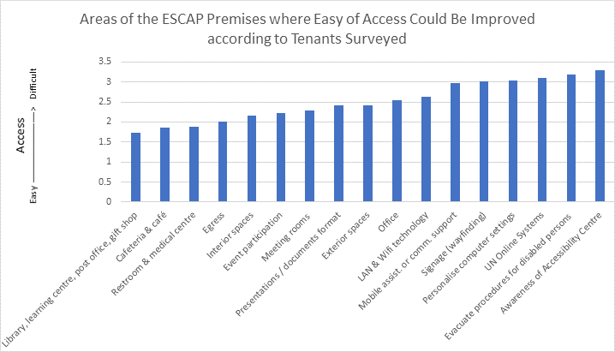

Appendix E: Accessibility Assessment on-site

WEEK OF 19-23

19 June, Monday – PRE-PLANNING
- Introduction Meeting (UNCC, Theater) – 8:30-11:00
- Overview of the Seismic Mitigation Project(SMP) and the scope of the Access. Assessment (extends beyond SMP)
- Review of structure of agencies, decision makers, tenants, working groups committees, scope extents
- Pre-planning Finalized Meeting (UNCC, Meeting Room (MR) E) – 11:00-12:00
- Review TOR - future recommendations
- Review Pre-planning documents / questions / follow-up

20 June, Tuesday – PRE-PLANNING / PLANNING
- Review Pre-planning documents / questions / follow-up
- Review survey questions and list of persons to email and include
- Accessibility Working Group Meeting (UNCC, Meeting Room (MR) F) – 10:00-11:00
Attendees: FMU, CMU, SDD, IMCTS, SSS, - INFM information was presented herein. Agenda as emailed
- Medical Center Meeting (UNCC, Medical Center) – 11:00-11:30
- OMT Meeting – 14:00-15:00 UNCC, MR F (meeting with all agencies that are tenants in the building) Agenda as emailed

21 June, Wednesday – TOUR with FMU
- Formal Tour with FMU (FMU Chief’s office - Rieger) - 8:30-11:45
- Renovation of 14th floor interior layout Review and discussion
- Past works – Accessibility Register
- New Library Building

22 June, Thursday – MEET with WORKING GROUP MEMBERS
- Meeting with SSS (SSS office – Kerry’s) – 8:30-11:30
- Meeting with SDD (SDD office - TBD) - 1-4pm
29 – 30 June Survey finalizing / considerations as per meeting with SDD Director

23 June, Friday – MEET with WORKING GROUP MEMBERS
- Meeting with IMCTS – (Kalman’s Office) – 9am- 12pm Agenda as emailed
- Meeting with David Lamotte - 3.00-3.30pm - Meeting organised by David Clarkson

WEEK OF 26-30

26 June, Monday – Holiday
- The consultants will be consulting a walk-through survey Saturday-Monday during non-business hours.

27 June, Tuesday
- Meeting with CMU (CMU Office) – 8:30am-11:45am
- Meeting with Director of Administration (DDA office) – 2-3pm
- Meeting with Martin HESSE (DA IMCTS RMU) – 3-3:30pm (Greg and Tyler SDD)

28 June, Wed
- Meeting with Mick and Jack - OCSS (skype) – 8pm -9pm – NOT CONFIRMED YET – Mick to coordinate as appropriate as OCSS is the oversight body and provides best practices for Facility Management
- Meeting with SDD on web publishing back end (Greg and Tyler) – SDD office
- Meeting with SMTP) – 2pm -3pm (Mick and Aiko) Agenda as emailed

29 June, Thursday
- Inclusivity Survey: Part 1: 8:30-11:30 – survey of the facility w/persons with disabilities w/ a variety of disabilities (staff and visitors)
- Inclusivity Survey: Part 2: 13:00-16:00 – survey of the facility w/persons with disabilities w/ a variety of disabilities (staff and visitors)

30 June, Friday
- Meeting with Atsuko Okuda, Chief, ICT and Development Section, ICT and Disaster Risk Reduction Division 10:00-11:00 – Atsuko’s office, Floor 8, Room 802
- Meeting with Nagesh Kumar, Director, Social Development Division – Nagesh ‘s Office, Floor 6 Block B - 13:15-13:45
- Inclusivity Survey (Staff) – Meeting Room 6A (Secretariat) 14:00-15:30 -

WEEK OF 3-7 July
- J.Harrison (Architect) onsite during this week. Free for consultant planning
- Meeting via Skype with Yuko Kitada (Learning Centre) and Aiko Akiyama (SDD)
- 1pm -2pm with Greg Alchin dialling in from Australia

Appendix F: Ministerial Regulation Prescribing accessible facilities for persons with disabilities and the elderly. 2005AD (B.E.2548)

Clause 3: The following types and categories of buildings shall have accessible facilities as prescribed in this Ministerial Regulation in area accessible by the public:
(1) Hospital, healthcare center, public health center, primary health care center, office of government, state enterprise, and government organization established under provision of law, educational institution, library building and public museum, public transport terminal, such as airport, train station, bus station, and wharf with area accessible by the public greater than 300 square meters;
(2) Office, theater, hotel, auditorium, stadium, mall, and department store with area accessible by the public of any part of a building greater than 2,000 square meters.
Chapter 1 Accessible facility sign

Clause 4: Building under Clause 3 shall have proper accessible facility sign with details as follows:
(1) Symbol of access;
(2) Directional signage to accessible facilities
(3) Symbol or text identifying type of accessible facilities
Clause 5: Symbol of access, directional signage to accessible facilities, and symbol or text identifying type of accessible facilities under Clause 4 shall be in white on blue background or blue on white background.
Clause 6: Accessible facility sign must be clear and visible and shall be posted where it does not cause confusion and shall be equipped with extra lighting day and night.
Chapter 2 Ramp and Lift
Clause 7: In building under Clause 3, if the difference between floor levels inside the building, or between floor level inside and outside the building, or floor level of walkway outside the building exceeds 20 mm, a ramp or lift between such height difference of those levels shall be provided. If the level difference is 20 mm or less, a 45 degree or less chamfer is required.
Clause 8: Characteristic of a ramp shall be as follows:
(1) Ramp surface material shall be non-slippery.
(2) Surface of connecting point between floor and ramp must be leveled and prevent stumble.
(3) The minimum clear width shall be 900 mm. In case total length of each run is 6,000 mm or more, the clear width shall not be less than 1,500 mm.
(4) Landing of a ramp shall be 1,500 mm minimum in width.
(5) The maximum slope of a ramp shall be 1:12 and the maximum length of each run shall be 6,000 mm. If the ramp is greater than 6,000 mm in length, a landing of 1,500 mm minimum in width shall be provided between each run.
(6) For ramp without side wall, curbs of 50 mm minimum in height and railing shall be provided.
7) For ramp which is 2,500 mm or more in length, handrail with the following characteristics shall be provided on both sides:
(7) For ramp which is 2,500 mm or more in length, handrail with the following characteristics shall be provided on both sides:
(a) It must be made of smooth material and safe to hold and non slippery
(b) It must be round in shape with diameter of 30 to 40 mm
(c) It shall be mounted at 800 to 900 mm above the floor.
(d) For handrail adjacent to a wall, it shall not be less than 50mm away from the wall and shall not be less than 120 mm above the studs, and the wall adjacent to the handrail must be plump.
(e) Handrail must be continuous and the studs must not obstruct or interfere with the usage of persons with visual impairment.
(f) Handrail shall extend beyond the top and bottom of the ramp for a distance of 300 mm or more.
(8) There shall be signage for direction, position or floor level identification, which persons with visual impairment or the elderly understand, installed at both ends of the ramp connecting between each floor.
(9) There shall be symbol of access posted near the accessible ramp.
Clause 9: Building under Clause 3 which is two-storey or higher shall have accessible lift or ramp between each floor. An accessible lift should serve all floors. Lift control system must be easily controlled, safely used, and located where it is easy to access by persons with disabilities and the elderly. Symbol of access shall be posted outside the door opening of the accessible lift.
Clause 10: Lift car of an accessible lift shall be as follows:
(1) Minimum dimension of the lift car shall be 1,100 mm wide by 1,400 mm long.
(2) Door of the lift shall have a clear width of at least 900 mm and installed with light curtain system to ensure that doors do not make physical contact with passengers.
(3) Tactile ground surface indicator shall be installed in front of lift door with the size of 300 mm wide and 900 mm long commencing from 300 mm to 600 mm back from the door.
(4) Call buttons, control buttons, and emergency bell shall:
(a) be placed at a height of 900 mm to 1,200 mm from the floor level, and away from the corner of the lift car not less than 400 mm in case the lift car is less than 1,500 mm in width and length;
(b) have a diameter not less than 20 mm with Braille marking at every button which illuminates and makes audible sound when pressed; and
(c) be free from any obstruction.
(5) There shall have handrails fixed around the lift car interior and such bars shall be as prescribed in Clause 8 (7) (a) (b) (c) and (d).
(6) There shall have an audible announcement when the lift stops and moves up or down.
(7) There shall have signages for floor level designation and direction posted clearly in lobby lift area.
(8) In case of lift malfunction incident, there shall have a blinking red light with audible signal to notify persons with visual or hearing impairments, and blinking green light to signal to persons with hearing impairment that people outside acknowledge the incident and help is arriving.
(9) There shall have emergency phone inside the lift to contact personm outside and shall be placed at a height of 900 mm to 1,200 mm from the floor.
(10) In case of power outage, there shall have the automatic lift systemto move the lift to ground level and open lift doors.
Chapter 3 Stairs
Clause 11: For building under Clause 3, at least a set of accessible stairs with the following characteristics must be provided:
(1) a clear width of not less than 1,500 mm;
(2) a landing at every 2,000 mm of vertical distance;
(3) handrails installed on both sides and as described under Clause 8 (7);
(4) uniform risers of maximum 150 mm and uniform threads of
minimum 280 mm after splay backwards, and splay backwards or stair nosings
can be up to a maximum 20 mm;
(5) stair surface material shall be non-slippery;
(6) open risers are not permitted; and
(7) signages for direction, position, or floor level designation, which persons with visual disabilities and the elderly can understand, shall be located near the landings of each floor level.
Chapter 4 Parking
Clause 12: For building under Clause 3, there shall be accessible parking space for persons with disability or the elderly at the least in accordance with the following ratio:
(1) If there are 10 parking lot or more but less than 50 lots, at least 1 accessible parking lot is required.
(2) If there are 51 parking lot or more but less than 100 lots, at least 2 accessible parking lot are required.
(3) If there are 101 parking lots or more, at least 2 accessible parking lots are required, and one additional accessible parking lot is required for every subsequent 100 lots. For any part thereof, if greater than 50 lots, it shall be deemed as 100 lots
Clause 13: Accessible parking shall be located as close as possible to the entrance of a building, not parallel to roadway, on smooth and level surface, and with symbol of access with dimension of at least 900 mm by 900 mm painted on the designated lot adjacent to driveway. And another signage with dimension of at least 300 mm by 300 mm shall be installed at a height of at least 2000 mm where it is clearly seen.
Clause 14: Accessible parking shall be rectangular with minimum dimension of 2,400 mm by 6,000 mm and a clear space beside the parking lot with the size of at least 1,000 mm wide along the length of the lot. And such clear space must be smooth surface and level to the lot.
Chapter 5 Building entrance, walkway between buildings, and passageways.
Clause 15: For building described under Clause 3, accessible building entrance shall be:
(1) smooth, level, and non-slippery without obstructions which may hinder or cause harm to persons with disabilities or older persons; and
(2) at the same level with the road outside or parking lot floor. In case of different levels, a ramp near parking must be provided.
Clause 16: In case there are more than one building under Clause 3 in the same area and are used together, either with or without fence, walkways between those buildings and from each building to public way, parking lot or car parking building shall be provided.
Walkway as prescribed in Paragraph one must be as follows:
(1) Walking surface must be smooth and non-slippery with a minimum clear width of 1,500 mm.
(2) If there are floor drain pipes or drainage, drain covers must be provided. If such covers are gratings, it shall have gaps or diameter of holes not greater than 13 mm wide and the long dimension is perpendicular to the direction of travel.
(3) Tactile ground surface indicators shall be provided at intersection or turning area.
(4) If obstructions are necessary along the walkway, they shall be arranged in the same line without obstructing the walkway. There shall be tactile ground surface indicators or barriers to notify of protrusions at least 300 mm before approaching.
(5) Signage or any other hanging above walkway shall be placed not less than 2,000 mm above the walkway.
(6) In case there is a change of levels between walkways and roadways, ramp shall be provided with gradient not steeper than 1:10
Clause 17: Buildings according to Clause 3 which have passageway Between each building shall have walls or handrails on both sides and mounted with handrails in compliance with Clause 8 (7) (a), (b), (c), (d), and (e), and passageway in compliance with Clause 16 (1), (2), (3), (4), and (5).
Chapter 6 Doors
Clause 18: Doors of a building as prescribed under Clause 3 shall have characteristics as follows:
(1) They must be easily opened and closed;
(2) If there is a threshold, the height of a threshold shall not exceed 20 mm and both edges must be chamfered to an angle of not greater than 45 degrees, so wheelchair or persons with disabilities and the elderly with walking aids may cross with ease.
(3) Doorway must have a minimum clear width of 900 mm.
(4) Where two-way swing doors are used, a minimum clear floor space of 1,500 wide by 1,500 long at the walkway or terrace must be provided.
(5) Where sliding or hinged doors are used, there shall be a vertical bar handle with same size of gripping surface as handrails prescribed under Clause 8 (7) (b) installed on both sides of the door where the top of the handle is 1,000 mm or more above the floor and the bottom of the handle is 800 mm or less from the floor. In case of outward opening door, a horizontal handrail shall be installed inside the door. In case of inward opening door, a horizontal handrail shall be installed outside the door. Such handrail shall be installed at a height from 800 to 900 mm above the floor and along the door width.
(6) In case of glass door or glazed door, there shall be a clearly visible sign or color band.
(7) Door operating device shall be a lever or latch and mounted at a height of 1,000 mm to 1,200 above the floor.
Doors under Paragraph one shall not be equipped with any door closer which may shut on or slam on persons with disabilities or the elderly.
Clause 19: Provision of Clause 18 shall not be applied to fire door or automatic door.
Chapter 7 Accessible Toilets
Clause 21: Accessible toilet shall be as follows:
(1) Clear internal dimensions shall be at least 1,500 mm diameter for wheelchair turning and maneuvering space.
(2) Toilet door shall be an outward swing door with minimum opening of 90 degrees or a sliding door with a symbol of access attached at the door in front of such accessible toilet. In addition to the characteristic of the door specified herewith, the door shall be as prescribed under Chapter 6
(3) Toilet floor and outside floor shall be flush. If there is a change in level, a ramp according to Chapter 2 must be provided and floor material must be non-slippery.
(4) The floor must have appropriate gradient to floor drain to avoid puddles on the floor.
(5) There shall be a sitting toilet with its seat located at the height of 450 mm to 500 mm above the floor, with a backrest against which persons with disabilities or the elderly may lean while sitting, and accessibility flush control with lever or big button or any other device where persons with disabilities or the elderly may use with ease. The toilet shall be positioned where one side of such toilet is close to the wall with a distance of 450 mm to 500mm from the center the toilet to such side wall. The washroom shall be equipped with a handrail and there shall be enough space on the other side for wheelchair to access easily. In case the distances between the toilet and walls on both sides are greater than 500 mm, handrail in accordance with (7) shall be installed.
(6) On the side wall adjacent to the toilet, there shall be horizontal and vertical handrails mounted as follow:
(a) Horizontal handrail shall be mounted at 650 mm to 700 mm above the floor and shall extend 250 mm to 300 mm beyond the tip of a toilet bowl.
(b) The length of vertical handrail extending upward from front edge of horizontal handrail shall be at least 600 mm.
Handrails according to (6) (a) and (b) can be a continuous handrail. (7) On the side of the toilet, away from the side wall, there shall be a horizontal swing away handrail with easy release locking mechanism when swung out mounted at 150 mm to 200 mm away from the side rim of the toilet with a minimum length of 550 mm.
(8) Aside from handrail according to (6) and (7), handrails aiding other sanitary products inside the toilet shall be installed at the height of 800 mm to 900 mm above the floor.
(9) There shall be a light and audible signal system which enables person outside the toilet to alert persons with disabilities or older persons in case of emergency, and another light and audible signal system inside the toilet, with press or touch button to activate the signal installed at easy to access position, so persons with disabilities or the elderly can alert caregivers or ask for emergency aid.
(10) A washbasin must be installed and shall:
(a) be mounted such that the minimum distance between the edge of the washbasin and a side wall is 450 mm with clear space under the fixture and does not obstruct when approached;
(b) be mounted such that the top edge is at 750 to 800 above the floor and with flip-up horizontal handrails on both sides; and
(c) be installed with tap operated by pulling, pressing, or turning the lever or sensor operated.
Clause 22: In case of accessible water closet compartment located in a public toilet which has a doorway, the accessible water closet compartmentmust be located where it is easy to access.
The toilet cluster under Paragraph one, if men and women toilet are separated, a braille signage indicated men or women toilet shall be mounted on an entrance wall where it is easy to touch.
Clause 23: In case of men toilet which is not an accessible toilet according to Clause 20 and Clause 21, at least one urinal installed at floor level shall be provided. A horizontal handrail of 500 mm to 600 mm in length shall be mounted above the urinal at 1,200 mm to 1,300 mm above the floor. Vertical handrails shall be mounted on both sides of the urinal at 800 mm to
1,000 mm above the floor and extending from the wall from 550 mm to 600 mm.
Clause 24: Handrails in toilet shall be as prescribed under Clause 8 (7) (a) and (b).
Clause 25: Building according to Clause 3 shall have tactile ground surface indicators for persons with visual impairments, where there is a changein level of more than 200 mm at ramp or stair access located at doorway of building entrance and toilet door. The tactile ground surface indicators shall havea width of 300 mm and a length of full width of and parallel to such walkway which has a change in level, ramps, stairs, doors, at a distance from 300 mm to 350 mm.
In case of public transport terminal, the tactile ground surface indicators shall be located 600 mm to 650 mm away from platform.
Chapter 9 Theaters, Auditoriums and Hotels
Clause 26: Building according to Clause 3 which is a theater or auditorium shall have a specific area for wheelchair per every 100 seats which is flat floor with a minimum clear floor space of 900 mm wide by 1,400 mm long per seat, located where accessible.
End of regulation

